Turner
Comprehensive Plan Update
Section I

A Vision for Turner
Goals, Policies, Strategies
Future Land Use Plan
Regional Coordination Program
Capital Investment Plan

STATE APPROVED VERSION

May 13, 2020

Includes April 12, 2023 Revisions

TABLE OF CONTENTS

Introduction 4

Public Process ……………………………………………………………………………………5

A Vision for Turner 5
Character and Special Places 6
Future Growth 6
Outdoor Recreation 6

Village Areas………………………………………………………………………………6
Appearance of Development 7

PLANNING AREA: Historic and Archaeological Resources 8

PLANNING AREA: Economic Development 10

PLANNING AREA: Production Agriculture 13

PLANNING AREA: Public Services/Facilities 15

PLANNING TOPIC: Outdoor Recreation 20

PLANNING TOPIC: Transportation/Roadway System 23

PLANNING AREA: Affordable Housing 27

PLANNING AREA: Natural Resources 30

PLANNING AREA: Rare, Endangered and Significant Natural Features 39

PLANNING AREA: Scenic Resources 40

PLANNING TOPIC: Land Use/Development Patterns 41

FUTURE LAND USE PLAN 50
Purpose 50
Implementation 50
Future Land Use Plan 50
Critical Natural Resource Areas 54
Shoreland Areas 54
Resource Protection Areas 54
Limited Residential Areas………………………………………………………………..55
Limited Commercial Areas………………………………………………………………55
General Development I Areas …………………………………………………………55
General Development II Areas ………………………………………………………...56
Stream Protection Areas………………………………………………………………….56
Village Area 56
General Residential Area I 56
General Residential Area II 57
Rural Area I 57
Rural Area II 57
Commercial Area I 58
Commercial Area II 58
Agricultural/Industrial Area 58
Future Land Use Map… …………………………………………………………………59
Shoreland Future Land Use Map ……………………………………………………….60

PLANNING AREA: Regional Coordination 61

CAPITAL INVESTMENT PLAN 63
Introduction 63
Capital Improvements Financing 64
Low Interest Loans 65
Capital Investment Plan Implementation 65
Policy…………………….. 66
Implementation Strategy 66

PLANNING AREA: Hazard Mitigation 67

Introduction

Turner’s first Comprehensive Plan was adopted in 1991. That plan was last updated in 2006. In 2018, this Comprehensive Plan Committee started our work on what was expected to be a simple update of the 2006 plan. Once we completed our update of the inventory sections of this plan and public meetings, we had identified several issues with our current plan that we felt needed to be addressed. As we completed our rewrite of this plan, we found that the State had established new criteria they would be using to determine consistency with the goals and guidelines of the Growth Management Act.

This plan was completed by a committee of eleven Town citizens with support from the Town Manager and a secretary. While the Town did vote to provide funding for this work, the dollar amount provided was determined by the committee to be insufficient to hire a consultant to help with this plan update. We also felt that it would be a simple update that we could complete without help. After two years of work, this committee believes this update is complete and will comply with the goals and guidelines of the Growth Management Act.

This update to the Comprehensive Plan, should serve as a new guide for the community and town officials as they make decisions about the future of Turner. The Plan suggests general directions, recognizing that specific details will require further efforts. The Plan should be considered a living document, meaning that it will require review and revisions as Turner changes over time. In some areas, we have suggested updating or monitoring to be an annual consideration. At a minimum, the Town should consider a new update in 2030, or before that time if significant growth or changes in the community are noticed.

The Plan is, however, intended to guide future changes in the Town’s land use regulations so that they will reflect the goals and polices of this Plan. Similarly, the discussions of capital needs and spending priorities are intended as general guides, not specific proposals.

The cornerstone or most important elements of the Comprehensive Plan are the policies and strategies which the community adopts. They represent the directions the community will take to address issues identified in the Inventory and Analysis element of the plan. Policies are statements of direction the community desires to take, and strategies define specific actions the Town should undertake in order to carry out the directions contained in the policies.

Strategies or actions to carry out the plan have been identified as short-, mid- or long-term. This refers to the time frame that the plan recommends actions to occur. Short-term actions should occur within one to two years of plan adoption, mid-term three to five years from plan adoption and long-term six to ten years from plan adoption. Those that should be responsible for undertaking the strategies are also identified.

The Turner Comprehensive Plan Committee has thoroughly considered each and every one of the policies and strategies and assessed its implications during the updating of the plan first adopted in 1991. In addition, it relied heavily on what the citizens of Turner told the committee in the Citizen’s Survey and the Public Hearings conducted in 2018 in several public sessions. Although, in not all instances did the committee unanimously agree; it is the position of the committee that the following presents a realistic direction for Turner in the third decade of the 21st Century.

Public Process

The committee prepared a community survey to gather input on a number of issues, similar to surveys done with the prior plans. The survey was done online using SurveyMonkey between April and June of 2018. The results, as tabulated by SurveyMonkey, were relied upon by the committee as we developed community goals and strategies. The committee also received numerous written communications from citizens, all of which were reviewed and considered as we completed our work on this update. The committee also conducted several public meetings on the following topics:

Town Owned Buildings July 18, 2018
Outdoor Recreation August 21,2018
Shoreland Zoning with MDEP August 28, 2018
Village Areas October 10, 2018
Shoreland Zoning – Public November 14, 2018
Route 4 with MDOT December 13, 2018

Information gathered at these public meetings was very surprising and extremely helpful for the committee to understand some of the changes that have taken place in the community. All of the public comments were discussed on several occasions as we completed the inventory, analyzed those results and prepared our goals, policies and strategies contained in this plan.

A Vision for Turner - Based in part upon town visioning session of November 1, 2001 and several Public Hearings conducted in 2019.

Character and Special Places

Turner is a town of diversity. It has farm families that go back many generations, and young families who just moved in last year. It has modern state-of-the-art schools and historic grange halls. It has undeveloped forests and a busy commercial highway. It has lakes and farms, homes and businesses, villages and open space. Yet, all of Turner has these two things in common. The people are caring and friendly. And the community has an open, rural feel.

There is a feeling of home and community in Turner. Many families and family businesses have been a part of the Town for generations. The schools have a widespread reputation for excellence. People are independent, and prefer lower property taxes to city-type services.

The rural character of Turner is felt in its farms, its open space, its woodlands and fields, its scenery, and its peacefulness. Some of Turner’s special places include Turner Center, with its historic Grange Hall, churches, library, cemetery, and the Leavitt Institute; the views from General Turner Hill, from Upper Street and Lower Street, and from North Parish Road; the Androscoggin River with its state-owned lands and boating opportunities; the town beach on Bear Pond; and North Turner Village.

This Vision is the original vision based in part upon the visioning session conducted in November 1, 2001 and several Public Hearings conducted in 2019. The current committee felt that vision still held true today and did not need to be changed at this time.

Future Growth

Turner will continue to attract development in the future because of its vibrant school system, expansive scenery, low taxes, and community feeling. Commercial development will be concentrated along the Route 4 corridor. Elderly housing and multi-family housing will fit best in Turner Center and Turner Village. Single family homes will continue to be located throughout the community. Within this general pattern, here is the vision for Turner’s villages and districts.

Outdoor Recreation

With Town encouragement of the existing national events in disc golf, fishing tournaments and 24-hour endurance racing at the Riverlands Park, interest in outdoor activities in Turner are beginning to grow rapidly.

Maintaining the town boat launches at the town office on the Nezinscot River and at Pleasant Pond and the facilities at the Town Beach on Bear Pond, will be important to continue the expansion of outdoor recreational activities. The Town’s encouragement of private landowners to allow public access, such as through voluntary right of way easements or via grant applications that would allow for purchasing such easements for public access will continue to grow outdoor public recreational activities on our waters.

The Turner Ridge Riders Snowmobile Club and the Turner Timberland ATV Club have expanded their trail system to connect the Riverlands State Park trails. The Turner Ridge Riders Snowmobile Club has expanded north near Pleasant Pond, The Turner Highlands and extending to Livermore and West to include Ricker Hill and extending toward Buckfield. Many existing businesses are planning expansions to provide services to these visitors enjoying these outdoor activities.

Village Areas

Turner Village area has been expanded down Snell Hill Rd. to the dump facility and South to the County Road to allow for further residential development. Deteriorated buildings should be demolished. There will be a park and better access to Nezinscot River. The area around the Town Office will be redeveloped for better access to the river to accommodate recreational activities. Commercial development will expand in the area of the Northland Plaza and to the North of the Plaza. There will be improvements to the Rt. 4/ Rt. 117 intersection to improve safety.

Turner Center The sewerage treatment plant will be updated. The Turner Center Village area has been expanded north to Fish Street. The new Caldwell Field Complex will continue to be expanded to provide recreational facilities to Turner Athletic Association.

South Turner, Route 4 will continue to develop and expand as a commercial hub. Business and commercial development will stretch along Route 4 in South Turner (with the exception of used car dealerships). Cobblestone Crossing will be expanded towards Wood Street as the existing gravel pit is depleted. The current airport land will be redeveloped. Back away from Route 4, there will be new residential development. Along the river there will be a greenway, with improved access to the state land. The water quality in the aquifer will be protected – with sewer and water systems, if necessary.

North Turner will retain its friendly village character. The post office, church, and Boofy Quimby Memorial Center will remain. The BQMC will be improved. Recreation opportunities will be expanded, with public access to Bear Pond. The Route 219 intersection will be updated. Ponds will be protected. Route 4 will develop commercially, as to the south, but on a smaller scale, with limited access commercial parks, and no large retail “box” stores.

Chase’s Mills Village is beginning to see investment and redevelopment activities. A new lodge with a restaurant, banquet facilities and rental cabins has been developed. The lodge is very busy over the Fourth of July holiday and at harvest time at Ricker Orchards. They are also very busy when the national disc golf tournaments are held. Trails for walking and mountain biking are almost complete with proposed connections to Ricker’s and Martin Stream Campground. The Campground has been expanded and is at full capacity during the summer months with its trail connections and dock facilities on Martin Stream where paddle sports are now very active. A new open space subdivision is proposed to promote an active outdoor lifestyle. Fifty to one hundred lots are expected to be constructed over the next ten years.

The rural areas of Turner will continue to have farm activities. Where farming is no longer economically viable, public-private partnerships (involving state, local, and private funding) will purchase open space to keep the Town’s rural feel or the space could be utilized for solar farms. Agricultural-tourism will be a new economic activity, with people coming from the cities to the south to experience life on the farm. Also, food processing and related agricultural industries will be encouraged, such as cheese processing and ice cream. There will be trails for walking, for snowmobiles, and for cross-country skiing. Where housing occurs, clustering will be encouraged. There will be no junk yards. Water bodies will not be threatened by “funneled development” (the practice of combining access for many inland homes to the waterfront).

Appearance of Development

Commercial development will be encouraged to have landscaping and trees, pitched roofs and a New England building character.

Residential development will be encouraged to be in clustered locations off of main roads, with open space views preserved whenever possible.

PLANNING AREA: Historic and Archaeological Resources

Turner’s Goal

To maintain the values of important historic, cultural and archaeological resources.

Overview

Turner’s history dates back to the mid-1700's when the Town was known as Sylvester-Canada. Since the early days of the Town’s development, many of the historic resources have been destroyed or lost. Although much of Turner’s history has been visually lost, there remain individual structures, sites and areas which are reminders of the Town’s heritage. As the Town undergoes change, these reminders of Turner’s beginnings and history become invaluable.

Prior surveys showed that a majority of the respondents to the Turner Comprehensive Plan Survey identified historic sites and areas as important or very important resources to maintain. Although not generally seen as important as historic sites, known and yet to be discovered archaeological areas can provide details of our history. The Town’s history is represented by its buildings, historical sites and archaeological resources.

While there are no known threats to existing buildings, historical sites or archaeological resources with regulations contained in the existing Town Ordinances, the Town needs to continue its protection of these resources. If lost or diminished, Turner’s remaining historic values and significant archaeological sites will no longer represent the Town’s rich heritage.

Historic and Archaeological Policy

Pursuant to the goal, the historic and archaeological policies of the comprehensive plan are:

1. To encourage the maintenance of its historic buildings and sites.

2. To maintain and enhance the traditional characteristics of its three villages (Turner Village, Turner Center and North Turner) and the reestablishment of the old village area in Chase’s Mills.

3. To encourage and support the Turner historical groups.

4. To minimize the impacts of development or other land use activities upon recognized historic buildings and natural sites/areas.

5. To assure that before archaeological sites/areas are disturbed their values are fully assessed and preserved where appropriate.

6. To protect to the greatest extent practicable the significant historic and archaeological resources in the community.

Implementation Strategies

A. Short-Term Activities-To accomplish the goal and policies, the Turner Community should undertake the following within one to two years of plan adoption.

1. Work with local or county historical society and/or the Maine Historic Preservation Commission to assess the need for and to secure a grant to pay for a professional survey of archaeological and historic features, sites and structures and to document them as either of local significance or eligible for the National Register of Historic Places.

Responsibility: Selectmen/Historic Groups

2. The Town’s historical groups actively work with the owners of identified historic properties to assess the feasibility and assist in the nomination of buildings and sites to the National & State Register of Historic Buildings and Places.

Responsibility: Historic Groups

3. The Planning Board in development reviews consider the current provisions contained in Local Ordinances, relating to Preservation and Enhancement of Landscape and Relation of Proposed Buildings to Environment, to minimize the negative impacts to identified documented archaeological sites or historic buildings.

Responsibility: Planning Board

4. Prepare and submit applications for Grant funds for all village improvements.

Responsibility: Selectmen/Town Manager

5. Local Ordinances should require that archaeological sites and historical buildings be assessed and appropriately addressed before development takes place be required.

Responsibility: Planning Board

- The Planning Board should incorporate the Maine Historic Preservation Commission maps and information into their review process.

Responsibility: Planning Board

PLANNING AREA: Economic Development

Turner’s Goal

To provide for economic development which is suited to the town’s character and its fiscal and infrastructure resources.

Overview

It is often a goal or the desire of a community and its residents to increase its tax base in non-residential property, hoping to reduce the tax burden upon residential property. The approach employed most often to gain tax revenues by communities is to encourage economic growth in the commercial and manufacturing sectors.

Economic development occurs within a community due to a number of factors. These include market conditions, labor force availability, transportation systems, suitable land resources, availability of municipal infrastructure such as water, sewer and fire protection; tax rates; and a desire of the community to attract development. Several of the above factors are greatly influenced by the community whereas others are beyond the control of the community.

Market conditions, labor force, and the transportation system, to a degree, are beyond the control of Turner. However, they may be significant factors in local economic development. Factors such as providing suitable land resources through zoning provisions, adequacy of municipal infrastructure, tax rates, and community attitudes towards economic or business development can be directed by the municipality.

With support from the prior Comprehensive Plans, land resources through zoning provisions have been set aside to support economic development. While Turner has seen some economic growth, especially in South Turner, many areas previously set aside remain unutilized. We have also identified areas where we believe outdoor recreational uses should be encouraged along the shorelines of Martin Stream, the Nezinscot River and the Androscoggin River.

Previous Comprehensive Plans identified a large area lying southerly of Route 117 near Chase’s Mills as a Commercial Area I. This area has remained unchanged since it was first identified in 1991. This Committee has identified this area for the reestablishment of the old village of Chase’s Mills. With appropriate development controls discussed elsewhere in this Plan, we believe this change will allow some commercial activities with a mix of residential uses in this area. Changes to the Shoreland Areas along Martin Stream, the Nezinscot River and the Androscoggin River and the reestablishment of the old village in Chase’s Mills is intended to provide additional land areas through our zoning provisions and to express a community attitude that supports a variety of new economic and business development in Turner.

There are two main considerations relating to economic development within Turner. One relates to providing local employment opportunities and the availability of services and goods for the town’s residents. The second relates to economic growth and its impact upon property tax rates. The Comprehensive Plan can suggest various activities which may lead to additional economic development. These actions can be indirect such as providing through zoning regulations suitable locations for commercial/manufacturing businesses; or direct such as developing business parks or providing tax incentives to attract new business.

Economic development strategies that are intended to meet the goal of stabilizing or lowering the property tax rate are difficult to achieve. The issues relating to the advantages and disadvantages of major commercial/manufacturing growth on the local tax rate are many and beyond the scope of the Comprehensive Plan.

Turner’s agricultural base has been a significant factor in stabilizing the town’s tax base. Although a detailed analysis has not been conducted for Turner to determine the value of farmland in tax base stabilization, analysis from the Farmland Information Center in 2016 found:

Median Cost of Community Services Provided Per Dollar of Tax Revenue Raised, US, 2016:

Costs/$ Business/ Commercial/ Industrial use $0.30
Agricultural/Forestry/Working Lands $0.37
Residential $1.16

If these figures are representative of Turner’s situation, the value of farmland in relation to tax base is clear. Respondents to the Comprehensive Plan Citizen’s Survey indicated a desire to encourage service related businesses. Other economic or business-related development will provide additional local employment opportunities and an additional source of local tax dollars.

Economic Development Policy

Pursuant to the Goal, the economic development policies of the comprehensive plan are:

1. To encourage the continuation of production agriculture and associated business development including Agri-Entertainment.

2. To provide for land areas of sufficient size and in suitable locations for commercial and manufacturing land uses in those areas where it will not conflict with adjacent, less intense, land uses or cause damage to the environment.

3. To be an active partner in promoting appropriate economic development.

4. To develop an economic development strategy which reflects the ongoing needs of the town.

5. To allow for appropriate commercial development within village areas.

6. To allow home-based occupations in all areas of the community.

7. To develop/participate in programs with adjacent communities to retain and/or attract appropriate economic development.

- To encourage and support new enterprises for Outdoor Recreational activities.

- To make a financial commitment, if necessary, to support desired economic development, including needed public improvements.

Implementation Strategy

A. To accomplish the goal and policies, the Turner Community should undertake the following within one to two years of plan adoption.

1. Amend the Zoning Map to designate suitable locations of sufficient size for commercial and light manufacturing development.

Responsibility: Planning Board

2. Amend the Zoning Map to allow commercial and recreational development within the shoreland areas adjacent to Rivers, Martin Stream and the Androscoggin Riverlands Park.

Responsibility: Planning Board

3. Allow and develop an Economic Development Strategy for the Town if interest supports a committee and annually appropriate funds to provide professional support for that committee.

Responsibility: Selectman/Budget Committee and Town Manager

4. Amend the Zoning Map to designate the area lying southerly of Route 117 near Chase’s Mills as Village Area.

Responsibility: Planning Board

5. Local Ordinances should reflect the desired scale, design, intensity, and location of future economic development.

Responsibility: Planning Board

6. If public investments are foreseen to support economic development, the Selectmen should determine the best mechanisms to finance them (local tax dollars, creating a tax increment financing district, a Community Development Block Grant or other grants, bonding, impact fees, etc.) and seek appropriate input or approvals from Town Citizens.

Responsibility: Planning Board

- The Town should participate in any regional economic development planning efforts.

Responsibility: Planning Board

PLANNING AREA: Production Agriculture

Turner’s Goal

To encourage production agriculture.

Overview

Production agriculture is a significant element of Turner’s economy. In addition to its economic values, it has and continues to present significant elements of Turner’s character.

Production Agriculture Policies

1. To encourage the preservation of an agricultural land base suitable for production agriculture.

2. To seek changes to the Maine Constitution and laws so that taxes are based on current use.

3. To minimize the conflicts between agriculture and adjacent land uses.

4. To encourage use of prime agricultural lands for farming.

5. To not pursue at this time strategies that mandate exclusive agricultural zones.

6. To develop farm enterprise districts that allow for farm diversification that maintains land for farming.

7. To encourage the development of economic tax policies that support the maintenance of land and production agriculture.

8. To maintain the economic value of land owned by those engaged in production agriculture to allow its owners to finance ongoing farm operations.

Implementation Strategy

A. Short Term Activities- To accomplish the goals and policies, the Turner Community should undertake the following within one to two years of Plan adoption.

1. Seek changes to laws that would allow the Town to develop an agricultural land tax assessment program which encourages participation in the Farm & Open Space Tax Law by assessing land lower if it is registered under the Farm & Open Space Tax Law.

Responsibility: Selectmen/Assessors

2. Encourage agricultural landowners to participate in conservation easements and any other state program for the purchase of development rights of farmland. Assist in the application/proposal development and provide matching funds. Lobby at the state and federal level for the inclusion of Turner’s farmland in any state and/or federal programs.

Responsibility: Selectmen

3. Local ordinances should encourage the clustering of new subdivisions proposed for agricultural areas through density bonuses or other techniques. Clustering should be done in such a way as to maximize the potential for open space to be used for production agriculture.

Responsibility: Planning Board

4. Local ordinances should contain guidelines that provide a separation between new non-farm residential uses and existing agricultural land uses including well locations.

Responsibility: Planning Board

5. Work jointly with land trusts, in order to coordinate an approach to Purchase of Development Rights and to take advantage of all possibilities for putting farmland under conservation easement.

Responsibility: Selectmen/Land Trusts

6. Local ordinances should include farm enterprise uses that provide for diversified uses on farms that are compatible with farms and rural locations.

Responsibility: Planning Board

7. Local ordinances should allow the sale of individual lots in rural areas of not more than 80,000 square feet, as long as additional area is set aside with conservation easements to match zone density requirements.

Responsibility: Planning Board

8. Consult with Soil and Water Conservation District staff when developing any land use regulations pertaining to agricultural management practices.

9. Local Ordinances should allow land use activities on farms that support productive agriculture and forestry operations, such as roadside stands, greenhouses, firewood operations, sawmills, log buying yards, and pick-your-own operations.

B. Mid-Term Activities-To accomplish the goals and policies, the Turner Community should undertake the following within three to five years of plan adoption.

1. Investigate the merits of a regional Transfer of Development Rights program as a method to conserve agricultural land where rural agricultural areas would be the sending areas and the urban city areas the receiving areas.

Responsibility: Selectmen/Land Trusts

PLANNING AREA: Public Services/Facilities

Turner’s Goal

To provide necessary municipal services which are responsive to local needs in such a manner that will not overburden the community’s financial resources.

Overview

The delivery of necessary municipal services is extremely important for the community’s wellbeing. Adequate public safety services should be provided for the Town’s residents. Educational services must be responsive to changing demands. Municipal government must be accessible and responsive to local needs.

Public Safety

Public safety services include law enforcement, fire protection and emergency medical services. Turner does not provide any municipal law enforcement but rather relies upon the County Sheriff’s Department and State Police. Fire services are provided by volunteers and Turner Rescue utilizes paid personnel to provide 24 hour services to the town.

Turner residents are generally satisfied with the Town’s fire and rescue services.

Current development and population and anticipated future growth has and will create demands upon Turner’s public safety services.

Public Safety Policy

Pursuant to the goal, the public safety policies of the comprehensive plan are:

1. To assure that new growth and development does not exceed the capacity of public safety services.

2. To include adequate public safety facilities and equipment in the Capital Improvements Program.

3. To efficiently meet identified public facility and service needs.

4. To provide public facilities and services in a manner that promotes and supports growth and development in identified growth areas.

Implementation Strategies

A. Short-Term Activities-To accomplish the goals and policies, the Turner Community should undertake the following within one to two years of plan adoption.

1. Local ordinances should include provisions that require a municipal service impact analysis to be completed. Should that analysis indicate that a proposed development would require additional public expenditures above what it supports, off-site improvements, in-kind contribution and/or an impact-type fee can be required.

Responsibility: Planning Board

2. Identify any capital improvements needed to maintain or upgrade public services to accommodate the community’s anticipated growth and changing demographics.

Responsibility: Planning Board

3. Locate new public facilities comprising at least 75% of new municipal growth-related capital investments in designated growth areas.

Responsibility: Planning Board

4. Explore options for regional delivery of local services.

Responsibility: Planning Board

Education

Quality education is vital to community health and future development. Expected future growth in
Turner and the two other communities which comprise the School District will continue to place demands upon new/improved physical plants and human resources. Therefore, the following policies are adopted:

Education Policy

Pursuant to the goal, the education policies of the comprehensive plan are:

1. To maintain a dialogue with the School District so that the district is aware of proposed and approved development that will affect the school system.

2. To assess proposed new development impacts upon school capacities.

Implementation Strategies

A. Short-Term Activities-To accomplish the goals and policies, the Turner Community should undertake the following within one to two years of plan adoption:

1. The Town Manager will provide the CEO reports and Planning Board reports annually to the school district to show the growth of the town.

Responsibility: Town Manager

2. If the growth of the town begins to increase significantly, a meeting should be held with the Planning Board and the School District to review the potential issues that will be raised.

Responsibility: Town Manager

3. Local Ordinances should consider the phasing of residential development when it is found that school facilities are at capacity.

Responsibility: Planning Board

- To encourage the School District to provide adequate parking at their facilities to accommodate their special functions.

Responsibility: Planning Board/ School Board

Effects of Growth on Public Facilities and Services

From 2000 - 2010, Turner experienced the greatest increase in residential development of any Androscoggin County community. Studies have shown that rapid residential development can place burdens on public facilities and services and create a need for expanded and new services. Tax rates must be adequate to pay for the new and expanded services. Since 2010 population growth has stabilized and the committee feels that taxes will not be an issue given the current conditions.

Growth Policy

Pursuant to the goal, the public growth policy of the comprehensive plan is:

That future growth does not over burden the town’s ability to provide high quality municipal services at reasonable cost.

Implementation Strategies

A. Short-Term Activities-To accomplish the goals and policies, the Turner Community should undertake the following within one to two years of plan adoption.

1. The Town manager and CEO shall assess the effect of growth on the Town’s ability to provide reasonable services.

Responsibility Town Manager/ CEO

2. Should the annual assessment of rate of growth of residential development and its effect on the cost of municipal services indicate such growth is responsible for tax rate hikes, a growth limitation and /or impact fee ordinance should be developed for adoption by the town.

Responsibility Planning Board

Geographic Information System

Turner has not taken enough steps to bring its Geographic Information Systems up to current technological abilities. This will allow in the years ahead the town to create a system aiding in the delivery of municipal services and planning.

Geographic Information System Policy

Pursuant to the goal the Geographic Information System policy of the comprehensive plan is:

To create a Geographic Information System that is user friendly.

Implementation Strategies

Short-Term Activities- To accomplish the goals and policies, The Turner Community should undertake the following within one to two years of plan adoption:

1. Seek funding including grants to create the Geographic Information System.

Responsibility: Town Manager/Selectmen

- On an annual basis review the Geographic Information System and prioritize improvements/expansions to the system.

Responsibility: Town Manager/Selectmen

PLANNING TOPIC: Outdoor Recreation

Turner’s Goal

To provide outdoor recreation opportunities for town residents.

Overview

Turner’s growing population will place greater demands upon its existing and potential recreation resources. Developed recreation activities have generally been provided by the School District, Turner Athletic Association and, more recently, the Town. These, along with the traditional recreational activities of hunting, fishing, boating and other non-facility activities, have generally met demands. However, the increased population will demand additional or new recreational opportunities and programs. In addition, changing landownership characteristics have and will continue to alter traditional recreational opportunities. More than half of the respondents to the comprehensive plan survey supported the development of recreational facilities and programs, with walking and hiking trails being the primary preference.

The public meeting held to discuss outdoor recreation was the best attended of all public meetings held by this Committee. Attendees wanted more support for the creation of outdoor resource based activities. Today, there is a lack of understanding of the number of national events held annually in this community. There are currently several fishing tournaments held on Gulf Island Pond, a 24-hour ultra-running event held at the Riverlands Park and disc golf tournaments at two courses in Turner with little or no support from the Town. Therefore, the following policies are presented:

Outdoor Recreation Policy

Pursuant to the Goal, the outdoor recreation policies of the Comprehensive Plan are:

1. Plan for the necessary walking and hiking areas, recreation areas, facilities and programs within the community to serve the needs of all age groups.

2. Provide limited and defined access to ponds, streams and rivers including boat access to priority areas.

3. Seek involvement/ information and input regarding the management plan(s) of State lands at the Androscoggin Riverlands Park.

4. Encourage the practice of allowing public access to privately owned land by permission of landowners.

5. Minimize the negative impact upon trail corridors and traditional recreation activities by new development.

6. Support the efforts of the Turner Ridge Riders Snowmobile Club and the Timberlands ATV Club to maintain a multi-use trail system within the Town.

7. Encourage trails for ATV use to be properly planned and the use of those trails to be authorized by property owners.

8. Support efforts to develop ATV trails that connect the Town of Turner from the Riverlands Park to the BQMC and north to Livermore as outlined in the Action Plan for ATV Trail Development in Section II of this Comprehensive Plan.

9. Support and publicize national recreational events that occur in the Town on the Town’s website.

10. Support new outdoor based recreational business developments.

11. Support the Action Plan for Public Access to the Nezinscot River and beyond, as outlined in Section II of this Comprehensive Plan.

12. To maintain/upgrade existing recreational facilities as necessary to meet current and future needs.

13. To preserve open space for recreational use as appropriate.

Implementation Strategies

A. Short Term Activities- To accomplish the goal and policies, the Turner Community should undertake the following within one to two years of plan adoption:

1. Annually assess recreation facility and program needs and develop a plan to meet needs.

Responsibility: Selectmen/ Community Organizations

2. Evaluate potential access sites including boat access to great ponds, streams and rivers and the costs associated with acquisition and development.

Responsibility: Selectmen

3. Work with the Maine Bureau of Parks and Recreation to develop and monitor management plans for the State owned land in the Riverlands Park along the Androscoggin River.

Responsibility: Selectmen/ Community Organizations/ Planning Board

4. Develop an ongoing information and education program regarding the continuation of public use of privately owned lands and to include information on Maine’s landowner liability law regarding recreational or harvesting use, Title 14, M.R.S.A. §159-A.

Responsibility: Selectmen

5. Participate with ATV groups and Maine Inland Fish & Wildlife in the planning & maintenance of the ATV trails.

Responsibility: Selectmen

6. Develop off-street parking areas in priority locations for walkers.

Responsibility: Selectmen

7. Assess and work with the state to get reimbursement of the ATV registrations similar to the snowmobile registrations for ATV trail maintenance.

Responsibility: Selectmen/ Community Organizations

9. Adopt and implement the concepts outlined in the Action Plans for Public Access to the Nezinscot River and ATV Trail Development as outlined in Section II of this Comprehensive Plan.

Responsibility: Selectmen/Community Organizations

10. Expand the Town’s website to promote recreational events that are held at existing and future facilities and on our water ways.

Responsibility: Town Manager

11. Local Ordinances should limit non-residential development in rural II areas to natural resource-based businesses and services, nature tourism/outdoor recreation businesses, lodging, campgrounds, marinas, restaurants, rentals of boats, bikes, ATVs or snowmobiles, farmers’ markets, and home occupations.

Responsibility: Town Manager

B. Mid Term Activities- To accomplish the goal and policies, the Turner Community should undertake the following within three to five years of plan adoption:

- Develop off-street parking areas in priority locations for walkers.

- Maintain support for existing groups that provide for outdoor recreation.

PLANNING TOPIC: Transportation/Roadway System

Turner’s Goal

To maintain and improve a transportation system that ensures a safe means of travel.

Overview

A community’s roadway system is extremely important to future development. Traditionally, the roadway system has been second only to education in the amount of tax dollars expended annually. Turner has approximately 67 miles of totally town-maintained roads. In addition, there are some 16 miles of road for which the State Department of Transportation has summer maintenance responsibility and which Turner plows and sands in the winter. The 12.7 miles of Route 4 which bisect the Town are totally maintained by the State.

Roadway conditions as reported by the town found that 14.9 miles of town roads are in excellent condition, 24.4 miles in good condition, 21.8 miles are in fair conditions and 5.6 miles in poor condition. In addition, there are several locations that the Maine Department of Transportation has identified as “high crash locations.” Route 4 has been classified as a retrograde arterial.

The majority of the respondents to the Comprehensive Plan Survey were satisfied with road conditions. The respondents were 46% satisfied or very satisfied with the service the Town of Turner provides to our roads.

Current and future development will place demands upon the Town’s highway system. Therefore, the following policies are adopted:

Pursuant to the goal, the transportation/roadway policies of the comprehensive plan are:

1. Maintain a multi-year road improvement program.

2. Require the developers of new or redeveloped projects which will exceed existing public roadway and intersection capacity to make improvements necessary for anticipated traffic volumes.

3. New and reconstructed public and privately owned roads serving residential subdivisions and commercial/industrial development should conform to minimum construction standards that assure durability and safe access and movement of people and motor vehicles.

4. Require a separation of 600 feet between side streets, except in designated Village Areas, to provide safe traffic movement and maintain existing town character.

5. New development or redevelopment should not create or aggravate high crash locations.

6. Improve transportation systems that would benefit economic growth and the safe movement of the traveling public.

7. New developments or redevelopments along Routes 4, 117 and 219 and other important travel corridors should maintain traffic carrying functions and minimize congestion and crash potential.

8. Provide for pedestrian and bicycle transportation systems in densely developed areas including seeking grants through the bicycle and pedestrian program at MDOT to fund these improvements.

- New roads should be planned and laid out to create an efficient network now and in the future.

- To prioritize community and regional needs associated with safe, efficient, and optimal use of transportation systems.

11. To promote public health, protect natural and cultural resources, and enhance livability by managing land use in ways that maximize the efficiency of the transportation system and minimize increases in vehicle miles traveled.

12. To meet the diverse transportation needs of residents (including children, the elderly and disabled) and through travelers by providing a safe, efficient, and adequate transportation network for all types of users (motor vehicles, pedestrians, bicyclists).

13. To promote fiscal prudence by maximizing the efficiency of the state or state-aid highway network.

Implementation Strategies

A. Short Term Activities- To accomplish the goals and policies, the Turner Community should undertake the following within one to two years from Plan adoption:

1. The Road Commissioner/Road Committee maintains the five-year road improvement program that includes improvement priorities and estimated costs. Priorities should be directed toward the designated growth areas or high traffic areas.

Responsibility: Road Commissioner/Road Committee

2. Assess the feasibility of developing a local impact fee ordinance for road improvements necessitated by development.

Responsibility: Planning Board

3. Local Ordinances should contain provisions that require traffic impact analysis where necessary.

Responsibility: Planning Board

4. Local Ordinances should provide for an assessment of the impacts for through and/or commercial traffic between commercial development and residential neighborhoods.

Responsibility: Planning Board

5. Local Ordinances should include alternatives to individual driveways and entrances onto Route 4, 117 and 219, Lower Street and Upper Street.

Responsibility: Planning Board

6. The Selectmen should install stop signs in all directions at all the intersections on Main Street to help reduce travelling speeds along Main Street.

Responsibility: Planning Board/ Selectmen

7. Work with the Maine Department of Transportation to correct geometric design deficiencies that are a factor for high crash locations. (Rt. 4 & Rt. 219, Rt. 4 & Rt. 117 and Rt. 117 / Cobb Rd. / Center Bridge Rd.)

Responsibility: Selectmen

- Initiate or actively participate in regional and state transportation efforts including MDOT grant program for bicycle and pedestrian movements.

Responsibility: Selectmen

9. Maintain, enact or amend local ordinances as appropriate to address or avoid conflicts with:

a. Policy objectives of the Sensible Transportation Policy Act (23 M.R.S.A. §73);

b. State access management regulations pursuant to 23 M.R.S.A. §704; and

c. State traffic permitting regulations for large developments pursuant to 23 M.R.S.A. §704-A.

Responsibility: Selectmen

- Local Ordinance standards for subdivisions and for public and private roads, as appropriate, should foster transportation-efficient growth patterns and provide for future street and transit connections.

Responsibility: Selectmen

- Local Ordinances should provide street construction design standards for common driveways, privately-owned streets, minor streets, collector streets, industrial/ commercial streets and mobile home park streets that will support the type of traffic use and provides safe vehicle, bicycle and pedestrian movements.

Responsibility: Selectmen

B. Mid Term Activities- To accomplish the goals and policies, the Turner Community should undertake the following within three to five years of Plan adoption:

1. Develop a sidewalk construction program that establishes priority construction in Turner Center and seek grants and/or dedicate municipal funds for construction.

Responsibility: Road Commissioner/Road Committee

2. Work with Maine Department of Transportation to divert Route 117 from crossing Route 4 at the Town Office and move Route 117 to continue from Chase’s Mills to Weston Road and then turn left (north) onto Route 4 at Northland Plaza and continue to the Intersection of Route 219.

Responsibility: Road Commissioner/ Road Committee

PLANNING AREA: Affordable Housing

Turner’s Goal

To allow a variety of housing types in various price ranges.

Overview

The availability of affordable housing is a major concern in various areas of Maine. Affordable housing is housing which is within the financial reach of prospective households. Affordable housing means decent, safe and sanitary living accommodations that are affordable to lower income households and moderate income households, in accordance with the following provisions:

An owner-occupied housing unit is “affordable” to a household if the unit’s selling price/market value does not exceed that for which reasonably anticipated monthly housing costs (including mortgage principal and interest payments, mortgage insurance, homeowners’ insurance, and real estate tax) would equal 30% of the household’s gross monthly income.

A renter-occupied housing unit is “affordable” to a household if the unit’s monthly housing costs (including rent and utilities) do not exceed 30% of the household’s gross monthly income. Monthly housing costs do not include government subsidies.

The cost of purchasing or renting a home has increased significantly in recent years throughout Maine. Increased housing costs are also evident in Turner. Numerous factors have led to these increased costs including inflation, construction cost and market demand. Turner’s attractiveness for residential development has been a factor in increased housing costs.

Real Estate Transfer Tax declaration forms provide sale prices of all homes sold; new or existing and mobile homes. Turner’s average sale price of homes in 2000 was $110,900 and has risen to $210,000 by 2017. A detailed rental rate survey was not conducted as an element of the comprehensive plan. Based upon discussions with several individuals, rental rates generally fall into the $900-$1,100 per month range, however their non-availability makes it difficult for those wishing to rent in Turner.

Affordable Housing Policy

Pursuant to the goal, the affordable housing policies of the comprehensive plan are:

- Provide for mobile home park development only in those areas where municipal services and roads are adequate to provide such services to that type of development.

- Allow the development of “accessory apartments” provided building regulations and sewage disposal standards are met.

- Provide a density bonus of 10% when a proposed development will provide lots or structures which are and remain affordable.

- Allow mobile homes in individual lots in all locations within the community where traditional single-family homes are allowed.

- Allow multi-family housing development at greater densities in areas with suitable infra-structure.

- To encourage and promote adequate workforce housing to support the community’s and region’s economic development.

- To ensure that land use controls encourage the development of quality affordable housing, including rental housing.

- To encourage and support the efforts of the regional housing coalitions in addressing affordable and workforce housing needs.

Implementation Strategy

A. Short-Term Activities- To accomplish the goal and policies, the Turner Community should undertake the following within one to two years of plan adoption.

1. Local Ordinances should limit mobile home park development and expansion to areas designated as General Residential I as defined in the Future Land Use Plan.

Responsibility: Planning Board

2. Local ordinances should allow the conversion of single family dwellings in existence prior to 1993 to contain accessory apartments. Regulations adopted should ensure suitable off-street parking, adequate sewage disposal capacity and maintenance of external structural characteristics and square footage of living space that comply with applicable building code standards.

Responsibility: Planning Board

3. Local ordinances should provide a density bonus of up to 10% of the total lots or units in multi-family development if sewage disposal capacity exists and the applicant agrees to market such lots or units within defined affordable guidelines. In addition, provisions must be included in an agreement that continues the affordability to future purchases or renters.

Responsibility: Planning Board

4. Local Ordinances should allow for multi-family type development in the General Residential I and Village Districts at a density of one unit per 20,000 square feet.

Responsibility: Planning Board

5. Local Ordinances should provide a density bonus of 10% when a proposed development will provide lots or structures which are and will remain affordable.

Responsibility: Planning Board

B. Mid-Term Activities- To accomplish the goal and policies, the Turner Community should undertake the following within three to five years of plan adoption:

1. Assess the level of interest from adjacent communities in developing a regional affordable housing analysis. If interest exists, technical assistance should be sought.

Responsibility: Planning Board

C. Long-Term Activities- To accomplish the goal and policies, the Turner Community should undertake the following within five to ten years of plan adoption:

1. Coordinate with adjacent communities to develop a regional fair share affordable housing formula.

Responsibility: Planning Board

PLANNING AREA: Natural Resources

Turner’s Goal

To maintain the high quality of its own natural resources and those it shares, or to improve the quality if they have been diminished.

Overview

Turner is endowed with significant natural resources. These resources have played an important role in community development. The Town recognizes the importance these resources will play in future community development as well. It is also recognized that without proper management of the Town’s shared natural resources, various community and/or regional values may be diminished or lost.

Natural resources which include soils, vegetation, surface and ground water, wetlands and wildlife habitat are significant factors in Turner’s character. They have and continue to be important to the local economy and are valued by residents and nonresidents alike.

The citizens of Turner placed a high level of importance upon the Town’s natural resources. Respondents to the 2018 survey stated that they believed the Town does and adequate job of maintaining its natural resources.

Soils are extremely important to community development. They are the underlying material upon which roads, buildings, sewage, waste disposal and agricultural activities occur. Development upon soils that are unsuitable for such purposed uses will likely increase development and construction costs, annual maintenance costs and cause environmental degradation. Turner’s agriculture is dependent upon high quality soils or “prime farmland soils” for the production of various crops.

Forests provide many resource values including wood, wildlife habitat, water quality protection, clean air, ecological values, recreation, existence values and avian species habitat. The existence of these values happens to coincide with maintaining the rural character of the town. The blend of fields, farms and forests creates the naturally diverse landscape. Most of the land in Turner, some 28,000 acres, is forested at this time.

Wetlands are important natural resources and their values are becoming more recognized by towns’ people. They provide habitats for a broad range of plants, animals, fish, insects, reptiles, and amphibians. In addition, wetlands serve as water purifiers for contaminants and storage areas which reduce flooding by absorbing and dispersing excess rainfall. Wetlands generally include swamps, marshes, bogs and similar areas.

Turner’s surface waters include the Androscoggin and Nezinscot Rivers, 14 ponds and a number of brooks and streams. None of the Town’s surface water is used directly for a source of public drinking water. However, some surface waters do serve as a domestic water supply and are important recreationally. Currently, water quality of 6 ponds located in Turner is being tracked by ongoing monitoring. All ponds currently meet class GPA standards. Efforts should be made to monitor all ponds in Town.

The significant improvements to the water quality of the Androscoggin River have made the river attractive for many recreational activities. When water contact recreation is possible, a significant demand will develop. The Nezinscot River continues as an important recreation and wildlife resource.

Directly related to the quality of water in Turner’s ponds are the activities which take place in their individual watersheds. Increased runoff from development within a watershed can create higher concentrations of phosphorus, a major detriment to high water quality. Invasive aquatic plants are a new threat to water quality and recreational activity.

Turner shares the watershed of Lake Auburn, the source of public water supply of the Cities of Auburn and Lewiston, with several other communities. Also, Bear Pond and Little Wilson Pond cross town borders. The Androscoggin River flows past Turner as well as many other communities from its source in the Western Mountains to Merrymeeting Bay.

Groundwater from bedrock or sand and gravel aquifers is the primary source of water for residential and nonresidential uses in Turner. Groundwater can be contaminated from substances that seep into the ground directly or carried into the ground after dissolving in water. In the past, there has been documented contamination of ground water in Turner by petroleum products, road salt storage, and manure application and storage.

An extensive sand and gravel aquifer runs the entire length of Turner generally following Route 4. Within this major aquifer, there are several high yield sand and gravel deposits that have the potential to produce significant volumes of water. If, in the future, a need for a public water supply becomes necessary, the source will likely be from groundwater rather than from surface water. Large quantities of water can be found in bedrock aquifers as well as sand and gravel aquifers. They both may be a source for a public water supply. Respondents to the citizens’ survey placed a high value on clean drinking water and the protection of aquifers. It is well known that aquifers can be degraded by improper land use activities.

Turner’s numerous wetland areas, woodlands and farmlands provide outstanding wildlife habitats. In addition, the Maine Department of Inland Fisheries and Wildlife has mapped the location of 21 deer wintering areas in Turner. Food, water and shelter are basic requirements that must be supplied by an animal’s habitat. The abundance and condition of a species of animals are a reflection of the quantity and quality of its available habitat. Wildlife habitat is constantly changing through natural selection or at the hand of man.

All wildlife is affected in one way or another by man. Land use practices ranging from agriculture to timber harvesting to residential development results in varying habitat and associated wildlife populations. As local and regional conditions and land use practices change, the wildlife of an area can also be expected to change, for all wild animals require adequate habitat to sustain their populations. Water quality factors including temperature, dissolved oxygen, and hydrogen-ion concentrations are critical to suitable fisheries habitat. Various activities including direct discharges or timber harvesting can alter fishery habitat.

A floodplain is the flat expanse of land along a river or shoreline that is covered by water during a flood. During a flood, water depths in the floodplain may range from less than a foot in some areas or more than ten feet in others. Floodplains in Turner are located along the Androscoggin and Nezinscot Rivers and all brooks and streams. They are natural features where significant agricultural land is located as well as hazardous areas during flooding events.

Natural Resource Policy

Pursuant to the Goal, the natural resource policies of the comprehensive plan are:

1. To permit development and other land use activities only upon or in soils which are suited for such use, unless technological advances remove the possibility of any environmental harm and such activities are permissible under the Department of Environmental Protection criteria.

2. To conserve the integrity of wetlands so that their overall benefits and values are maintained.

3. To place a high level of protection on wetlands regulated by the Shoreland Zoning Act and the areas within 250' of the upland edge of such wetlands identified as being of significant wildlife value.

4. To promote an appropriate level of management of forest lands.

5. To require development that takes place in forested areas to conserve forest lands and resource values.

6. To provide, maintain and define public access to each Great Pond, the Androscoggin River, Martin Stream and Nezinscot River.

7. To maintain the significant natural resource values of Gulf Island Pond and its adjacent shorelines, while allowing for recreational access.

8. To participate in joint efforts to improve the water quality and realize the full values of the Androscoggin River.

9. To maintain and improve the quality of surface waters in Turner.

10. To minimize phosphorus loading as the result of development or other activities within watersheds of great ponds.

11. To assign a high Lake Protection Level for great ponds in the Town of Turner.

12. To regulate by local ordinance all activities adjacent to surface waters so the cumulative effects of those activities do not bring water quality below state standards as in Title 38, MRSA Sec. 464.

13. To permit development adjacent to surface waters in such a manner that protects water quality, maintains wildlife travel corridors, aesthetics, and other natural resources, while allowing more access for more citizens to enjoy.

14. To minimize the threat of the spreading of invasive aquatic species into the ponds in Turner.

15. To protect the quality and quantity of ground water resources for current and future use.

16. To regulate by local ordinance all activities over significant aquifers so that the cumulative effect of those activities does not bring water quality below state drinking water standards.

17. To allow construction and development in floodplain areas based upon FEMA standards, to limit the risk of property loss and/or increase the level of flooding.

18. To maintain wildlife resources through habitat conservation and/or enhancement.

19. To maintain deer wintering areas.

20. To maintain wildlife travel corridors, along streams, rivers, ponds and wetlands.

21. To maintain surface water quality suitable for fishery habitat.

22. To conserve critical natural resources in the community.

23. To coordinate with neighboring communities and regional and state resource agencies to protect shared critical natural resources.

Implementation Strategies

A. Short Term Activities- To accomplish the goal and policies, the Turner Community should undertake the following within one to two years from plan adoption

1. Provide ongoing training to the Road Commissioner and Road Foreman in soil erosion and storm water control practices. After appropriate training is acquired, this individual should oversee all road construction/reconstruction.

Responsibility: Selectmen/Road Commissioner

2. Update all great pond watershed surveys for stormwater damage to determine the adequacy of existing erosion control measures and necessary corrective measures to be taken.

Responsibility: Selectmen

3. Local ordinances should require, in development reviews, the identification of potential soil contaminants and place conditions upon such developments to safeguard against soil contamination.

Responsibility: Planning Board

4. Implement an education program for woodland owners to include programs available through Small Woodlot Owners Association, the Forest Products Industry, Maine Forest Service and others relating to woodlot management.

Responsibility: Selectmen

5. Local ordinances should encourage the clustering of new subdivisions proposed for woodland areas through density bonuses or other techniques. Clustering should be done in such a way as to maximize the potential for productive woodlands and open space.

Responsibility: Planning Board

6. Support efforts by land trusts to encourage woodland owners to place conservation easements on woodland or to acquire easements and fee interests.

Responsibility: Selectmen/ Town Manager

7. Amend the Zoning Map to place wetlands rated as high value by the Maine Department of Inland Fisheries and Wildlife and the area within 250' of their upland edge in the Resource Protection Districts. Other wetlands should be placed in the Limited Residential District as identified on the Future Land Use Map.

Responsibility: Planning Board/ Selectmen

8. Local ordinance provisions should require that permits by the Natural Resource Protection Act (Title 38, M.R.S.A. Sec. 480-A-S) and Section 404 of the Federal Water Pollution Control Act (FWPC) 33 USC Sec. 1344), are obtained prior to the start of any construction.

Responsibility: Planning Board/Code Enforcement Officer

9. Encourage landowners adjacent to the Town’s Great Ponds to establish lake associations or reactivate existing lake associations.

Responsibility: Selectmen/ Town Manager

10. Evaluate potential access sites to Great Ponds and rivers without public access and the costs associated with acquisition and development. Seek grants or town funding to create public access to all Great Ponds and rivers.

Responsibility: Selectmen/ Town Manager

11. Establish a procedure to monitor development at each Pond’s lakeshore and watershed to determine current and future impacts detrimental to water quality and recommend corrective measures.

Responsibility: Planning Board/ Code Enforcement Officer

12. In connection with the Lake Stewards of Maine, continue water quality testing for each Great Pond in Turner and make the information available at the town office.

Responsibility: Selectmen/ Town Manager

13. Provide waterfront residents information relating to the need for septic system periodic maintenance, how to determine if their septic system is operating properly, methods to limit phosphorus export, the value of vegetative buffers and water quality generally.

Responsibility: Code Enforcement Officer/ Town Manager

14. Local Ordinances should allow the Planning Board to require a Phosphorous Impact Analysis and Control Plan and a long-term maintenance plan for all phosphorous control measures.

Responsibility: Planning Board

15. Local Ordinances should include standards that control phosphorous export from individual residential lot development within great pond watersheds

Responsibility: Planning Board/Code Enforcement Officer

16. Local Ordinances should include standards that regulate funnel development.

Responsibility: Planning Board

17. Meet annually with municipalities that share common watersheds to discuss water quality protection measures and their effectiveness.

Responsibility: Selectmen/ Code Enforcement Officer

18. Provide information on how to prevent the spread and effects of invasive aquatic species on our priority ponds.

Responsibility: Town Manager/ Town Website

19. The Planning Board members should acquire and utilize a listing of potential threats to ground water published by the Maine Geological Survey or the United States Geological Survey for use when development proposals are reviewed.

Responsibility: Planning Board

20. Local ordinances should limit the uses of land over sand and gravel aquifers to protect the quality and quantity of ground water. The Planning Board should recommend necessary amendments.

Responsibility: Planning Board

21. Work with the Department of Environmental Protection and the Department of Human Services to implement measures to mitigate ground water degradation.

Responsibility: Selectmen/Code Enforcement Officer

22. Provide educational information to inform residents of the importance of ground water and the potential threats to it.

Responsibility: Town Manager

23. Enforce all existing ordinance provisions relating to sand and gravel pits, particularly the prohibition of storage or dumping of any substance that could produce harmful leachate, unless they are placed under cover and on an impermeable spill proof base and excavation into the seasonal high water table.

Responsibility: Planning Board/Code Enforcement Officer

24. Local ordinances should include existing performance standards relating to development located on sand and gravel aquifers, particularly those requirements of a hydrogeological study, a nitrate/nitrogen study, monitoring wells, and spill containment facilities.

Responsibility: Planning Board/Code Enforcement Officer

25. Local ordinances should regulate any commercial and industrial uses in areas defined as significant sand and gravel aquifers, which carry a significant threat to ground water. These may include but not necessarily be limited to the following:

dry cleaners photo processors printers
auto washes laundromats meat packers/slaughter houses
salt piles/sand-salt piles wood preservers
leather and leather products electrical equipment manufacturers
plastic/fiberglass fabricating chemical reclamation facilities
industrial waste disposal/impoundment areas landfills/dumps/transfer stations
junk and salvage yards graveyards
chemical manufacturing pesticide/herbicide stores
metal platers concrete/asphalt/tar/coal companies
bulk fuel storage Marijuana/ Hemp

Responsibility: Planning Board

26. Local ordinances should require activities over significant sand and gravel aquifers will not bring water quality below State Drinking Water Standards.

Responsibility: Planning Board

27. Local ordinances should include the rules promulgated under the Forest Practices Act (Title 12, M.R.S.A. Section 8869) to assess their impacts upon maintaining significant wildlife habitat.

Responsibility: Planning Board

28. Local ordinances should be revised to be consistent with the minimum guidelines for Shoreland Zoning.

Responsibility: Planning Board

29. Local ordinances should ensure that deer wintering areas identified as “high value” and “moderate value” are afforded the minimum protection recommended by the Department of Inland Fisheries and Wildlife.

Responsibility: Planning Board

30. Local ordinances should request and use information concerning critical wildlife habitats as defined by the Maine Department of Inland Fisheries and Wildlife as an element of development review.

Responsibility: Planning Board

31. The Town should request the Maine Department of Inland Fisheries and Wildlife to complete/update the mapping of “Significant Wildlife Habitat” as defined in the Natural Resource Protection Act.

Responsibility: Planning Board

32. Strictly administer and enforce the Town’s Floodplain Management Ordinance.

Responsibility: Code Enforcement Officer

33. Local Ordinances should incorporate stormwater runoff performance standards consistent with:

a. Maine Stormwater Management Law and Maine Stormwater regulations (Title 38 M.R.S.A. §420-D and 06-096 CMR 500 and 502).

b. Maine Department of Environmental Protection's allocations for allowable levels of phosphorus in lake/pond watersheds.

c. Maine Pollution Discharge Elimination System Stormwater Program

34. Local Ordinances, as applicable, should incorporate low impact development standards.

Responsibility: Selectmen/Planning Board

35. Local Ordinances should maintain public wellhead and aquifer recharge area protection mechanisms, as necessary.

Responsibility: Selectmen/Planning Board

36. Local Ordinances should require water quality protection practices and standards for construction and maintenance of public and private roads and public properties and require their implementation by contractors, owners, and community officials and employees.

Responsibility: Selectmen/Planning Board

37. Ensure that land use ordinances are consistent with applicable state law regarding critical natural resources.

Responsibility: Selectmen/Planning Board

38. Provide educational materials at appropriate locations regarding aquatic invasive species.

Responsibility: Selectmen/Planning Board

39. Local Ordinances should require subdivision or non-residential property developers to look for and identify critical natural resources that may be on site and to take appropriate measures to protect those resources, including but not limited to, modification of the proposed site design, construction timing, and/or extent of excavation.

Responsibility: Selectmen/Planning Board

40. Local Ordinances should require the Planning Board to include as part of the review process, consideration of pertinent Beginning with Habitat maps and information regarding critical natural resources where those resources are regulated by State Law.

Responsibility: Selectmen/Planning Board

41. Participate in inter-local and/or regional planning, management, and/or regulatory efforts around shared critical and important natural resources.

Responsibility: Selectmen

42. Pursue public/private partnerships to protect critical and important natural resources such as through purchase of land or easements from willing sellers.

Responsibility: Selectmen

43. Distribute or make available information to those living in or near critical or important natural resources about current use tax programs and applicable local, state, or federal regulations.

Responsibility: Town Manager

44. Local Ordinances should limit non-residential development in rural II areas to natural resource-based businesses and services, nature tourism/outdoor recreation businesses, lodging, campgrounds, marinas, restaurants, rentals of boats, bikes, ATVs or snowmobiles, farmers’ markets, and home occupations.

Responsibility: Selectmen/Planning Board

45. Pursue public/private partnerships to protect the shoreline of Gulf Island Pond from significant changes in water levels that create shoreline erosion and degrade water quality. This includes taking an active role in any applications to relicense the Gulf Island Dam.

Responsibility: Selectmen/Planning Board

PLANNING AREA: Rare, Endangered and Significant Natural Features

Turner’s Goal

To maintain the values of rare, endangered and significant natural features.

Overview

Turner contains a number of rare, endangered and significant natural features or areas. The loss or degradation of these will have lasting impacts.

Rare, Endangered and Significant Natural Features Policy

Pursuant to the goal, the rare, endangered and significant natural features policies of the comprehensive plan are:

1. To protect identified rare and endangered plant and animal species from degradation.

2. To recognize the Androscoggin River and its undeveloped adjacent lands as a significant natural resource that should be available for public use and enjoyment.

3. To protect significant natural features including Devils Den and the scenic qualities of Lower and Upper Street.

Implementation Strategies

A. Short-Term Activities-To accomplish the goal and policies, the Turner Community should undertake the following within one to two years of plan adoption.

1. Develop a list and a map of rare and endangered species found in Turner for use by the Planning Board in their development reviews.

Responsibility: Code Enforcement Officer

2. Local ordinances should contain standards that require information concerning the impact proposed development would have on rare and endangered species and to ensure that measures are carried out to protect them.

Responsibility: Planning Board

B. Mid-Term Activities-To accomplish the goal and policies, the Turner Community should undertake the following within three to five years of plan adoption.

1. Inform land owners of the benefits of State tax programs, conservation easements and support landowners to preserve their lands appropriately.

Responsibility: Town Manager

PLANNING AREA: Scenic Resources

Turner’s Goal

To maintain the scenic qualities of Turner.

Overview

Scenic areas and views are a major resource. Residents strongly agree that the scenic values are very important to the character of Turner and should be maintained.

Scenic Policy

Pursuant to the goal, the scenic policies of the comprehensive plan are:

1. To recognize identified scenic views as a significant natural resource.

2. To minimize the loss of the values of significant scenic areas and sites by encroaching development.

3. To provide the public with the opportunity to enjoy the Town’s significant scenic resources.

Implementation Strategies

A. Short-Term Activities-To accomplish the goals and policies, the Turner Community should undertake the following within one to two years of plan adoption.

1. Local ordinances should require proposed development which is found to impact identified scenic sites and views to minimize negative impacts through the use of mitigation measures like spacing, locating structures off ridge lines and height limitations.

Responsibility: Planning Board

2. Local ordinances should allow the Planning Board to utilize scenic easements as a method to protect Identified Scenic sites and views.

Responsibility: Planning Board

3. Local ordinances should allow the Planning Board as a factor in considering a development approval to provide for reasonable public access to Identified Scenic sites and views.

Responsibility: Planning Board

4. When road construction or reconstruction is undertaken by developers, the Town and/or State, design plans should include turn outs or suitable shoulders to allow vehicles to leave the travel way in Identified Scenic View locations.

Responsibility: Planning Board/Selectmen/Road Commission/Foreman

PLANNING TOPIC: Land Use/Development Patterns

Turner’s Goal

To manage development so that its valued character including farmland, scenic views, natural resources and open space is maintained and unreasonable demands are not placed upon the community as the result of that development.

Overview

Past, current and future development patterns shape a community. They present overall community character and dictate to a large extent the cost and delivery of various municipal services.

Turner, with approximately 62 sq. miles, is geographically the largest community in Androscoggin County. Agricultural land use has been traditionally the most prevalent use of land in Turner other than forestland. In excess of 4,500 acres of land is actively under agricultural management. Activities include orchards, crop and pasture lands. Turner has realized a net loss in agricultural land over the last 10 years. Residential development has accounted for that loss.

Residential development has accounted for the most significant shift in land use over the past 20 years. An estimated 2,635 year-round housing units were located in Turner in 2016. Some 256 units were constructed between 2007 and 2017. A significant portion of these new dwellings have been located on individual lots ranging from two to five acres. This residential growth has consumed land which was forested, and, to a lesser extent, agricultural lands.

The importance of Turner’s three traditional villages as commercial centers has long since diminished. The land along Route 4, with a daily traffic volume in excess of 13,000 vehicles, has attracted Turner’s numerous new commercial ventures.

The area along Route 117 in Chases Mills has been set aside for Future Commercial Development in the prior Comprehensive Plans. This Committee has identified this area for re-establishment of the old village in Chases Mills. This area has been designated as a Village Area to conform to existing lot sizes near the old mill on Martin Stream and to allow for a mix of residential and commercial uses in the undeveloped areas. Local ordinances should limit access points on Route 117, but otherwise the existing provisions of the Village Area should apply in this area.

Respondents of the 2018 survey felt that Turner should encourage commercial/ industrial development in the South Turner area. In regards to the type of residential development the majority of the respondents would like to see more individual homes as the primary type of housing unit. Respondents of the survey felt that residential, commercial and agriculture were equally important to the future development of Turner.

Auto graveyards, heavy manufacturing, mobile home parks, shopping malls, commercial development and industrial parks were once uses that respondents in the previous survey felt should be confined to specific areas of the community.

The longstanding land use characteristics of an agricultural community are moving towards those of a residential significance and retail related business. This change can bring with it a philosophical conflict between traditional town character and new development. Local land use and development decisions Turner will make over the next several years will significantly shape the Town’s future character.

Land Use/Development Policy

Commercial Development

Commercial development can be important to community growth. Over the past several years, Turner has experienced a rather significant level of new commercial development. The majority of this new development has occurred outside the traditional village centers. The majority of the commercial growth has taken place on the southern portion of the highly traveled Route 4, with the exception of Hannaford and Dollar General.

Appropriate locations of new commercial development are critical to Turner’s future. Inappropriate locations for new commercial development can detract from community character, create unnecessary traffic congestion and/or hazards and cause environmental degradation.

Pursuant to the Goal, the commercial development policies of the comprehensive plan are:

1. To encourage appropriate commercial development within village areas.

2. To encourage the creation of controlled commercial development along the Route 4 corridor and the adjacent shoreland areas.

3. Allow new commercial development compatible with agriculture to locate in significant agricultural areas to provide for diversification and income supplementation.

4. That the architectural design of new commercial development and characteristics of advertising features including signs are compatible with the community and surrounding area.

5. Allow for home-based occupations within the community.

6. To consider the suitability of the highway/road system in approving the development of new commercial development.

- Provide suitable locations for commercial development.

- To encourage residential and commercial development in the open village areas of Chases Mills.

- That the production, processing, or selling of adult use and medical marijuana be conducted in a safe and fair manner for the health, safety, and welfare of the community.

Implementation Strategy

A. Short Term Activities- To accomplish the goals and policies, the Turner community should undertake the following within one to two years from plan adoption.

1. Local ordinances should require, when deemed necessary, applicants to conduct a traffic analysis as part of their development application.

Responsibility: Planning Board

2. Architectural design review standards should be included in the zoning ordinance for commercial/industrial and institutional structures.

Responsibility: Planning Board

3. Amend the zoning map to allow commercial activities within the village areas adjacent to Route 4, Route 117, and other areas identified in the future land use plan.

Responsibility: Planning Board

4. Amend the zoning map to allow commercial development districts along the Route 4 corridor and adjacent shoreland areas as shown on the Future Land Use map.

Responsibility: Planning Board

5. Local ordinances should contain provisions that require proposed commercial subdivisions to utilize shared/common access points or frontage roads.

Responsibility: Planning Board

6. Local ordinances should include a floating Commercial Zone which could be affixed to the zoning map under the following conditions:

- only affixed in the Rural I or II Districts;

- the District be a minimum of 50 acres and be suitable for commercial development;

- the District shall be affixed no more than two times without Comprehensive Plan update;

- the road systems and other public services have the capacity to service the district;

- will not adversely affect production agriculture or residential areas;

Responsibility: Planning Board

7. Local ordinances should include farm enterprise uses that provide for diversified uses on farms that are compatible with farms and rural locations.

Responsibility: Planning Board

8. Prepare ordinances that direct marijuana related business to appropriate locations.

Responsibility: Planning Board

- Prepare ordinances that establishes a limit of the type and number of marijuana businesses.

Responsibility: Planning Board

B. Mid Term Activities- To accomplish the goals and policies, the Turner community should undertake the following within three to five years from plan adoption.

1. Study the feasibility of the Town purchasing the airport facility.

Responsibility: Selectman

Alternative Energy Systems

Over the last 10-15 years there has been a great interest in reducing the dependence on fossil fuels for the worlds energy needs. It is recognized by many that fossil fuels are a major factor in climate change. That has led to the development of alternatives to fossil fuel for our energy needs. In Maine, grid scale wind farms have been developed as an alternative energy source. Wind farms have specific location requirements, and it appears that with current technology Turner does not rank high for wind farm siting. Solar energy farms use technologies to convert sunlight into electrical energy either through photovoltaic (PV) panels or through mirrors that concentrate solar radiation. This energy can be used to generate electricity. Turner does have the locational requirements for grid scale solar farms. As of June 2023, there are a number of solar farms approved in Turner. Solar farms are becoming a more attractive alternative energy option, but their siting and scale needs to be managed to retain the valued characteristics of Turner.

Pursuant to the Goal, the alternative energy systems policies of the comprehensive plan are:

            - To recognize that current alternative energy systems and future technologies are important to our energy needs and help with addressing climate change.

            - That the siting of alternative energy systems are undertaken in a manner that retain existing and future residential area values, scenic areas, and the most productive agricultural soils.

            - That alternative energy systems do not define the landscape of Turner.

            - To be proactive rather than reactive as new alternative energy system technology is developed.

Implementation Strategies

- Short Term Activites – To accomplish the goal and policies, the Turner Community should undertake the following within one to two years from plan adoption.

- Enact/amend ordinances that direct the location of alternative energy systems to areas that will not negatively impact critical natural resource areas, primarily residential areas, identified scenic sites and views, important farmland soils, and fisheries wildlife habitat.

Responsibility: Planning Board

- Amend ordinances that direct alternative energy systems to the commercial, industrial, and rural I zoning districts.

Responsibility: Planning Board

- Amend ordinances to establish the maximum acreage that may be developed for alternative energy systems. This is to be based on land suitable for such use and not let such land used define town character.

Responsibility: Planning Board

- Ongoing Activities- To accomplish the goal and policies, the Turner Community should undertake the following on an ongoing basis of plan adoption.

- Stay informed of the advances in alternative energy technology and if needed recommend ordinance provisions so that the vision of Turner is retained.

Responsibility: Planning Board

Manufacturing/Industrial Development

Today, Turner does not contain what is considered traditional manufacturing or industrial land uses. However, there are several saw mills and metal fabrication businesses located in Turner. In addition, several of the agricultural processing facilities in Turner are considered under manufacturing/industrial type land use.

In the years ahead, manufacturing/industry may be attracted to Turner. Such development may be the most intensive use of land. Conflicts including traffic, noise and odor may develop between industry and less intensive land uses.

Pursuant to the Goal, the manufacturing/industrial development policies of the comprehensive plan are:

1. To provide for manufacturing land uses in those areas where they will not conflict with adjacent less intense land uses or cause environmental degradation.

2. That new industry should be complementary and not detrimental to Turner’s character and environment.

Implementation Strategy

A. Short Term Activities- To accomplish the goals and policies, the Turner community should undertake the following within one to two years from plan adoption.

1. Local Ordinances should prohibit manufacturing/industrial development in areas of concentrated residential development.

Responsibility: Planning Board

2. Local Ordinances should have an agricultural/manufacturing and industrial district in the area of the Plains Road.

Responsibility: Planning Board

3. Local Ordinances should require the analysis of the financial impacts upon municipal services of proposed manufacturing/industrial development.

Responsibility: Planning Board

4. Study the feasibility and location options for a business park.

Responsibility: Selectman

Residential Development

Residential development and its patterns have significant impact upon a community. Residential development brings increased population, the need for improved or additional municipal services and generally greater municipal expenditures to provide needed new services. The pattern or location and character of residential development is a major component of how a community is perceived. Such development may damage temporarily or permanently the environment or other sensitive areas.

Over the period between 2007 and 2017 there was a 10% growth rate in year round housing units. The majority of this development has been low density development. Most of the residential development had occurred on newly constructed roads in wooded areas. Prior Comprehensive Plans found that 70% of this development was located in the Rural Areas of Turner. The demand for new residential development is expected to remain consistent over the planning period. Between 2007 and 2017, only 46% of new homes were located in the Rural Areas and 54% of the new homes were constructed in the Growth Areas.

The most significant impact on residential development in Turner has been the increase of building costs. Current day housing costs are beyond the financial capacity of many residents and potential residents.

Pursuant to the Goal, the residential development policies of the comprehensive plan are:

1. To encourage that more than 75% of new residential development over the next 10 years will occur in Growth Areas.

2. To direct new residential development to those areas where municipal services can be the most efficiently provided.

3. To assure that new residential development is located on or served by roads that have the capacity to handle new traffic generated by such development.

4. To direct new residential development in such a manner that it will not conflict with production agriculture and other rural uses.

5. To encourage when new residential development is to be located along existing public roads shared access points should be considered.

6. To provide for innovative residential development techniques that will include a Density Transfer Program that would conserve land, significant natural areas and reduce construction costs.

7. To provide for a variety of housing and tenure types to meet changing needs of housing consumers.

8. To assure that new residential development minimizes impacts upon the natural environment.

9. To require the consideration of clustering of new residential development in prime agricultural and other rural areas.

10. To consider varying lot sizes as part of an overall program to conserve land resources.

11. To allow for mobile home park development in environmentally suitable areas.

12. To provide for mobile home park development in those areas where municipal services and roads are adequate to provide such services to that type of development.

13. To maintain the economic and social values of residential areas.

14. To maintain, upgrade and expand where appropriate the traditional villages including the reestablishment of the old village in Chase’s Mills.

15. That residential development does not diminish the scenic characteristics of ridge lines, hill sides and vistas.

16. To manage the rate of residential growth so that it does not over burden municipal service delivery.

Implementation Strategy

A. Short Term Activities- To accomplish the goals and policies, the Turner community should undertake the following within one to two years from plan adoption.

1. Local ordinances should require, when deemed necessary, applicants to conduct a traffic analysis as part of their development application.

Responsibility: Planning Board

2. Local ordinances should include provisions which restrict commercial development in primarily residential areas.

Responsibility: Planning Board

3. Local ordinances should encourage the clustering of new subdivisions proposed for agricultural areas through density bonuses or other techniques. Clustering should be done in such a way as to maximize the potential for production agriculture and open space.

Responsibility: Planning Board

4. Local ordinances should provide for open space subdivisions that maximize usable land for agriculture and open space, conserve scenic vistas and natural landscape features. The building envelopes may be reduced to 20,000 square feet except in the Village District, where it may be reduced to 10,000 square feet.

Responsibility: Planning Board

5. Local ordinances should provide a density bonus of up to 20 percent for the clustering of residential subdivisions of appropriate design in fields and other rural locations.

Responsibility: Planning Board

6. Local ordinances should require all lots to contain a building envelope of a minimum of 20,000 square feet of land area which does not include floodplains, slopes greater than 20 percent or wetlands.

Responsibility: Planning Board

7. In January of each year, assess the rate and location of residential development for the average of the previous 5 years to determine if there is a greater than 60% of growth is occurring in Growth Areas. Based on the rate and location of residential development, develop options to meet the 60% goal. These will include but will not be limited to changes in Growth and Rural Areas, a deferential residential growth cap ordinance and/or ordinance which limits the amount residential development.

Responsibility: Code Enforcement Officer

8. Local ordinances should encourage a buffer between new residential development and agricultural uses.

Responsibility: Planning Board

Forest Land

Forest or woodlands cover the majority of land in Turner. It is estimated that some 28,000 acres are covered by trees at various stages of maturity. Forest lands are important as a natural resource in that they provide raw materials for local and regional industry. They are also critical to water quality protection, wildlife and the quality of the air. Forest lands also provide numerous recreation opportunities.

Pursuant to the Goal, the forest land policies of the comprehensive plan are:

1. To promote an appropriate level of management of forest lands capable of supporting commercial forestry.

2. To require development that takes place in forested areas to conserve forest lands and resource values and economic viability.

Implementation Strategy

A. Short Term Activities- To accomplish the goals and policies, the Turner community should undertake the following within one to two years from plan adoption.

1. Implement an education program for woodland owners of programs available through Small Woodlot Owners Association, the Forest Products Industry, Maine Forest Service and others relating to woodlot management.

Responsibility: Planning Board/Soil & Water
Conservation District

2. Local ordinances should encourage the clustering of new subdivisions proposed for forested areas through density bonuses or other techniques. Clustering should be done in such a way as to maximize the potential for forestry and open space.

Responsibility: Planning Board

3. Support efforts by Land Trusts to acquire easements and fee interest in woodland areas and Land Trusts should allow for an appropriate forest management and harvest practices.

Responsibility: Planning Board

- Local Ordinances should require applicants to comply with regulations pertaining to forest management practices and the Liquidation Harvesting Rules.

Responsibility: Planning Board

- The Town should consult with the Maine Forest Service district forester when developing any land use regulations pertaining to forest management practices as required by 12 M.R.S.A. §8869.

Responsibility: Planning Board

- Local Ordinances should limit non-residential development in rural II areas to natural resource-based businesses and services, nature tourism/outdoor recreation, businesses, lodging, campgrounds, marinas, restaurants, rentals of boats, bikes, ATVs or snowmobiles, farmers’ markets, and home occupations.

Responsibility: Planning Board

FUTURE LAND USE PLAN

Purpose

The primary purpose of the Future Land Use Plan and Map contained in the comprehensive plan is to plot the future development characteristics of Turner. It is based upon the various policies and strategies relating to production agriculture, natural resources, land use/development patterns, future economic development desires and the availability of municipal services.

The narrative of the Future Land Use Plan attempts to generally identify the future development characteristics of the Town. The development types have been based upon a desire to direct future development to environmentally sound and suitable municipal serviced areas.

The Future Land Use Map visually depicts the development types or areas. It is the purpose of the Future Land Use Map to indicate the general locations of desired future development characteristics. The map was developed utilizing various information obtained during the development of the comprehensive plan, including environmentally sensitive areas, soil characteristics and current development patterns. While the maps show individual parcel boundaries for the Town Tax Base, it was developed without consideration of individual property lines or ownership and thus should be viewed (as indicated earlier), as a visualization of how and where the comprehensive plan recommends the Town grows in the years ahead.

The Committee held a public meeting to discuss changes to the Town Shoreland Zoning requirements. Based upon comments from the public and a representative from the Maine Department of Environmental Protection, the Committee believes that the Town Shoreland district names, allowed uses and mapping areas should be changed to be more consistent with the State Minimum Guidelines for Municipal Shoreland Zoning Ordinances. The narratives below outline district name changes and the general allowed uses in those districts, based upon the State requirements. The Committee has also developed a second Shoreland Future Land Use Map as a visualization of what portions of the Town should be included within the Shoreland Areas and our recommendation of where each district should be located within the Town. These areas are the same areas as shown on the Future Land Use Map, but the Committee felt the second map would help guide the discussions in any future zoning mapping of the Town.

Implementation
The Future Land Use Plan and Future Land Use Map will be implemented through amendments to the zoning ordinance. The Future Land Use Plan will provide basic direction for amending the zoning ordinance in relation to the purposes of the various development districts and dimensional requirements. The public will be given ample opportunity, through public meetings and hearings for input during the amendment process.

Future Land Use Plan

A major purpose of the comprehensive plan is to establish a guide for ongoing development of the community. The plan establishes the foundation for land use decisions, defines growth and rural areas within the community, and aids in the definition of future capital improvement needs. It is, therefore, important that the plan sets forth a realistic development guide so that the community can prosper and at the same time maintain valued characteristics.

The Future Land Use Plan identifies desired future development patterns and characteristics. The Future Land Use Map synthesizes the statement of policies presented in the comprehensive plan. It must be realized that as demands dictate, the Future Land Use Plan and Maps will require revisions. Principles which guided the development of the Future Land Use Plan included the following:

The type and density of development should be compatible with the natural and environmental constraints of the land to absorb future development. Maintenance and protection of surface and ground water, the soils capacity for subsurface sewage disposal, the slope of land and the presence of unique natural areas were key factors in the development of the Future Land Use Plan.

- The desire to encourage production agriculture.

- The desire to encourage the use of prime agricultural land for agriculture.

- The desire to manage development so that Turner’s valued characteristics including farmland, scenic views, natural resources and open spaces are maintained.

- The desire to provide for suitable locations for appropriate commercial, industrial, and manufacturing development.

- The desire to maintain, upgrade and expand where appropriate traditional village areas and reestablishment of the old village in Chase’s Mills.

- The desire to maintain the values of residential areas.

- The desire to promote more resource based commercial business that provide recreational opportunities in the rural areas.

- The desire to maintain important wildlife areas and travel corridors.

- The desire to maintain the high quality of Turner’s own natural resources and those it shares.

- The desire to maintain the significant natural resources of Gulf Island Pond and the Nezinscot River and their shorelands for the recreational enjoyment of all citizens.

- The desire to change our current shoreland zoning to be more consistent with the State minimum guidelines for shoreland areas.

- The desire that the type and location of development be compatible with municipal services including the transportation system.

- The desire to discourage random, uncontrolled commercial development along the Route 4 corridor.

- The desire to maintain Turner’s historic heritage and significant scenic values.

The comprehensive plan has made various projections and predictions relating to growth and development to the year 2026. Population has been targeted to reach approximately 5,900 by 2026.

With increased population, it is expected that new and expanded commercial and service related businesses will be attracted to Turner. In addition, the Town’s economic development strategy should encourage creation of new outdoor resource based business opportunities that would provide access to our natural resources and promote paddle sports or other enjoyment in outdoor recreational activities that will bring more visitors to our community. The Town also needs to continue our efforts to direct future commercial development to land areas suitable for those uses in our community.

The Future Land Use Plan and Maps have identified general areas of appropriate location and size to accommodate predicted and desired growth and development. The Future Land Use Plan has not attempted to identify precise land areas needed to accommodate predicted growth and development. In addition, the comprehensive plan has not assessed the individual landowner’s desires to sell his or her land for development to develop it themselves or to leave it undeveloped.

With these unknowns considered, the Future Land Use Plan has identified areas of realistic size to accommodate predicted growth and development and has identified each area as a growth area, rural area or critical rural area for purposes of the State Growth Management Act.

Pursuant to the Goal, the Future Land Use policies of the comprehensive plan are:

1. To coordinate the community’s land use strategies with other local and regional land use planning efforts.

2. To support the locations, types, scales, and intensities of land uses the community desires as stated in its vision.

3. To support the level of financial commitment necessary to provide needed infrastructure in growth areas.

4. To establish efficient permitting procedures, especially in growth areas.

Implementation Strategy

- The Selectmen, with input from the Planning Board, shall decide which committee will have the responsibility for creating a new Zoning Map to implement the zone changes shown in the Future Land Use Plan and the new Zoning Map shall be implemented only when approved by the citizens at a Town Meeting.

Responsibility: Selectmen/Planning Board

2. The Selectmen, with input from the Planning Board and utilizing subject matter experts where possible, shall decide which committee will use the descriptions provided in the Future Land Use Plan narrative and other narratives provided in this Comprehensive Plan, to suggest amendments to all local ordinances as appropriate to:

a. Clearly define the desired scale, intensity, and location of future development;

b. Establish or maintain fair and efficient permitting procedures, and explore streamlining permitting procedures in growth areas;

c. Clearly define protective measures for critical natural resources and, where applicable, important natural resources; and

d. Clearly define protective measures for any proposed critical rural areas and/or critical waterfront areas, if proposed.

Responsibility: Selectmen/Planning Board

            - The Selectmen, with input from the Planning Board and Budget Committee, shall include in the Capital Investment Plan anticipated municipal capital investments needed to support proposed land uses.

Responsibility: Selectmen/Planning Board

            - The Town Manager will meet with neighboring communities to coordinate land use designations and regulatory and non-regulatory strategies.

Responsibility: Town Manager

            - The Selectmen will ensure that the Code Enforcement Officer has the tools, training, and support necessary to enforce land use regulations, and ensure that the Code Enforcement Officer is certified in accordance with 30-A M.R.S.A. §4451.

Responsibility: Selectmen

            - The Town Manager or Code Enforcement Officer will track new development in the community by type and location.

Responsibility: Town Manager/ CEO

            - The Selectmen and Budget Committee should direct a minimum of 75% of new municipal growth-related capital investments into designated growth areas identified in the Future Land Use Plan.

Responsibility: Selectmen/ Budget Committee

            - The Selectmen shall appoint a committee to periodically (at least every five years) evaluate implementation of the plan in accordance with Chapter 208, Section 2.7 of the Comprehensive Plan Review Criteria.

Responsibility: Selectmen

Critical Natural Resource Areas (These areas are located in Growth & Rural Areas)

Certain areas within Turner warrant special consideration due to their likelihood of degradation as the result of various land use activities. Land use activities within these areas require stricter regulation than in other areas or, in some circumstances, prohibition. These areas include:

Significant groundwater supply areas/sand and gravel aquifers: These areas, because of the potential for degradation and/or contamination, require new development or redevelopment to take safeguards to minimize potential degradation. Performance standards will protect these water resources.

Watersheds: The land area which drains to a pond or watershed, directly affects the quality of that pond’s water. Development within watersheds will be regulated to minimize water quality degradation as a result of erosion, sedimentation and phosphorus.

Critical wildlife habitats including travel corridors: These areas will be maintained through development standards that minimizes detrimental alteration to critical areas.

Wetlands: Forested and non-forested wetlands of 10 acres and larger and not rated, or rated as low wildlife value, will be protected by shoreland zoning standards. Other wetlands, through standards contained in the zoning and subdivision ordinances, should be conserved to maintain their resource values and functions.

Shoreland Areas (These areas are located in Growth Areas, Rural Areas and Critical Natural Resource Areas)

Shoreland Areas should include several areas as outlined in the State Minimum Guidelines for Municipal Shoreland Zoning Ordinances. This is a significant variance from how shoreland areas are regulated in the current Town Turner Zoning Ordinances. Those ordinances should be rewritten and updated to be more consistent with the current guidelines. The revised Shoreland Areas should include the following areas and the land use charts, definitions and dimensional or environmental standards of the current zoning ordinances should be revised to be consistent with the current State Minimum guidelines in effect at the time of any ordinance amendments.

Resource Protection Areas (Critical Natural Resource Areas)

The Resource Protection Areas include areas in which development would adversely affect water quality, productive habitat, biological ecosystems, or scenic and natural values. This area shall include the following areas when they occur within the limits of the shoreland zone, exclusive of the Stream Protection Areas.

- Floodplains along rivers and floodplains along artificially formed great ponds along rivers, defined by the 100 year floodplain as designated on the Federal Emergency Management Agency’s (FEMA) Flood Insurance Rate Maps or Flood Hazard Boundary Maps, or the flood of record or in the absence of these, by soil types identified as recent floodplain soils.
- Areas of two (2) or more contiguous acres with sustained slopes of 20% or greater.
- Areas of two (2) or more contiguous acres supporting wetland vegetation and hydric soils, which are not part of a freshwater wetland as defined, and which are not surficially connected to a water body during the period of normal high water.
- Land areas along rivers subject to severe bank erosion, undercutting, or riverbed movement.
- Areas with 250 feet, horizontal distance, of the upland edge of freshwater wetlands, which are rated “moderate” or “high” value waterfowl and wading bird habitat, including nesting and feeding areas, by the Maine Department of Inland Fisheries and Wildlife (MDIF&W). These areas are generally depicted on a Geographic Information System (GIS) data layer.

Riverland Park Area (Critical Natural Resource Area)

The Riverland Park Area is the land that comprises the Androscoggin Riverland State Park owned by the State of Maine and managed by the Bureau of Parks and Lands. In the late 1980’s a little more than 2,000 acres of the Park became available for sale when the Diamond Occidental Timber Company decided to sell. The land had been open to public for hunting and recreational uses. In 1990 the land was purchased by the state of Maine based on an application with the emphasis of the value of the environmental features at the property; the large, unbroken acreage of wildlife habitat, and access to the river. Commonly heard comments about the future of the Park was to preserve and protect the existing natural areas and wildlife habitat, scenery and special qualities found at The Riverlands, while keeping the traditional uses at the park, which include hunting, fishing, trapping, hiking, biking, horseback riding, snowmobiling, snowshoeing, cross-country skiing, boating and ATV use.

The purpose of this area is to retain the traditional uses of the Park while encouraging more responsible public use. The areas uses will include: non-intensive recreational uses not requiring structures such as hunting, fishing and hiking, motorized vehicular traffic (ATV and snowmobile), small facilities for educational, scientific, or nature interpretation purposes, parking facilities, primitive restroom facilities, piers and docks, and primitive campgrounds.

It is recognized the Turner’s Zoning Ordinance is only advisory to the State of Maine, in most cases. However, this area is intended to inform the Bureau of Parks and Lands of our vision of the Park and we will ask that weight to that vision is given in their land use decisions. We also ask that their land use decisions comply with The Integrated Resource Policy which provides direction to the Bureau of Parks and Lands as it relates to management of the Park.

Limited Residential Areas (Rural Area)

The Limited Residential Areas include those areas suitable for residential and recreational development. It includes areas other than those in the Resource Protection Areas, or Stream Protection Areas, and areas which are used less intensively than those in the Limited Commercial Areas or the General Development Areas.

General Development I Areas (In Village Area – Growth Area)

The General Development I Areas include the following types of existing, intensively developed areas:

- Areas of two or more contiguous acres devoted to commercial, industrial or intensive recreational activities, or a mix of such activities, including but not limited to the following:

  - Areas devoted to manufacturing, fabricating or other industrial activities;
  - Areas devoted to wholesaling, warehousing, retail trade and service activities, or other commercial activities; and
  - Areas devoted to intensive recreational development and activities, such as, but not limited to amusement parks, race tracks and fairgrounds.

- Areas otherwise discernable as having patterns of intensive commercial, industrial or recreational uses.

General Development II Areas (These areas are located in Growth and Rural Areas)

The General Development II Areas include the same types of areas as those listed for the General Development I Areas. The General Development II Areas however, shall be applied to newly established General Development Areas where the pattern of development at the time of adoption is undeveloped or not as intensively developed as that of the General Development I Areas.

Portions of the General Development District I or II may also include residential development. However, no area shall be designated as a General Development I or II District based solely on residential use.

Stream Protection Areas (These areas are located in Growth and Rural Areas)

The Stream Protection Areas include all land areas within seventy five (75) feet, horizontal distance, or the normal high-water line of a stream, exclusive of those areas within the two hundred fifty (250) feet, horizontal distance, of the normal high-water line of a great pond, or river, or within two hundred and fifty (250) feet, horizontal distance, of the upland edge of a freshwater wetland. Where a stream and its associated shoreland area are located within two hundred fifty (250) feet, horizontal distance, of the above water bodies or wetlands, that land area shall be regulated under the terms of the shoreland area associated with that water body or wetland.

Village Area (Growth Area)

These areas include the three traditional village areas, Turner Village, Turner Center and North Turner and areas for expansion. A new village area has been defined under the Comprehensive Plan update to reestablish the old village area in Chase’s Mills. It is a major focus of the comprehensive plan to maintain and improve the vitality of these villages. A mixture of land use and development activity currently exists including commercial, business, services, residential and public and semi-public. This mixture of uses should continue into the future. Development regulations should be flexible to provide for a continuation of traditional village character. Density requirements should be flexible and depending, on soil conditions range from 20,000 to 40,000 per unit or structure with frontages and setbacks reflective of current development.

General Residential Area I (Growth Area)

General Residential Area I is located where the greatest densities of residential development currently exist or are appropriate for this type of development at such densities. Residential development should be high density (one dwelling per 40,000 sq. ft. with the exception of mobile home parks). The area should be primarily residential; however, other land uses appropriate and compatible with residential uses should be permitted. These include public and semi-public uses and commercial uses associated with residential areas and mobile home parks.

General Residential Area II (Growth Area)

General Residential Area II is located where residential development currently exist or are appropriate for this type of development at such densities. Residential development should be medium density (one dwelling per 80,000 sq. ft.) The area should be primarily residential, except mobile home parks. Other land uses appropriate and compatible with residential uses should be permitted. These include public and semi-public uses and commercial uses associated with residential areas.

Rural Area I (Rural Area)

The Rural I area comprises a significant land area in Turner. The purpose of this area is to maintain a rural character of the town including agricultural and forest lands. Portions of these areas are served by road systems not designed for high traffic volumes. Residential development should be medium density (less than one dwelling per 80,000 square feet) and not conflict with rural uses including agriculture and commercial forestry.

Building envelopes should contain a minimum of 20,000 square feet of land area which does not include floodplains, slopes greater than 20 percent or wetlands as defined in the Natural Resource Protection Act. Development regulations should encourage residential development to occur on existing or newly constructed interior roads. Also, where driveways will enter off-site public streets, common driveways should be encouraged but not required. Clustering of residential development should be encouraged through flexible lot standards and road frontage reductions and other techniques, with the undeveloped land remaining available for agriculture or other open space uses. Land uses requiring rural locations and land use compatible with rural areas that include natural resource-based business, recreation, public and semi-public, are appropriate for this area.

Rural Area II (Rural Area)

The Rural II areas are locations in Turner that are not well suited for development. They are not well suited for development because of natural resource values that include wildlife habitat and wetlands, physical characteristics that include steep slopes and soils not well suited to development, adjacency to large undeveloped tracts of land, lack of accessibility by public roads, and areas where new public roads could result in significant public expenditures and critical lake watersheds. These factors make the Rural II areas only suitable for new development at low densities. Lots created outside of subdivision approvals would include a minimum of 5 acres when suitable private road access is available. Lot densities for residential subdivisions, in these areas, shall be a minimum of one dwelling per 5 acres and no new public roads shall be created. Clustering of residential development shall be required with flexible lot standards, including density bonuses. Land uses compatible with remote rural areas that include natural resource-based business, saw mills, recreational business, campgrounds, sporting camps or remote residential homes are appropriate for this area. The Riverlands Park and surrounding area has been specifically placed in this area to allow natural resource based business, campgrounds, lodging facilities, marinas or other similar activities to promote visitor use of the Park and surrounding areas.

Commercial Area I (Growth Area)

This area is an important element of the land use plan with its purpose to provide primary commercial development space. Much of the area is adjacent to Route 4 and thus development must be undertaken in a manner that will not conflict with its traffic carrying function. In addition, Route 4 serves as the gateway to Turner and future development should enhance not detract from Turner’s valued characteristics. It is intended that development be regulated to avoid the creation of a commercial strip through requiring “planned” commercial development and limiting curb cuts to Route 4. Appropriate uses include commercial, services, and light manufacturing with accessory residential uses.

The Commercial I areas exhibit suitable site considerations. Development in these areas should have a minimum lot area of 40,000 sq. with maximum lot coverage ratios not to exceed 75%.

Commercial Area II (Growth Area)

Much of this area is adjacent to Route 4 and is also adjacent to Resource Protection Areas along Route 4. With Route 4 access, it is suitable for commercial development, but that development should not conflict with the natural resource protection areas or the traffic carrying function of Route 4. Development should be regulated to avoid the creation of a commercial strip through requiring “planned” commercial development and limiting curb cuts to Route 4. Appropriate uses include commercial, services, and light manufacturing with accessory residential uses.

The Commercial II areas exhibit natural constraints to development or prohibited traffic safety limitations. Development in these locations require stricter regulation and should be allowed only as a conditional use. Lot size should be a minimum of 80,000 sq. with maximum lot coverage ratios not to exceed 60%.

Agricultural/Industrial Area (Growth Area)

This area is located in the vicinity of the Plains Road and includes the DeCoster Egg Farm operations. Found here are egg production, processing, shipping facilities and fleet maintenance. This area is suitable for industrial, manufacturing, warehousing and other businesses that can coexist with egg production and processing. New residential development except employee housing will not be permitted in this area. These uses are allowable provided that safeguards are maintained to minimize degradation to the sand and gravel aquifer which underlies this area. Lot sizes should be based on area to be covered by structures, outside storage and parking. Maximum lot coverage ratios should not to exceed 75% if it can be shown that groundwater resources will be protected.

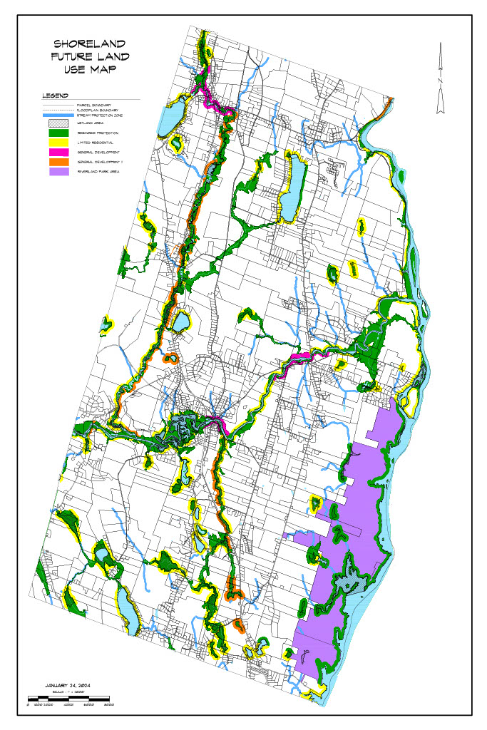
PLANNING AREA: Regional Coordination

Turner’s Goal

To develop and participate in regional programs to achieve common desires.

Overview

Turner shares several significant natural resources with adjacent and nonadjacent communities. It is recognized that to maintain their resource values, joint action and coordination is necessary. In addition to natural resources, other programs such as affordable housing delivery, economic development and solid waste disposal may have inter-local approaches.

Based upon the results of the Inventory and Analysis element of the comprehensive plan, knowledge of issues of adjacent communities and the various policies contained in this plan, the following inter-local issues are contained in the Regional Coordination Program.

1. Lake Auburn watershed and that portion of the watershed contained in Turner

2. Bear Pond and the Bear Pond Watershed

3. The Androscoggin River Corridor shared with Livermore, Livermore Falls, Leeds, Greene, Auburn and Lewiston

4. The Nezinscot River Corridor shared with Buckfield

5. Economic development

6. Transportation

7. Compatibility of development; and

8. Affordable housing delivery

Regional Coordination Policy

Pursuant to the Goal, the regional coordination policies of the comprehensive plan are:

1. To continue to participate in a Lake Auburn Watershed Commission.

2. To develop, in conjunction with appropriate communities, an acceptable lake protection level for phosphorous concentration for Bear Pond and Little Wilson Pond.

3. To regulate development within the Lake Auburn and Bear Pond Watersheds to comply with assigned lake protection levels.

4. To recognize the Androscoggin River, the Nezinscot River and Martin Stream and their shorelines as significant regional resources that should be shared and enjoyed by the citizens.

5. To develop/participate in programs with adjacent communities to retain and/or attract appropriate economic development.

6. To participate in regional approaches to improve and expand transportation systems.

7. To coordinate with adjacent communities in zoning district designations.

8. To coordinate and/or work jointly with existing housing authorities on programs to provide affordable housing.

Implementation Strategy

A. Short Term Activities- To accomplish the goal and policies, the Turner community should undertake the following within one to two years of plan adoption.

1. Continue to have a Turner representative on the Lake Auburn Watershed Commission

2. Seek professional assistance in determining appropriate lake protection levels and ordinance provisions to implement the selected lake protection levels.

Responsibility: Planning Board

3. Coordinate with the Androscoggin River, the Nezinscot River and Martin Stream Corridor communities to assess compatibility of proposed shoreland development strategies during ordinance amendments.

Responsibility: Planning Board

4. The Town should assess regional options to solid waste disposal and recycling programs and recommend appropriate direction.

Responsibility: Selectman

5. Meet with adjacent communities to determine the interest in joint community approaches to economic growth.

Responsibility: Town Manager

6. Participate in the Regional Transportation Advisory Committee process for improvements to regional highway systems that improve mobility and safety.

Responsibility: Town Manager

7. Prior to any public hearing on a zoning district change that abuts or is in proximity to an adjacent Town’s border, provide a copy of the proposed zoning amendments to the appropriate community and request their analysis of impacts if adopted.

Responsibility: Planning Board

CAPITAL INVESTMENT PLAN

Introduction

Road, school, highway and fire equipment, recreation areas and other public facilities are required to support projected growth in Turner over the next ten years. Town development depends on renewing, expanding and improving systems that support and/or stimulate development.

To promote appropriate development and accommodate Turner’s projected growth to correct existing and emerging problems; to improve the quality of life for Turner’s residents; to promote their health, safety and welfare; and fulfill the policies and strategies, calls for implementing various public improvements. Capital investments as used in the Capital Investment Plan refer to expenditures greater than $25,000, do not recur annually, have a useful life of greater than three years and result in fixed assets. They may include new or expanded physical facilities, rehabilitation or replacement of existing facilities, major pieces of equipment which are expensive and have a relatively long period of usefulness, the cost of engineering or architectural studies and services, and the acquisition of land for community facilities.

Capital investments or improvements usually require the expenditure of public funds: town, state, federal or some combination thereof. Funding limitations will likely make it impossible to pay for or implement all needed major public improvements at any one time or even over a multi-year period. The formal Capital Improvement Program called for within the Comprehensive Plan will be the process whereby the needs identified here will be formalized and specific priorities and implementation periods targeted.

Listed below are the significant capital investments identified during the comprehensive planning program that are expected over the next ten years. Individual items represent necessary equipment replacement/upgrading, facility improvements and investments necessitated by projected growth. In addition the various identified improvements have been assigned a high, medium or low priority which relates to its urgency to implement.

Identified Capital Investments Needs
2019-2029
Revised 6/26/19

Item | Year | Priority | Estimated Cost | Probable  Funding  Source
Highway Improvements  Dump Truck & Plow Works  Turner Village Dam Repair  Dump Truck & Plow Works  Fire Truck  Fire Truck  Sidewalks-Turner Center  Transfer Station Upgrade  Nezinscot River Park/Access  Recreation Facilities  Dump Truck & Plow Works  Rescue Unit  Tidswell Bridge Replacement  BQMC/ North Fire Station  Re-Evaluation  GIS | Annually  2020  2027  2021  2022  2028  2020  2021  2025  2029  2027  2021  2020  2025  2023  2024 | High  High  High  High  Medium  Medium  Medium  High  High  Medium  Low  High  High  High  High  Medium | $475,000  $195,000  $200,000  $195,000  $120,000  $180,000  $30,000  $ 25,000  $150,000  $ 75,000  $150,000  $100,000  $180,000  $225,000  $230,000  $ 50,000 | P  RF  RF/P  RF/P  RF  RF  G/P  RF/G  RF/G  P/TP  RF  RF  G/P  G/P  RF  RF

Pay-as-you-go - P Bonding - B Reserve Fund - RF Grants - G
Time Phased - TP Donations - D

Capital Improvements Financing

Capital improvements, as they are prioritized and scheduled for implementation through Turner’s multi-year Capital Improvement Program, require a funding source or means of financing. A variety of techniques for financing capital improvements exist and are outlined here. State laws usually govern which techniques are authorized and how they are to be carried out.

Current Revenues (Pay-As-You-Go)

The most fundamental and simplest means of paying for capital improvements is on a pay-as-you-go basis: funding capital improvements from current revenues. This has the advantage of avoiding bonding and its interest costs. Its disadvantage is that large scale capital improvements may require a similarly large amount of money to finance them that would create an inordinate tax burden for the implementation period and extreme fluctuations in the tax rate. Spreading these costs over a longer period reduces such sudden impacts and rate swings.

Bonding

Borrowing against future taxes (general obligation bonds) or future service charges or fees (revenue bonds) to finance long-term public improvements is widely practiced and makes good sense from the standpoint of “paying-as-you-use”. Bonding evens out the tax impact over time and allows the municipality to obtain vital improvements earlier in time than current revenue or reserve fund arrangements would permit. As a general rule, no improvement or equipment should be bonded beyond its service life and thus violate the pay-as-you-use rule. The chief disadvantage of bonding is the payment of interest on the borrowed money. The fact that purchasers of municipal bonds are usually exempt from payment of taxes on interest received causes the interest rate on such bonds to fall below market rates.

Reserve Fund

A reserve fund is analogous to a family savings account for a future big ticket purchase (car, appliance, etc.). Reserve funds are often used to replace equipment with a known service life whose cost and date of replacement are fairly accurately known and can be planned for. The full replacement cost thus becomes available at the time when replacement is necessary without the necessity of bonding or suffering a sudden impact on the tax rate. Other advantages are that reserve funds may be invested to collect interest on their principal, thus reducing the tax revenue contribution required. Reserve funds, like bonding, even out the flow of revenues required for capital improvements.

Grants and Cost Sharing

A number of state and federal grant-in-aid programs exist to share the cost of certain categorical public improvements. Full advantage should be taken of these cost-sharing programs to maximize the benefits to the community, recapture an equitable share of locally generated taxes and secure vitally needed public improvements. Cost sharing grant programs exist in a wide variety of areas such as highways and streets, water quality, sewers, energy cogeneration, parks, community development, conservation, school construction and bike paths.

Low Interest Loans

In some cases, the federal and state governments have developed special low interest loan programs to support certain categories of public improvements. These should be investigated as possible funding mechanisms for capital improvements falling within those categories at least cost to the town and its taxpayers.

Capital Investment Plan Implementation

To implement the Capital Investment Plan, the Town of Turner should develop a formal Capital Improvements Program (CIP).

The plan provides a mechanism for estimating capital requirements; scheduling all projects over a fixed period with appropriate planning and implementation; budgeting high priority projects and developing a project revenue policy for proposed improvements; coordinating the activities of various departments in meeting project schedules; monitoring and evaluating the progress of capital projects; and informing the public of projected capital improvements.

In its most basic form, the CIP is no more than a schedule listing capital improvements, in order of priority, together with cost estimates and the proposed method of financing them.

Each year the CIP should be reviewed and updated to reflect changing community priorities, unexpected emergencies or events, unique opportunities, cost changes or alternate financing strategies. The CIP is comprised of three elements:

A. inventory and maintenance plan;
B. capital improvements budget (first year); and
C. long-term CIP (5 years)

Policy

1. It is a policy of the Town of Turner to maintain a multi-year Capital Investment Program.

2. To finance existing and future facilities and services in a cost effective manner.

3. To explore grants available to assist in the funding of capital investments within the community.

4. To reduce Maine’s tax burden by staying within LD 1 spending limitations whenever feasible.

Implementation Strategy

1. Develop and publish in the Annual Report the Capital Improvement Program that identifies costs and timing of investment.

Responsibility: Selectmen/Budget Committee

- Seek funding, including grants, to purchase equipment, improve facilities and build new facilities or parks identified on the capital investment program.

Responsibility: Selectmen/Budget Committee

- Explore opportunities to work with neighboring communities to plan for and finance shared or adjacent capital investments to increase cost savings and efficiencies.

Responsibility: Selectmen/Budget Committee

- The Selectmen should determine the best mechanisms to finance capital investments (local tax dollars, creating a tax increment financing district, a Community Development Block Grant or other grants, bonding, impact fees, etc.) and seek appropriate input or approvals from Town Citizens to make those investments.

Responsibility: Selectmen/Budget Committee

PLANNING AREA: Hazard Mitigation

Town Goal:

To protect life and property from natural disasters and hazards.

Hazard Policy

Pursuant to the Goal, the hazard mitigation policies of the comprehensive plan are:

1. To minimize losses due to flooding.

2. To encourage owners of property in floodplains to undertake flood proofing measures.

3. That structures are constructed to withstand snow and wind loads common for the Turner area.

4. That development proposed in forested areas are designed to minimize loss due to forest fires.

5. To encourage property owners to be prepared for severe summer or winter storms.

6. To assure dams are maintained in a safe condition.

Implementation Strategies

A. Short-Term Activities - To accomplish the goal and policies, the Turner Community should undertake the following within one to two years of plan adoption:

1. Place floodplains in resource protection district under shoreland zoning ordinance.

Responsibility: Planning Board

2. Provide owners of property located in floodplains with information on methods to flood proof.

Responsibility: Code Enforcement Officer

3. Develop a public infrastructure improvement plan to correct areas frequently damaged by flooding.

Responsibility: Selectmen

4. Assess building standards for snow and wind loads.

Responsibility: Code Enforcement Officer

5. Develop ordinance standards to minimize loss of structures from forest fires.

Responsibility: Planning Board

6. Provide residents with information on how to prepare for severe summer and winter storms.

Responsibility: Director of Civil Emergency Preparedness

7. Conduct assessment of the condition of Town owned dams and seek funds for necessary repairs.

Responsibility: Selectmen

Turner
Comprehensive Plan Update Section II

Inventory & Analysis

TABLE OF CONTENTS

INTRODUCTION 74

COMMUNITY OVERVIEW 75
Location Overview 75
Historical Overview 76

POPULATION CHARACTERISTICS 78
Findings and Trends 2004-2018 78
Introduction 78
Year-round Population Growth 78
Seasonal Population 80
Age Distribution 81
Occupation of Residents 82
Household Size 82
Household Income 83
Projected 2026 Population 84

ECONOMY 85
Findings and Trends 2018 85
Historical Economic Overview 85
Regional Economic Perspective 86
Turner's Economy 88
Current Economic Characteristics 92
Conclusion 92
Economic Expectations 93

PUBLIC SERVICES AND FACILITIES 94
Findings and Trends 2002-2018 94
Introduction 94
Public Water Supply 95
Source Water Assessment Program: Non-Transient, Non-Community Source Maps… ..96
Non-community Source Water Protection Map………………………………………….97
Community Source Water Protection Maps…………………………………………….100
Public Sewerage System 104
Solid Waste Disposal 104
Septage Waste Disposal 104
Public Safety 104
Fire Protection……………………………………………………………………..……104
Emergency Medical Services…………………………………………………………...105
General Administrative and Service Facilities 105
Town Garage 106
Post Offices 106
Cultural Facilities 106
Utilities………………………………………………………………………………… 106
Cemeteries 106
Public Transportation …………………………………………………………………106
Bicycle Trails 106
Town Owned Buildings …………………………………………………………..…..107
Education 107
Turner Infrastructre Map……………………………………………………………..…109

FISCAL CAPACITY 110
Findings and Trends 2002-2018 110
Introduction 110
Revenues 110
Mill Rate & Valuation…………………………………………………………………. 111
Expenditures 113
Major Capital Expenditures 114
Balance Sheet 114
Fiscal Capacity 114

TRANSPORTATION 115
Findings and Trends 2002-2018 115
Introduction 115
Roadway Conditions 116
Roadway Capacities 120
Traffic Volumes 122
High Crash Locations 123
Retrograde Arterial 124
Sidewalks 124
State Highway Improvement Plan 124

OUTDOOR RECREATION RESOURCES 125
Findings and Trends 2002-2018 125
Introduction 125
Public/Semi-Public Recreational Facilities/Areas 125
Recreation Programs……………………………………………………………………127
Formal Public Access to Surface Waters 127
Action Plan for public access to Nezinscot River and beyond ……………………….128
Open Space Areas 128
Action Plan for ATV trail development… ……………………………………………129
Androscoggin Riverlands State Park Map ……………………………………………130
Important Hunting and Fishing Areas 131
Facility Need Analysis 131

SCENIC RESOURCES 133
Findings and Trends 2002-2018 133
Introduction 133
Scenic Resources 133

HISTORIC AND ARCHAEOLOGICAL RESOURCES 136
Findings and Trends 2002-2018 136
Introduction 136
Historic Resources 136
Archaeological Resources 138
Prehistoric Archaeology Sensitive Areas Map 139

LAND USE/UTILIZATION 140
Findings and Trends 2002-2018 140
Introduction 140
Agricultural Land Use 140
Turner Agricultural Resources Map…………………………………………………….142
Forested Land 143
Residential Land Use 143
Turner Development Constraints Map………………………………………………….145
Traditional Compact Village Areas 147
Low Density Subdivision 147
Turner Subdivisions Map……………………………………………………………….149
Scattered Residential 150
Commercial Land Use 150
Industrial/Manufacturing Land Use 151
Institutional Land Use 151
Undeveloped Land 151
Development/Land Use Trends 152
Turner Natural Resource Co-Occurrence Map………………………………………….153
Turner Aerial Photo……………………………………………………………………..154
Turner Zoning Map……………………………………………………………………..155

HOUSING 156
Findings and Trends 2002-2018 156
Introduction 156
Housing Trends 156
Type of Housing Unit 158
Owner/Renter Patterns 159
Housing Conditions 159
Housing Costs 160
Rental Rates 161
Vacancy Rates 161
Affordable Housing 161
Future Housing Demand 163
Future Housing Mix 163

NATURAL RESOURCES 164
Findings and Trends 2002-2018 164
Introduction 164
Topography 165
Soils………….. 166
Prime Farmland Soils 166
Forest Resources 167
Wetlands 168
Wetlands Characterization Map………………………………………………………...169
Surface Waters 170
Androscoggin River 170
Nezinscot River 171
Streams and Brooks 172
Lakes and Ponds 172
Turner Water Resources & Riparian Habitats Map....………………………………….175
Ground Water 179
Bedrock Aquifers 180
Composite Map Significant Sand & Gravel Aquifer Map ……………………………181
Wildlife Habitat 182
High Value Plant & Animal Habitats Map……………………………………………..184
Undeveloped Habitat Blocks & Connectors Map …………………………………….185
Floodplains 186
Flood Map …………………………………………………………………………….187

RARE, ENDANGERED AND SIGNIFICANT NATURAL FEATURES 188
Findings and Trends 2002-2018 188
Introduction 188
Rare or Exemplary Botanical Features 188
Androscoggin River Corridor 189

NATURAL HAZARDS/TECHNOLOGICAL HAZARDS/CHEMICAL 190
Findings and Conclusions 190
Introduction 190
Flooding 190
Severe Winter Storms 191
Severe Summer Storms 191
Forest Fires 192
Drought 192
Dam Failure 193
Earthquake 193
Technological Hazards/Chemical Spills 194
INTRODUCTION

The comprehensive plan update process needs to be based on an accurate and comprehensive understanding of the community. In planning terms, the “community” means its people, infrastructure, services, and natural features. To provide that factual informational base, the Comprehensive Plan Committee, collected, organized, and analyzed information about Turner. The starting point for this information was the 2006 Turner Comprehensive Plan. The committee has attempted to update the information in the 2006 Plan with new information and trends over the past 10 years. Areas considered in the updated inventory and analysis element related to population, economy, housing, transportation, natural resources, historic, cultural, and, archaeological resources, land use and development patterns, outdoor recreation, public facilities, and fiscal capacity.

The information to prepare the inventory and analysis came from a number of sources. Individual committee members collected information only available in Turner. Such information included road conditions, the sale prices of homes and recent development trends. Other information came from state and federal sources. State agencies provided information on the location of wildlife habitat, traffic volumes and traffic accidents. For much of the characteristics concerning Turner’s recent population tends is from the U.S. Department of Commerce 2010 Census and American Community Survey 2016.

The Committee also held five public meetings to discuss the Village Areas, Route 4, Municipal Facilities, Outdoor Recreation and Shoreland Zoning. Information gathered at these public meetings provided new and very important insights to the Committee. Many of the changes included in this comprehensive plan update are a direct result of this new information and the Committee’s belief that these changes will lead to an enhanced feeling of home and community in Turner.

The updated inventory and analysis also made several forecasts for the 10-year planning period. These included population growth and housing demand. Such forecasts were based on past trends and acceptable forecasting techniques.

The inventory and analysis is intended to be a snapshot of Turner based on the best information available in 2018. Communities are dynamic places and thus the inventory and analysis may not reflect all community characteristics at time of the adoption of the plan or five years from adoption. However, it presented a reliable picture of Turner and provided the necessary direction for the Comprehensive Plan Committee to identify issues and implications and formulate updated town goals and policies.

COMMUNITY OVERVIEW

Location Overview

Turner is located in west-central Maine and shares its southern border with the City of Auburn which with its sister city of Lewiston, forms the second greatest concentration of population in Maine. With a land area of 62 square miles, Turner is the largest geographic municipality in Androscoggin County. The Town has been known for its scenic and open space areas, a by-product of Turner’s traditional agricultural base. More than 12 miles of the Androscoggin River and Gulf Island Pond form the eastern border of Turner. Although it was once felt that the Androscoggin River was a liability to the Town, its waters and sparsely developed shorelines are now seen as a significant community asset.

The urban center of Auburn and Lewiston to Turner’s south provide opportunities for employment and acquisition of services. That population center also places demands upon Turner in the way of residential development and open space recreation activities. Route 4 bisects the community nearly in half. This major traffic corridor carries commuter traffic south to Auburn and Lewiston and north to paper mills in Jay and Rumford and to Maine’s largest recreation area of the Western Mountains.

Turner longs to hold on to its rural small town character and values, but it has reached a period of transition. The fourth most populated community in Androscoggin County, it will have many decisions to make over the next several years.

Historical Overview

Turner’s recorded history began in 1765 when the General Court of Massachusetts chartered the Town of Sylvester-Canada. The original grant was made to “the heirs and assigns of Captain John Sylvester and his company, for services rendered in the invasion of Canada under Sir William Phipps in 1690".

Conditions of the grant of Sylvester-Canada were that within six years the grantees would undertake the following:

Settle 30 families in said town
Build a house for public worship
Settle a learned minister
Layout 1/64 part of said town for use of the first settled minster
1/64 part for the ministry
1/64 part for a grammar school
1/64 part for the use of Harvard College

It has been reported that a major motivation of at least some of the original proprietors of Sylvester-Canada was economic gain. No estimates have been made of the proprietors’ actual gain or loss from their financial stake in their township. It would appear, however, from all the trials and tribulations they experienced in convincing families to settle in their town, the difficulties of obtaining and maintaining a settled minister, and the expenses involved in laying out roads and building the required town house, that they may have profited little from their efforts and expenditures.

Despite these difficulties, the available evidence seems to indicate that Sylvester-Canada/Turner has been relatively prosperous for most of its history from its late 18th century beginning to the late 20th century.

In 1786, Sylvester Plantation was incorporated into the Town of Turner. The Town’s name was chosen out of respect for the Reverend Charles Turner, honoring his character and service.

Turner developed as an agricultural and manufacturing community. By the mid-1800s, each of Turner’s three village areas (Turner Center, Turner Village and North Turner) were manufacturing centers. In 1860, Turner’s population had reached 2,700 people. Many of these individuals were employed at the local mills producing lumber, boxes and furniture and processing locally produced vegetables and milk. All of these businesses were directly related to the Town’s natural resource base. Turner’s manufacturing base was set back several times by disasters, fires and freshets, but it was likely the new sources of power and the concentration, in the late 19th century of textile and shoe manufacturing in the urban centers that were the demise of manufacturing in Turner.

Ever since 1777 when Joseph Leavitt, one of the very first settlers, carried young apple saplings strapped to his back as he traversed a trail through the forest to the then Sylvester-Canada, agriculture has been economically, socially and psychologically important in Turner.

“The early settlers chose the highlands as best for the first crops, hence they selected farms on the ‘Upper Street’ and on the ‘Lower Street’ which run parallel with each other, 3/4 of a mile apart.” Today Lower Street and Upper Street (and its continuation, the North Parish Road) continue to be the location of commercial apple orchards as well as several of Turner’s dairy farms. It is possible that the original choice of lots on the Town’s hillsides was based on a little more than that they were judged to be “best for their crop.” In addition to the air drainage, a necessity for apple production in New England, the ridges were probably less densely forested than were the valleys. The rational farmer knew that under these circumstances, he could get his fields cleared more easily and quickly. The soils on the ridges were better drained, and transportation was easier than in the damp meadowlands. Also, the higher air was believed healthier than that in the lowlands.

Apple trees were planted on almost every farm, but dairying apparently became the most common commercial farm practice. The burgeoning volume of milk presented a marketing problem to Turner dairy farmers. Supply exceeded local demand. A partial solution to the problem was reached in 1882 with the establishment of the Turner Center Dairy Association. The business abilities of the creamery’s management were demonstrated early in its history.

The initial concentration was cheese making which “achieved a fair degree of success.” At first, many farmers in the town did not associate themselves with the creamery because they preferred to make butter. The creamery operators heard the message, and the plant began to make butter--450 pounds per day. Butter making was a natural outlet for Turner’s milk.

As in most Colonial era towns, particularly in heavily forested, stream and pond intersected, hill and valley areas such as Central Maine, the Town of Turner became the site of several population concentrations early in its history. Some of the early neighborhoods--Keene’s Mills, Howe’s Corner, and Chase’s Mills--are now more memories than realties. Over time, they lost their ecological and/or social/economic functions. Today, these villages of North Turner, Turner Center and Turner Village are the primary centers. However, their importance is lessening due to recent development characteristics.

Source: Turner - A Study in Persistence and
Change, Louis A. Ploch, 1989

POPULATION CHARACTERISTICS

Findings and Trends 2004-2018

❖ Population in Turner increased by 772 between 2000 and 2016, the largest increase in Androscoggin County.

❖ Turner’s population is slightly older than that of Androscoggin County.

❖ The median household income of $58,408 in Turner is the highest of all surrounding communities except Greene.

❖ Turner’s 2026 population is expected to reach 5,900.

Introduction

The following presents an overview of Turner’s and surrounding communities’ recent population trends. An examination of recent population trends and the characteristics of that population is extremely important to an understanding of the anticipated growth that will occur over the next ten years. In addition, the characteristics of that population will lend insight into future demands for various community services.

Turner has experienced a relatively significant population growth since 1980 but has been stagnant for the last 8 years. In the next 8 years the population is expected to grow to 5,900.

Year-round Population Growth

Turner’s population increased by some 1,400 people between 1980 and 2000. The decade of the 1990's was a high growth period for Turner while the population of all of Androscoggin County declined. Turner’s numerical population growth of 772 between 2000 and 2016 was the greatest of any municipality in Androscoggin County. The town’s population growth can be attributed to several factors that include availability of attractive residential lots in both subdivisions and individual lots, a lower property tax rate than Auburn and Lewiston, newer schools and the attractiveness of Turner.

Year-Round Population Change
1980-2016

Year-Round Population Change - 1980-2016
 | 1980 | 1990 | 2000 | 2010 | 2016 (est.) | %Change 00-16
Turner | 3,539 | 4,315 | 4,972 | 5,734 | 5,744 | 15.53%
Auburn | 23128 | 24,309 | 23,203 | 23,055 | 22,943 | -1.12%
Buckfield | 1,333 | 1,566 | 1,723 | 2,009 | 1,973 | 14.51%
Greene | 3,037 | 3,661 | 4,076 | 4,350 | 4,353 | 6.80%
Leeds | 1,463 | 1,669 | 2,001 | 2,326 | 2,108 | 5.35%
Livermore | 1,826 | 1,950 | 2,106 | 2,095 | 2,109 | 0.14%
Androscoggin County | 99,657 | 105,259 | 103,739 | 107,702 | 107,376 | 3.51%

SOURCE: U.S. Census

Both natural increase and in migration have been factors for Turner’s population growth over the past ten years. In the 1990's natural increase in population, births minus deaths, account for approximately half the town’s population increase. The remainder of the increase was the result of people moving into Turner. At the time of the 2018 plan the trend seems to be the same as before.

Births and Deaths
1990-2017

Year | Births | Deaths | Natural Increase
1990 | 52 | 12 | 40
1991 | 72 | 22 | 50
1992 | 58 | 24 | 34
1993 | 56 | 25 | 31
1994 | 54 | 19 | 35
1994 | 50 | 24 | 26
1996 | 63 | 28 | 35
1997 | 60 | 21 | 39
1998 | 58 | 27 | 31
1999 | 50 | 31 | 19
2000 | 64 | 28 | 36
2001 | 59 | 28 | 31
2002 | 52 | 27 | 25
2003 | 49 | 30 | 19
2004 | 74 | 30 | 44
2005 | 66 | 32 | 34
2006 | 48 | 29 | 19
2007 | 56 | 40 | 16
2008 | 51 | 28 | 23
2009 | 48 | 43 | 5
2010 | 59 | 28 | 31
2011 | 50 | 37 | 13
2012 | 59 | 33 | 26
2013 | 56 | 57 | -1
2014 | 44 | 35 | 9
2015 | 46 | 38 | 8
2016 | 54 | 35 | 19
2017 | 63 | 47 | 16
Totals 1990-2017 | 1,571 | 858 | 713

Population has been stagnant since 2004.

Seasonal Population

In 1970 the Public Affairs Research Center of Bowdoin College estimated Turner’s peak seasonal population would increase by approximately 900 people over that of the year-round population. Current estimates of seasonal population increases are much lower than the 1970 estimate. Based upon current number of seasonal dwellings and other facilities that attract seasonal population, it is estimated that the seasonal population during the summer months increases by some 500 people. Seasonal population is not considered a significant factor in Turner nor will it be over the next ten years. In the 2018 plan we find this statement to still be valid.

Age Distribution

Turner’s age distribution for 2010 indicates an older population than that of Androscoggin County. Although the average age of Turner’s population is becoming older, it has not been at the rate of Androscoggin County. The average age of Turner’s population in 2000 was 35.9 years and Androscoggin County was 37.2 years. The average age of Turner’s population in 2010 was 41.1 years and Androscoggin County was 39.8 years. In 2016, Turner’s average age was 45.8 and Androscoggin County’s was 40.7 years.

Population Distribution by Age
2010-2016

Population Distribution by Age - 2010
 | Turner |  |  |  | Androscoggin County
 | No. |  | Percentage |  | No. | Percentage
Under 5 | 331 |  | 5.86% |  | 6,864 | 6.36%
5-19 | 1,276 |  | 22.59% |  | 20,845 | 19.32%
20-44 | 1,515 |  | 26.82% |  | 35,410 | 32.83%
45-64 | 1,884 |  | 33.36% |  | 29,819 | 27.64%
65+ | 642 |  | 11.37% |  | 14,944 | 13.85%
Totals | 5,648 |  | 100.00% |  | 107,882 | 100.00%
Avg. Age. |  | 41.1 |  |  | 39.8

Population Distribution by Age - 2016
 | Turner |  |  |  | Androscoggin County
 | No. |  | Percentage |  | No. | Percentage
Under 5 | 310 |  | 5.40% |  | 6,864 | 6.36%
5-19 | 756 |  | 13.16% |  | 20,845 | 19.32%
20-44 | 1,682 |  | 29.28% |  | 35,410 | 32.83%
45-64 | 2,047 |  | 35.64% |  | 29,819 | 27.64%
65+ | 949 |  | 16.52% |  | 14,944 | 13.85%
Totals | 5,744 |  | 100.00% |  | 107,882 | 100.00%
Avg. Age |  | 45.8 |  |  | 40.7

Occupation of Residents

Over the ten-year period from 1980 to 1990 it should be noted that the percentage employed in farming and forestry decreased from 14% to 5%. The chart below represents the Census Data in 2016, however we believe the information regarding Farming, Forestry and Fishing numbers to be inaccurate. We do believe the number to be about 120 residents.

Employment by Occupation

Employment by Occupation - 2016
 | Turner |  | Androscoggin County
 | No. | % Total | % Total Population
Managerial, Professional and Related Occupations | 1,194 | 39.52% | 32.45%
Service Occupations | 424 | 14.04% | 18.86%
Sales and Office Occupations | 648 | 21.45% | 24.43%
Farming, Forestry and Fishing | 13 | 0.43% | 0.79%
Construction, Extraction and Maintenance Occupations | 263 | 8.71% | 8.95%
Production, Transportation, and Material Moving Occupations | 479 | 15.86% | 14.52%
Source: 2010 Census; American Community Survey 2016

Household Size

Number of Households

Number of Households 1990-2016
 | 1990 | 2000 | 2010 | 2016
Number of Households | 1,620 | 1,768 | 2,193 | 2,331
Average Household Size | 2.85 | 2.81 | 2.62 | 2.44

SOURCE: American Community Survey

Household Income

Median Household Income
2016

 | Median Household Income
Municipality | Median Income 1999 | Median Income 2010 | Median Income 2016
Turner | $ 46,207.00 | $ 61,949.00 | $ 58,408.00
Auburn | $ 35,652.00 | $ 41,649.00 | $ 46,976.00
Buckfield | $ 36,821.00 | $ 43,173.00 | $ 39,250.00
Greene | $ 48,017.00 | $ 56,719.00 | $ 63,889.00
Leeds | $ 37,993.00 | $ 51,429.00 | $ 52,969.00
Livermore | $ 38,850.00 | $ 41,833.00 | $ 51,250.00
Androscoggin County |  | $ 44,470.00 | $ 48,728.00
Maine | $ 37,240.00 | $ 46,933.00 | $ 50,826.00

SOURCE: U.S. Census

Household Income

Household Income - 2016
 | Count of Households | Percentage of Households
Less than $10,000 | 53 | 2.27%
$10,000 to $14,999 | 188 | 8.07%
$15,000 to $24,999 | 86 | 3.69%
$25,000 to $34,999 | 232 | 9.95%
$35,000 to $49,999 | 398 | 17.07%
$50,000 to $74,999 | 494 | 21.19%
$75,000 to $99,999 | 249 | 10.68%
$100,000 to $149,999 | 394 | 16.90%
$150,000 to $199,999 | 168 | 7.21%
$200,000 or more | 69 | 2.96%

SOURCE: U.S. Census

Projected 2026 Population

An estimate of Turner’s future year-round population is extremely important to the comprehensive planning process. Depending upon future population characteristics, various community facilities needs can be identified and planned for. It should be understood, however, that predicting future population with great accuracy is difficult. Many factors contribute to this difficulty.

With a local population the size of Turner’s, external forces could create sizable shifts in population. It is, therefore, not as important to identify future population in absolute numbers as it is to identify future population trends.

Population change is a result of two primary factors, natural increase and migration. Natural increase is derived from the number of live births minus the number of deaths over a specific period. Migration is the number of persons moving into or out of a community over a period of time. Births and deaths are readily obtainable. However, migration information is not readily obtainable. Therefore, the development of population trends utilizing migration, when migration is an important component, becomes difficult.

Most population forecasting techniques use in part past trends and judgmental factors. Using historic population counts to base future population is termed trend extrapolation. The advantages of trend extrapolation technique is its simplicity and reliability when only past census information is available. It has been found that this method to forecast population for a short period such as ten years works as well as much more complex techniques. Judgmental factors include knowledge of recent events that have affected population change and what local or regional factors will affect future population change. In the case of Turner continued residential development and regional economic growth was considered. Other factors considered included the aging of the baby boomers and a declining birth rate.

The 2006 Plan’s forecast for Turner’s year 2014 year round population using past trends results in an estimated population of 5,900. This number was based on the population growth rates since 1980. It is believed that over the 10-year planning period the rate of natural increase will decrease slightly over the 1990 to 2002-rate which was 401. It is also expected that in migration will continue at a rate similar to the 1900 to 2000 rate. The actual population in 2014 was 5,744.

Our aging population, or the baby boom generation that is nearing retirement age, is reflected in Turner’s estimated 2014 population age groups. The age group distribution of Turner’ 2014 population reflects an increase in the 45-64 age category to 29 percent. The 5-17 age category will decrease slightly by the year 2014 to 19 percent reflecting fewer people in the child bearing ages. The 65-year-old and older category will also increase significantly.

ECONOMY

Findings and Trends 2018

❖ Turner’s labor force increased by 148% between 1984 and 2018 or nine times greater than Androscoggin County.

❖ Between 2000 – 2018 the labor force increase was only 8.1%.

❖ Fewer residents of Turner worked in Turner in 2016 than in 2000.

❖ Auburn and Lewiston are the locations of work for 52% of workers living in Turner. 10% of the residents are commuting to the Portland area.

Historical Economic Overview

In the 1800s, Turner had an elaborate manufacturing economy. The economic profile of the community included a number of lumber mills, a box factory, a chair manufacturing firm, several canneries, can maker, a creamery and woolen cloth manufacturing. As throughout Maine and New England, the availability of water power was a significant factor for the manufacturing economy of Turner. The Androscoggin and Nezinscot Rivers provided readily available power during Turner’s early economic development.

Turner’s early economy was based largely upon the abundant supply of lumber and agricultural products. The Town was originally laid out as a farming community. Lots were based upon the former road along the Androscoggin River, much of which was flooded as the result of the construction of the Gulf Island Dam in the 1920s and along Upper and Lower Streets which were laid out generally parallel to the river. Since the late 1700s agriculture has been economically significant to Turner.

Apples were an early agricultural mainstay to Turner and the natural terrain lent itself to apple production. Some of those same areas that were developed by the early growers are still in production today. Dairying became a leading agricultural economic force in Turner during the 1800s. As the local farms’ milk production exceeded local demand, the Turner Center Association was created as was the cheese factory in North Turner. Early historians claimed that in the mid-1800s, Turner was the leading dairy town in the State.

Improved transportation, alternative sources of energy and the movement of textile manufacturing were major factors for the loss of manufacturing in Turner.

By the early 1900s, a population decline as well as a decline in local industry occurred. Since the loss of manufacturing, Turner’s local economy has generally been based upon agriculture.

Regional Economic Perspective

Turner, located adjacent to the major economic and population center of Auburn and Lewiston, is greatly influenced by that center. In addition, Turner’s close proximity to Jay and Rumford, major paper producing centers, provides other employment opportunities. It is the manufacturing and services of Auburn and Lewiston which have the greatest economic effect upon Turner. Historically, agriculture and forest products supported Androscoggin County’s rural population, while the paper, leather and textile industries have traditionally been the employment base in the urban areas. All these have declined as employers, and yet still employ significant numbers of workers and serve as important parts of the area’s economic base. Construction, wholesale and retail trade, public administration and service industries are gradually employing more workers, thus accounting for an overall employment increase.

Androscoggin County is principally made up of the Lewiston-Auburn Metropolitan Statistical Area (L/A MSA). Five communities located within Androscoggin County, specifically Durham, Leeds, Livermore, Livermore Falls and Minot, are excluded from the L/A MSA because they are included in adjoining labor market areas. The L/A MSA includes the communities of Auburn, Greene, Lewiston, Lisbon, Mechanic Falls, Poland, Sabattus, Turner and Wales.

The following table reports the percentage change in sectorial employment for the L/A MSA for the years 2000-2015. Highlights on employment by sector follows.

Lewiston-Auburn Metropolitan Statistical Area
Non-Farm Wage and Salary Employment 2000-2015
 | 2000 | 2010 | 2015 | % Change 2000-2015
Total | 46,040 |  | 49,646 | 7.8%
Total Manufacturing | 7,710 |  | 5,196 | 32.6%
Durable | 2,282 |  | 1,580 | 30.8%
Lumber & Wood | 440 |  | 506 | 15%
Logging | 10 |  | 17 | 70%
Non-Durable | 5,430 |  | 3,717 | -31.5%
Printing/Publishing | 900 |  | 433 | 26.8%
Leather & Leather Products | 380 |  | 365 | -4.0%
Total Non-Manufacturing | 38,330 |  | 44,349 | 15.7%
Construction | 2,210 |  | 2,409 | 9.0%
Transportation/Utilities | 1,840 |  | 2,511 | 36.5%
Wholesale Trade | 2,600 |  | 1,447 | -44.3%
Durable Goods | 1,070 |  | 1,728 | 61.5%
Retail Trade | 8,930 |  | 6,602 | -26.1%
Finance, Insurance, Real Estate | 2,530 |  | 2,093 | -17.3%
Services and Mining | 15,260 |  | 24,221 | 18.0%
Health Services | 5,150 |  | 9,937 | 92.3%
Government | 4,970 |  | 5,431 | 9.3%
Source: Maine Department of Labor Employment and Earnings Statistical Handbook

The L/A MSA includes many large employers in the health services, retail/telemarketing, and manufacturing sectors. As of 2nd quarter 2019, the largest private secton employers with over 500 employees included Central Maine Medical Center, Bates College, TD Bank, St. Mary’s Hospital, Walmart, John F Murphy Homes and Hannaford.

Over the past two years, the Lewiston/Auburn MSA was just below the State of Maine’s unemployment rate. Over the last 10 years unemployment was highest at 9.5% in February 2010 and was at its lowest in August of 2019, at 2.3%. Since 2010 the general trend has been decreasing rates of unemployment.

Between 2010 – 2016 employment increased the most in the agricultural industry(35%), public administration (12%), service industries (11%) and finance, insurance and real estate (7%). Employment in wholesale trade declined by 48%.

Number of Employees by Type of Industry
For Androscoggin County
1980 -2016

Industry | 1980 | 2000 | 2010 | 2016
Agriculture, forestry & fisheries | 1,157 | 597 | 511 | 690
Construction | 2,352 | 3,289 | 4,122 | 3,233
Manufacturing | 15,109 | 9,925 | 6,496 | 6,397
Transportation & public utilities | 1,759 | 1,932 | 2,223 | 2,102
Wholesale trade | 2,009 | 2,010 | 1,786 | 937
Retail trade | 6,874 | 7,628 | 8,141 | 7,649
Finance, insurance & real estate | 1,662 | 3,097 | 3,459 | 3,699
Services | 10,182 | 19,265 | 22,186 | 24,542
Public administration | 1,682 | 1,854 | 1,608 | 1,806
Other | 927 | 1,925 | 2,121 | 2,580
TOTALS | 43,718 | 51,522 | 52,653 | 53,635
SOURCE: U.S. Census*

NOTE: *Census employment is resident employment--how residents of a given town or county are employed, but not where they are employed.

Turner's Economy

It is unrealistic to examine Turner as a single economic unit. What happens in Turner, Androscoggin County, the State and Nation will impact Turner’s economy. An examination of various regional and local economic indicators will provide a picture of Turner’s past, current and future economic characteristics.

Turner’s labor force has increased at a significantly greater rate than that of Androscoggin County. In information developed by the Maine Department of Labor, Turner’s civilian labor force increased by 8% between 2001 and 2018, whereas the county decreased by 7%. This growth is reflective of the overall population growth in Turner over the period.

Unemployment rates in Turner have been below that of Androscoggin County between 2001-2018.

Civilian Labor Force
2001-2018

 | TURNER |  | ANDROSCOGGIN COUNTY
 | Labor Force | Unemployment Rate | Labor Force | Unemployment Rate
2001 | 3,002 | 3.7 | 60,144 | 4.1
2010 | 3,185 | 7.7 | 55,883 | 8.8
2018 | 3,248 | 2.7 | 55,990 | 2.9
% Change in Labor Force 1984-2018 | 148.5% |  | 16.5%
Source: Maine Department of Labor

The type of employment of Turner’s labor force has changed greatly since 2000 and is somewhat different from Androscoggin County as a whole. Some notable trends include the following. Employment in agriculture and forestry increased from 1.8% of the labor force in 2000 to 14.6% in 2018. The number of employees employed in manufacturing has decreased dramatically throughout the region, dropping by 3,000 between 2000-2016, and is reflective of the state’s declining paper industry.

Distribution of Labor Force by Industry
2016

 | TURNER |  | ANDROSCOGGIN COUNTY
 | # of Workers | % of Total | # of Workers | % of Total
Agriculture, forestry, fisheries & mining | 218 | 14.6 | 422 | 1.0
Construction | 157 | 10.5 | 2,794 | 6.4
Manufacturing | 12 | 1.0 | 5,036 | 11.5
Transportation & utilities | 63 | 4.2 | 2,662 | 6.1
Retail trade | 345 | 23.1 | 7,768 | 17.7
Finance, insurance & real estate | 17 | 1.1 | 2,135 | 4.9
Food Services | 54 | 3.6 | 3,527 | 8.0
Professional, scientific & Administrative services | 118 | 7.9 | 5,671 | 12.9
Healthcare | 95 | 6.3 | 9,782 | 22.3
Other services | 416 | 27.8 | 4,049 | 9.2
TOTALS | 1,495 |  | 43,846
Source: 2018 Census

An indication of the importance of the local employment to the local economy can be obtained from where people live and where they work. While Turner generally had a higher percentage of its residents working in their town of residence than that of surrounding communities there was a significant decline in the sixteen years from 2000-2016. This shift reflects population growth and changes in number of individuals employed in agriculture. This rate is expected to decrease again by the time of the 2020 census.

Place of Work by Town of Residence
1980-2016

 | 1980 |  | 2000 |  | 2016
 | In Town of Residence |  | In Town of Residence |  | In Town of Residence
 | # | % | # | % | # | %
Turner | 890 | 48.6 | 637 | 24.8 | 549 | 18.6
Buckfield | 149 | 31.1 | 212 | 16.1 | 187 | 20.6
Greene | 208 | 14.9 | 190 | 8.3 | 271 | 11.5
Leeds | 160 | 24.2 | 149 | 15.1 | 180 | 17.1
Livermore | 126 | 16.2 | 134 | 6.7 | 108 | 10.9
Source: 1980-2016 Census; AmericanFactfinder

Lewiston and Auburn have become the employment center for Turner residents. In 2013, 52% of employed persons in Turner travel to Lewiston and Auburn for work whereas as in 1980 only 25% did so. This trend points to Turner’s role as a bedroom community for the two cities.

Distribution of Labor Force by Place of Employment
1980-2013

 | 1980 |  | 2000 |  | 2013
Place of Employment | # of Persons | % of Total | # of Persons | % of Total | # of Persons | % of Total
Turner | 890 | 48.6 | 637 | 24.8 | 465 | 16.5
Auburn | 244 | 13.1 | 577 | 22.5 | 650 | 23.1
Lewiston | 232 | 12.8 | 581 | 22.7 | 814 | 28.9
Jay | 90 | 4.9 | 92 | 3.6 | 27 | 0.9
Greene | 34 | 1.9 | 26 | 1.1 | 52 | 1.8
Rumford | 28 | 1.5 | 63 | 2.5 | 111 | 3.9
Lisbon | 15 | 0.8 | 50 | 2.0 | 11 | 0.4
Livermore Falls | 13 | 0.7 | 26 | 1.0 | -- | --
Buckfield | 13 | 0.7 | 17 | 0.7 | -- | --
Portland MSA |  |  |  |  | 286 | 10.2
Other | 242 | 13.2 | 491 | 19.2 | 397 | 14.1
Total | 1,833 |  | 2,560 |  | 2,812

SOURCE: 1980-2010 Census; American Community Survey

Current Economic Characteristics

Over the past decade, Turner has not lost major employers but rather gained a number of new small employers, many of which are related to the service industry, in addition to the paper industries in Jay and Rumford. The Lewiston and Auburn’s service industry base has diversified providing employment opportunities for Tuner residents.

Agricultural Business
2018

Double Z – Abruzzi’s Pat Bates
Bradford Farm Brigeen Farms
Caldwell Family Farms Clark Farm
Greenwood Orchards
Shermirley Farm Hamel, Joyce & Robert
Hazel Hill Orchard Blue Heron Farm & Retreat
Hillendale Farms Hood Farms
Bonnie Lounsberry Nezinscot Farm
Greg Poland Ricker Hill Orchards
Jay Roebuck Cattle Bill Varney

Plus numerous successful “backyard” (vegetable and livestock) enterprises

Conclusion

Turner’s major industry has been agriculture. A conservative estimate has been made that the value of agricultural products produced exceeds $50 million per year has been reduced to $25 million per year, with the major reduction being in egg production. They are currently converting some of the barns to “free range” production, hopefully that will stabilize the industry for the future. The agricultural industry provides various economic benefits to the community and provides a number of employment opportunities. However, agricultural wages typically lag behind those of other industries. The evolution of Ag Entertainment (Retail Ag) has brought non-traditional Ag jobs to Turner. Nezinscot Farms, Greenwood Orchards, Caldwell Farms, Ricker Hill, and others have increased employment with jobs like: retail, baking, tour guides, meat cutting, delivery trucking, tasting room servers and maintaining retail and entertainment areas. There are a number of long established businesses in Turner and over the past ten years a significant number of new businesses have begun. The majority of these are service related, responding to Turner’s growing population.

In the next ten years, Turner needs to grow the Ag Entertainment opportunities and to make space for new business opportunities. One area of business development that could be important to Turner are outdoor resource based businesses. The Androscoggin River has become a significant outdoor activity resource with several large fishing tournaments held annually.

Economic Expectations

A realistic expectation of the local and regional economy is important to the comprehensive planning program. To accurately anticipate future economic conditions is extremely difficult. However, the following assumptions reflect anticipated local and regional economic trends.

- Lewiston/Auburn will continue to be a major manufacturing and service center providing employment opportunities.

- The paper industry will continue to be important to the region providing direct and secondary employment.

- New service related businesses directed at the needs of an expanding population will be established in Turner.

PUBLIC SERVICES AND FACILITIES

Findings and Trends 2002-2018

❖ Improved recreational access to the BQMC and Nezinscot River along with possible relocation of the North Turner Fire Station have been recommended.

❖ Over the last 10 years a new town office has been constructed and renovations made to the Turner Fire & Rescue building

❖ Since 2010 the overall enrollment in the district has declined by 97 students.

❖ We have switched the transfer station to single sort recycling.

Introduction

An examination of Turner’s public facilities and their current day capacities is an important element of the comprehensive plan. In addition, the future demands upon the Town’s public services and facilities must be assessed and their adequacy to meet future demands determined. Between 1980 and 2010 Turner’s population increased from 3,539 to 5,734. Between 2010 and 2016 the U.S. Census found that Turner’s population increased by only 10 to 5,744.

The Comprehensive Planning Committee found that Turner’s public facilities are limited in relation to its urban neighbors but comparable to rural Maine.

At the public meetings held to discuss municipal buildings and outdoor recreation there was significant discussion about how to upgrade indoor and outdoor recreation in the town to provide more activities to the residents of the town.

Public Water Supply

Neither the Town, A quasi-municipal body, nor a private water company, provides any public water supply within Turner. Although no municipal water supplies or distribution systems exist, there are several public water supplies that have been identified by the Maine Department of Human Services.

State law requires notification when specific activities are to be located in designated source protection areas or such areas are to be rezoned. The Department of Human Services has identified the following public water supplies in Turner.

Non-Transient, Non-Community Public Water Systems

MSAD 52 Leavitt Area High School
MSAD 52 Tripp Middle School
MSAD 52 Turner Elementary School
MSAD 52 Turner Primary School
MSAD 52 Alternative/Admin School
Northland Plaza
Kids Camp Learning Center
Hannaford Store
Calvary Baptist Church/ Academy
Youland Convenience, LLC.

Transient Public Water Systems

Bryant’s
Dollar General
Fore Seasons Restaurant & Banquet
DFD Russel Medical Center
CN Brown – Big Apple
On the Way Café (Since closed, however the facility is still classified as a public system)
Antigoni’s Pizza
Martin Stream Campground
Boofy Quimby Memorial Center

Community Public Water Systems

Hillview Estates
Nezinscot Village
Turner Square Apartments
Sandy Bottom Estates MHP

Source: Department of Human Services, Division of Health Engineering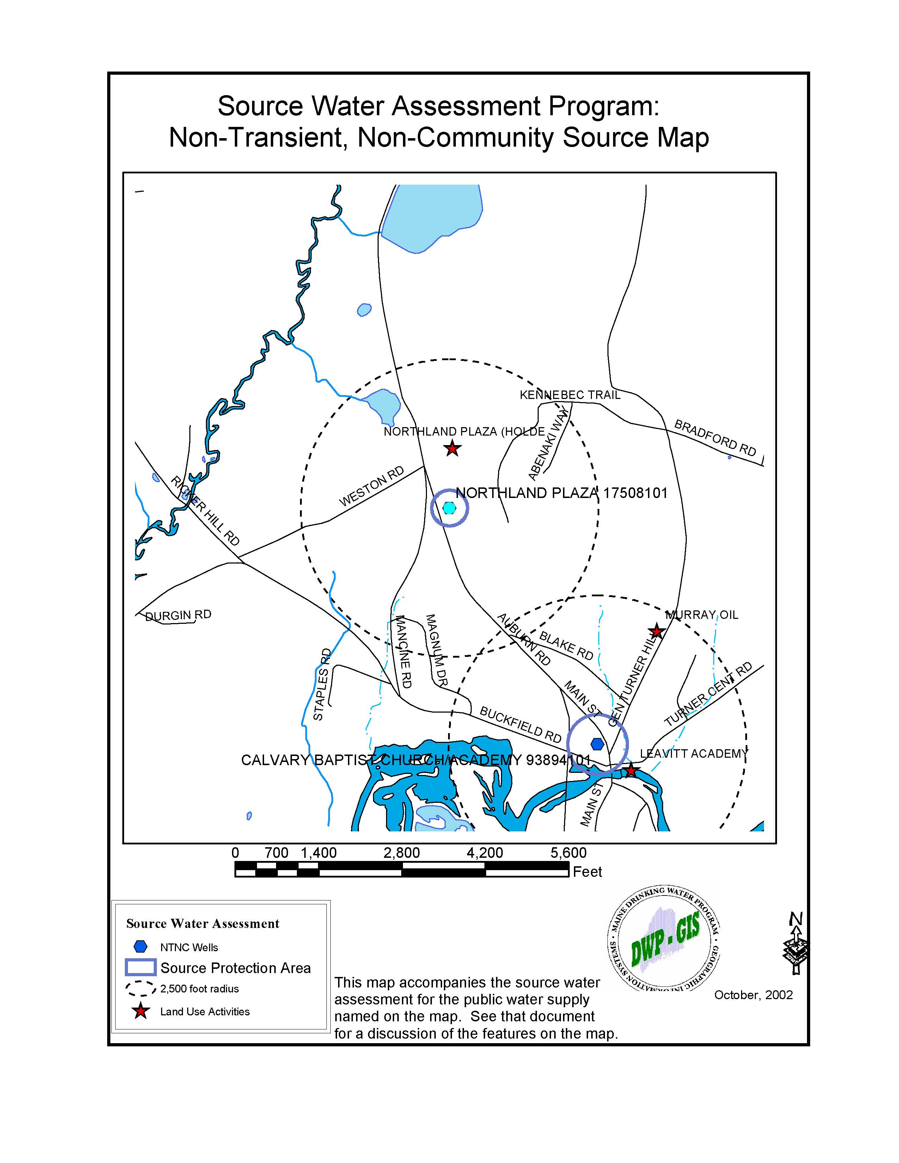

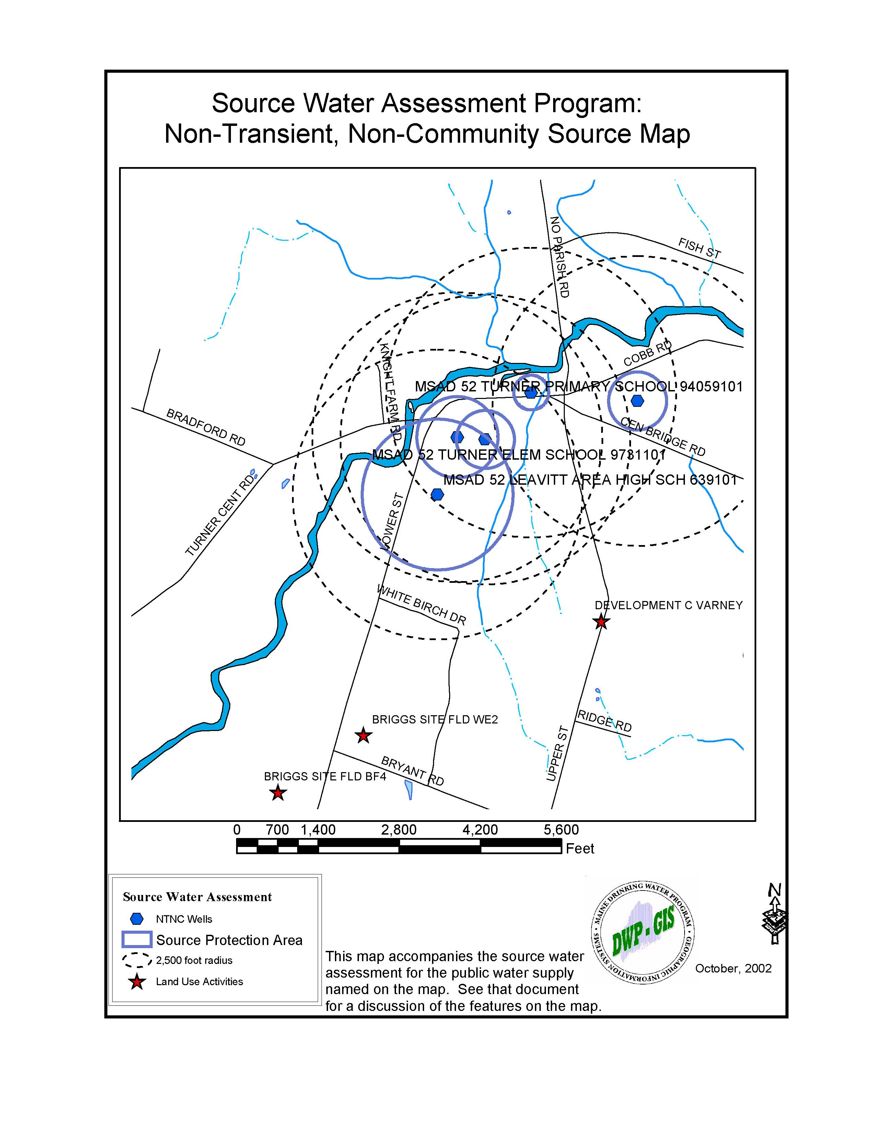

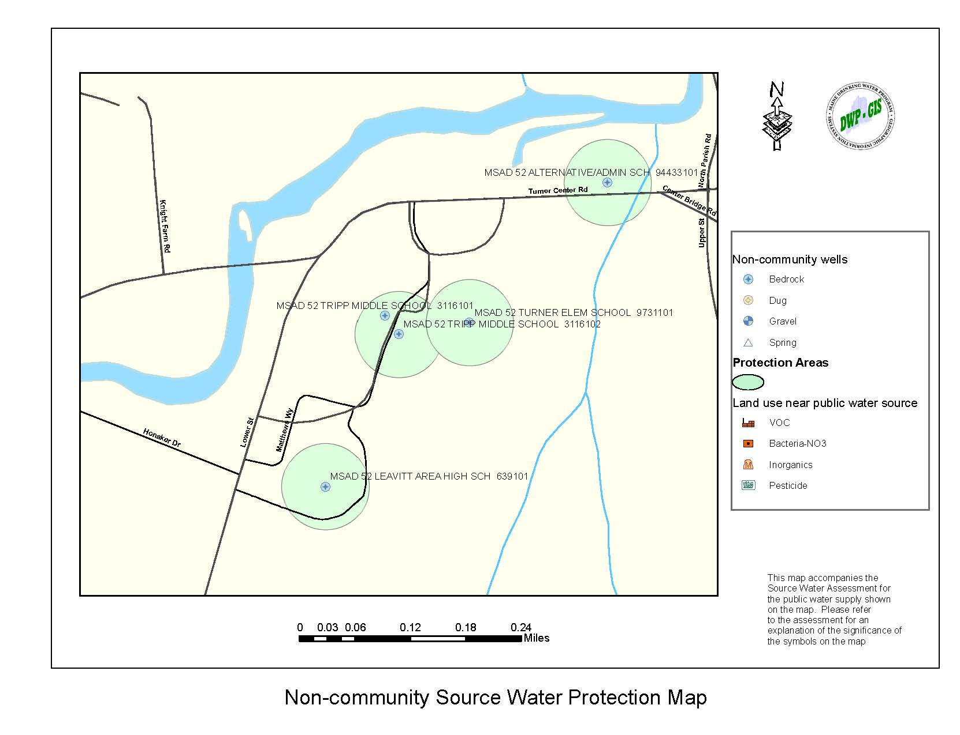

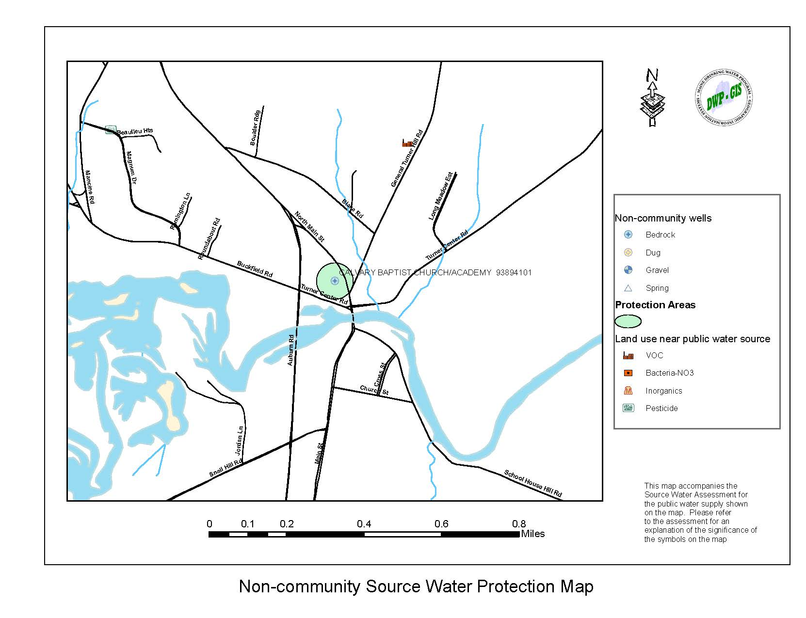

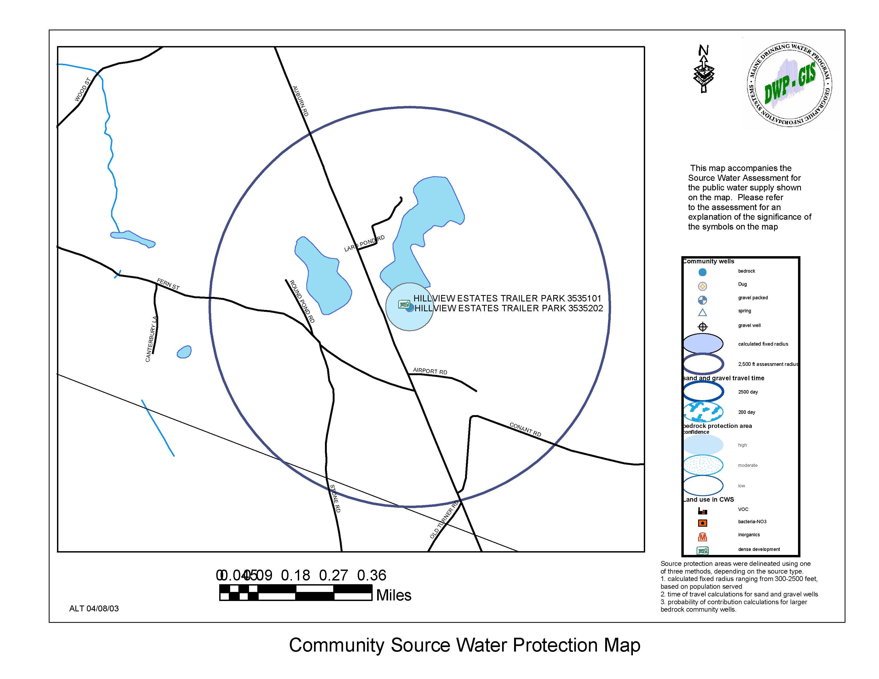

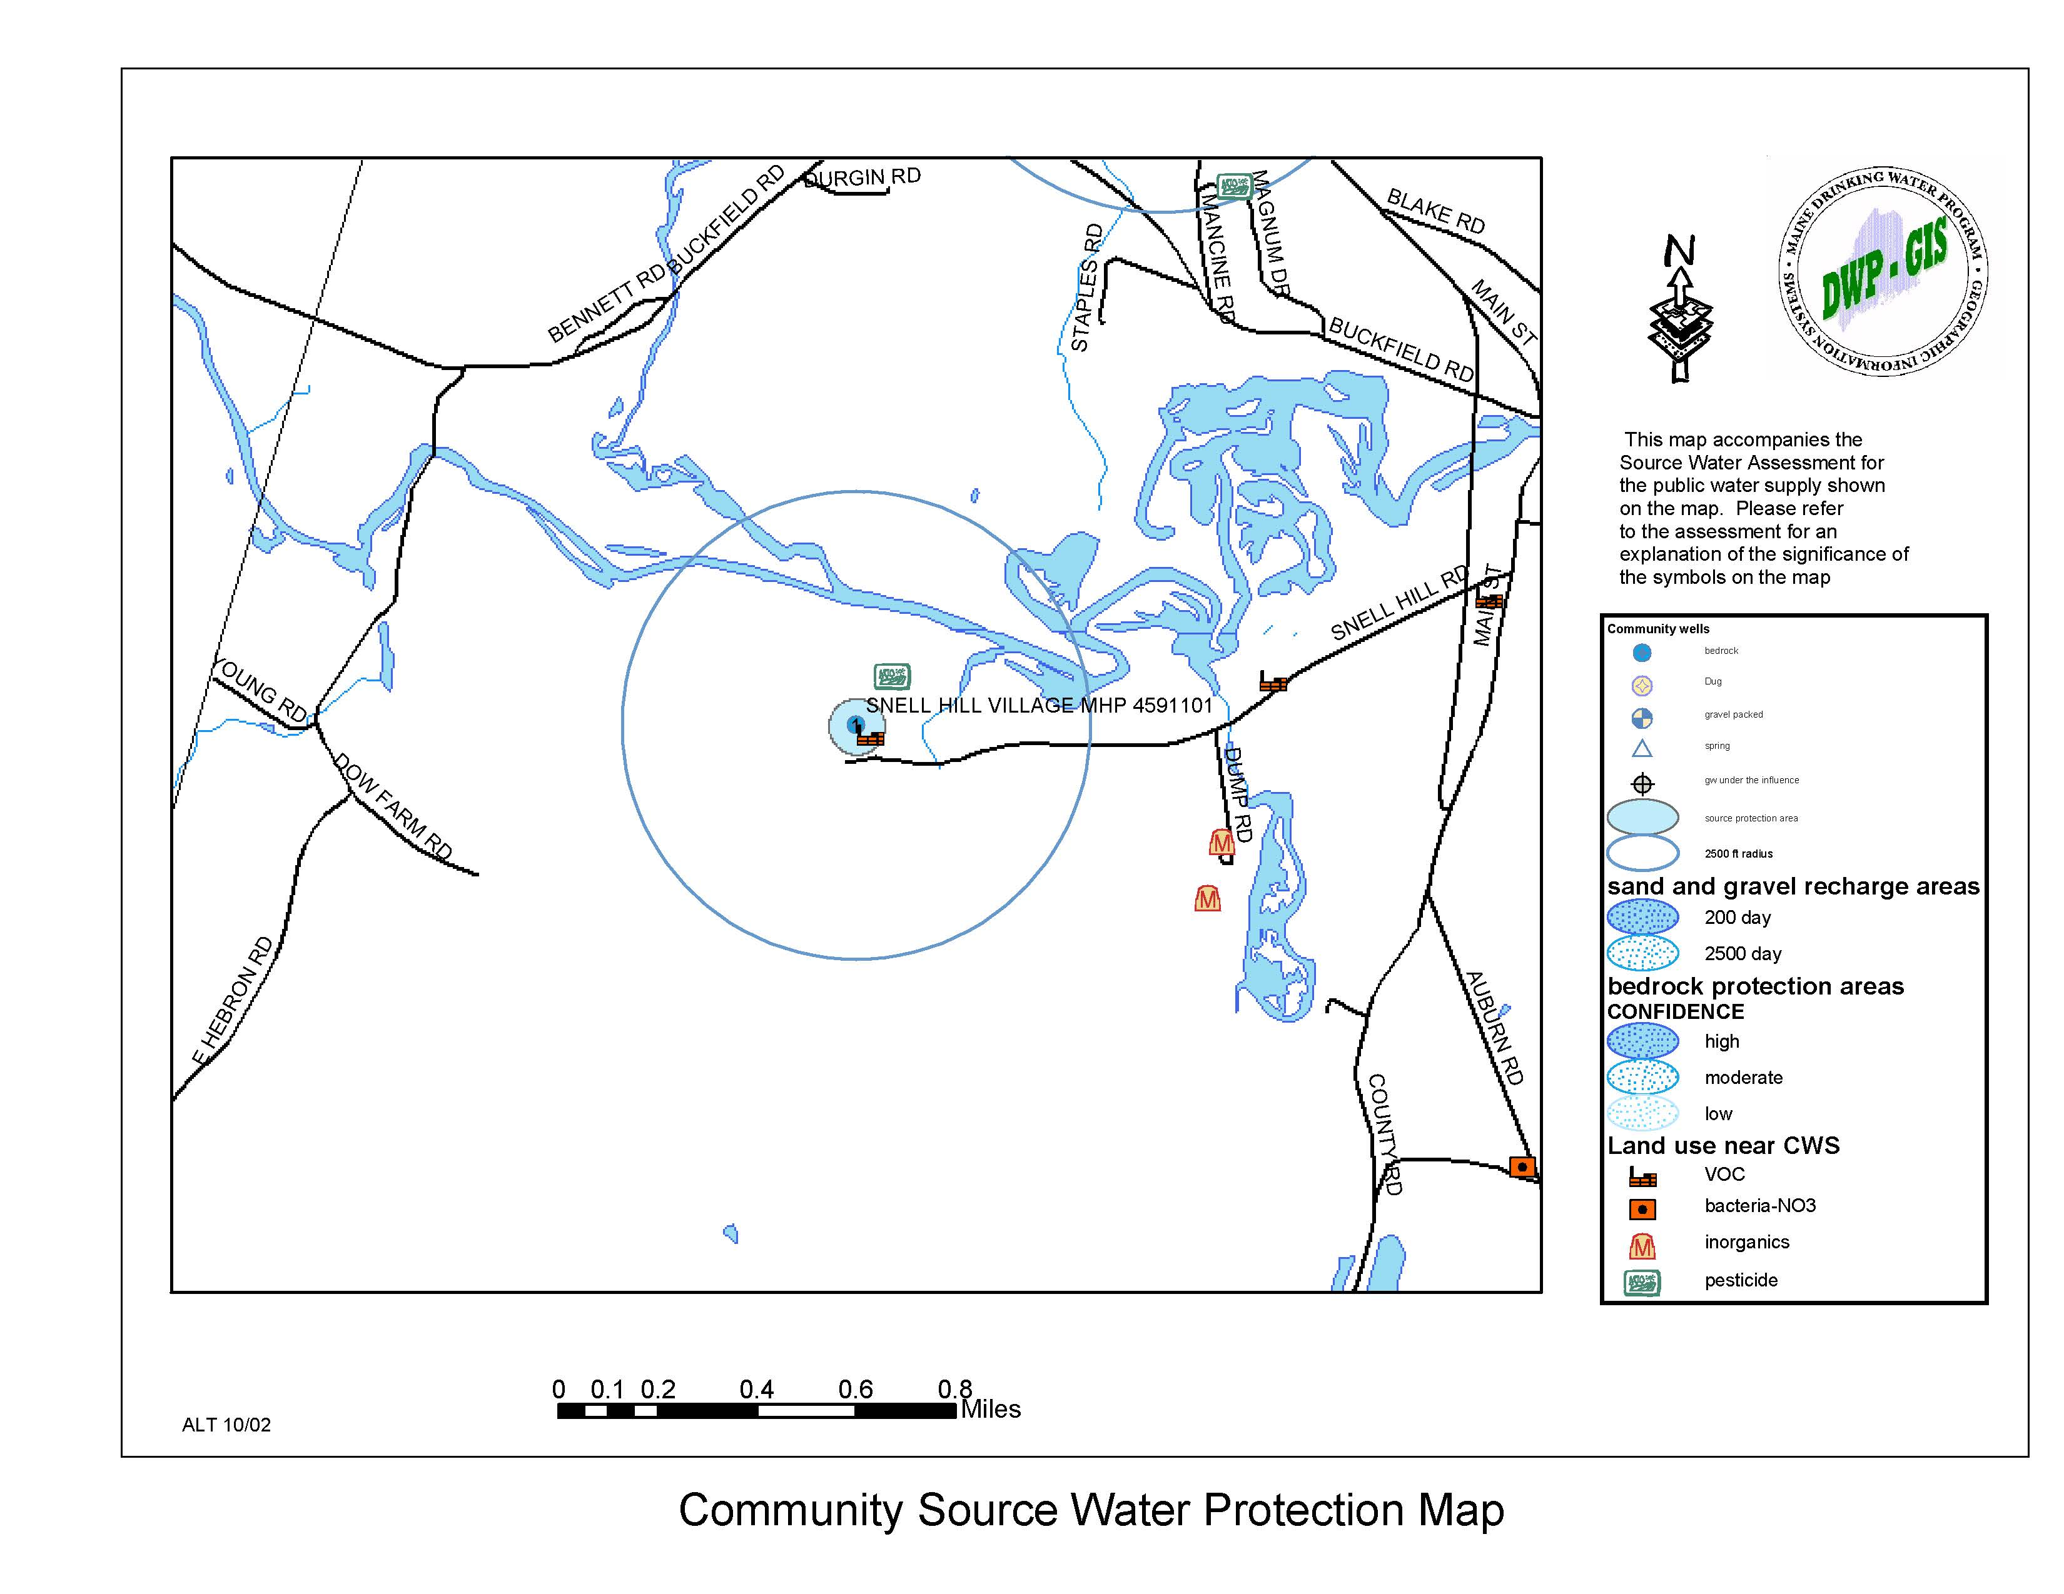

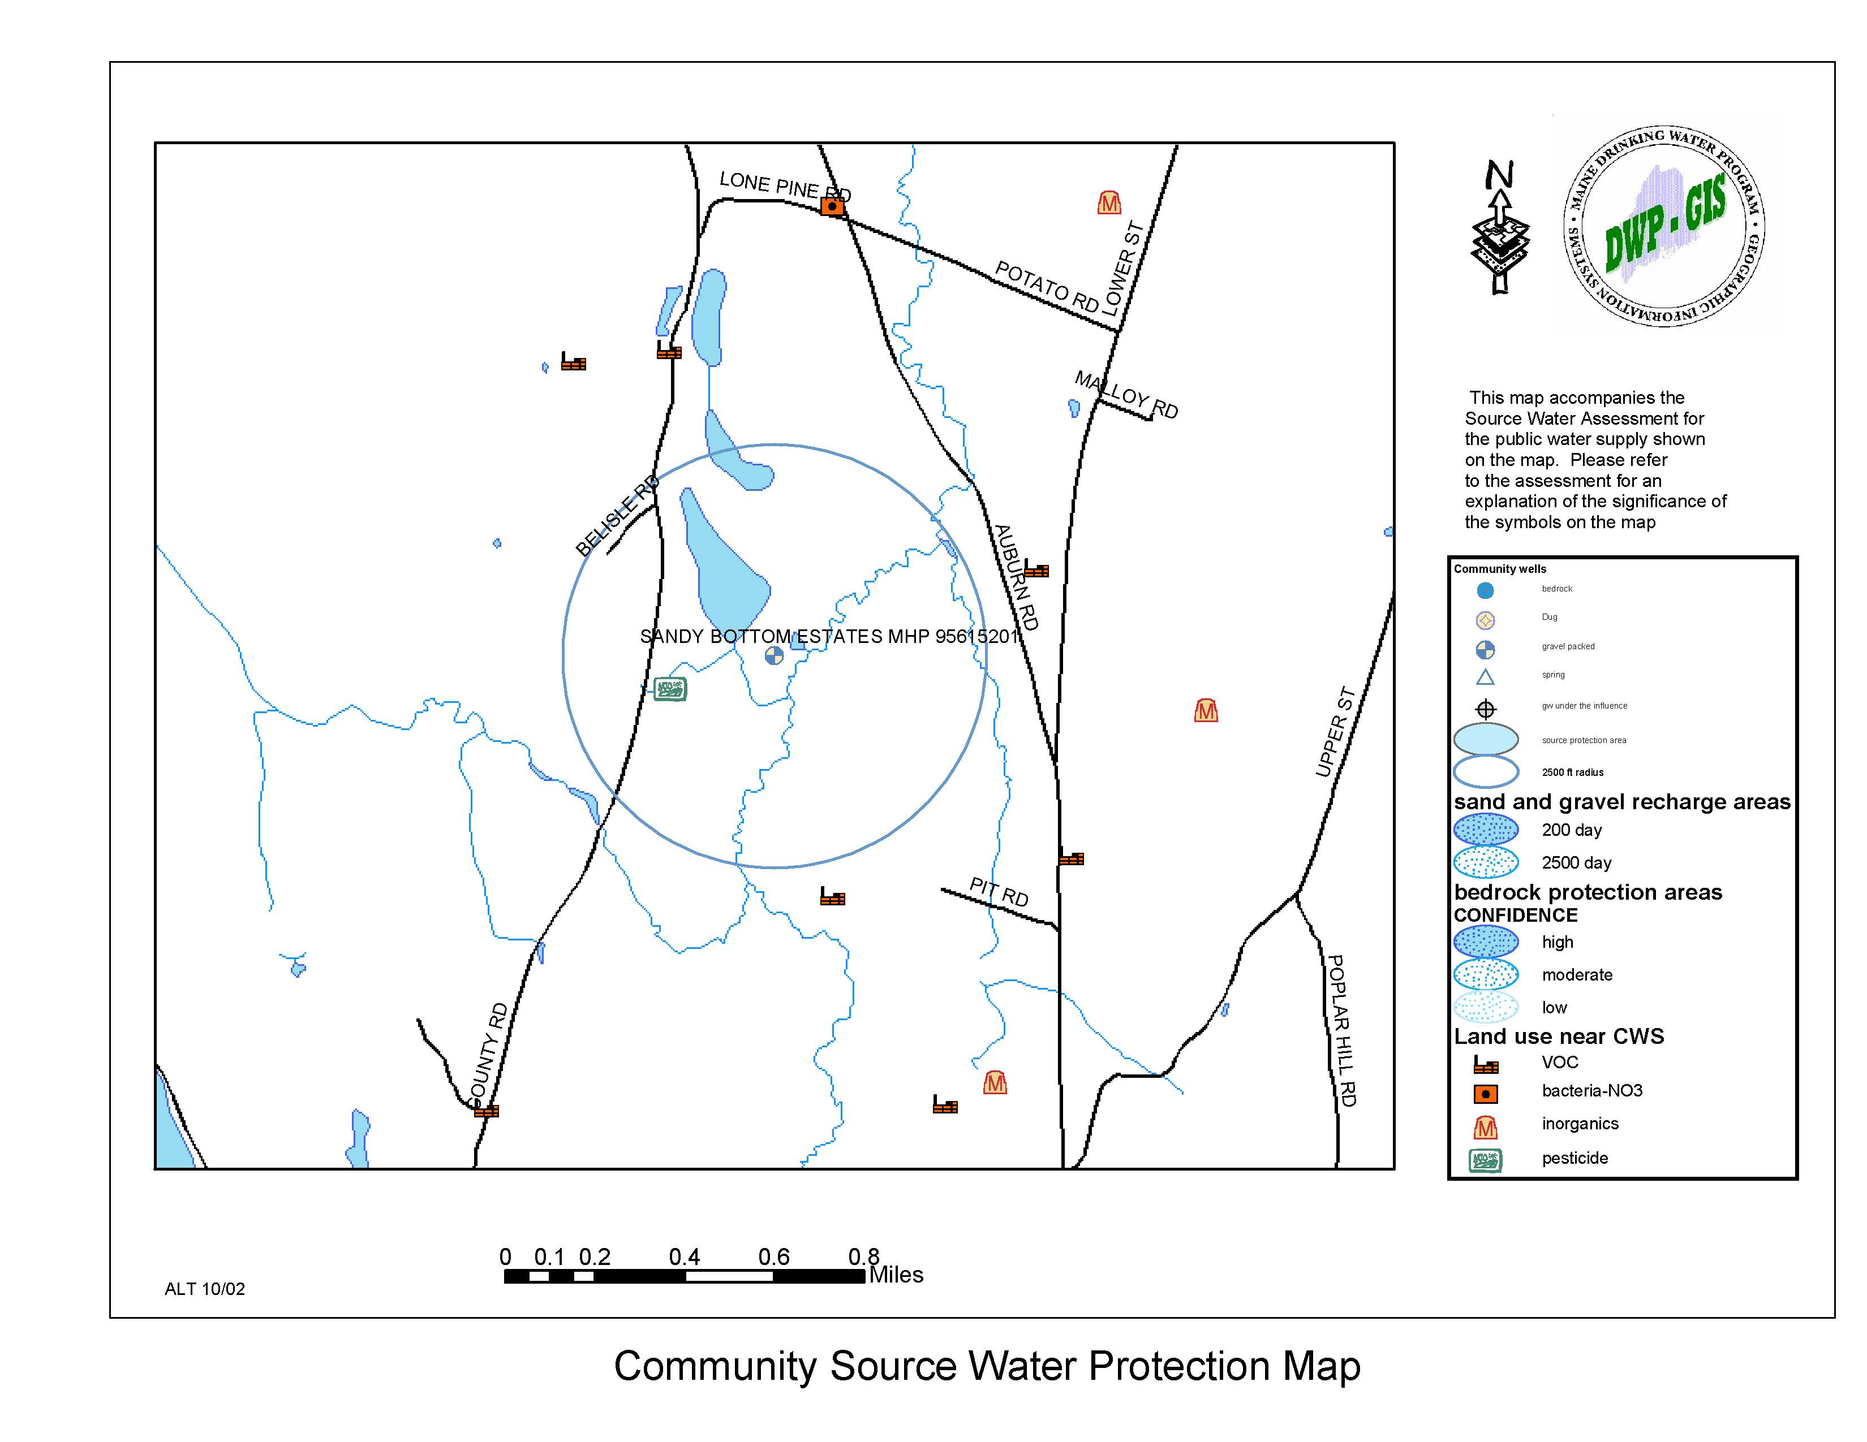

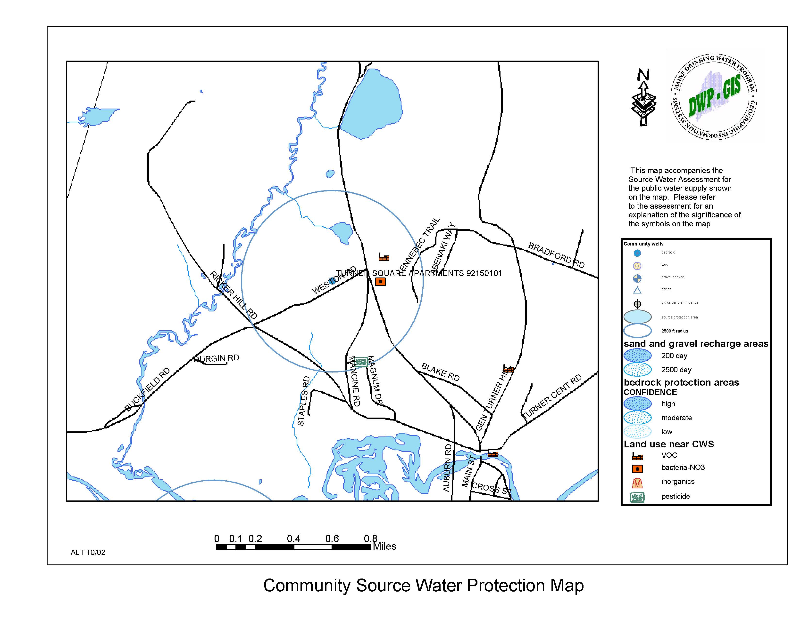

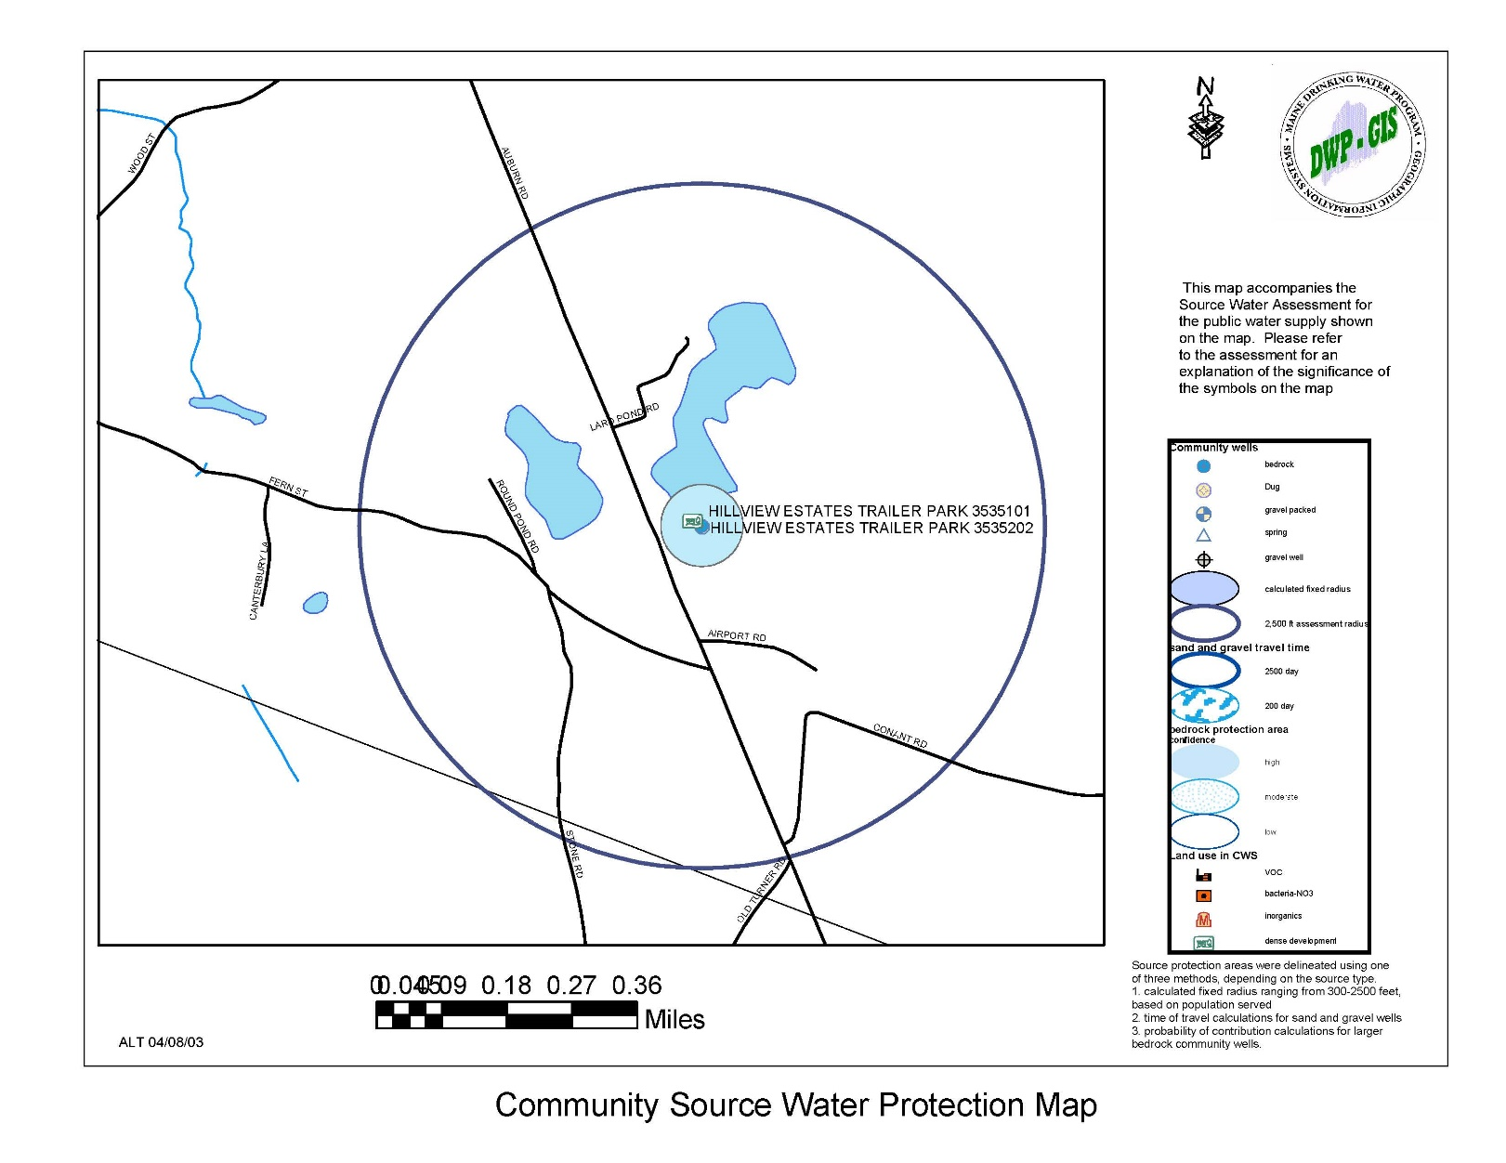

Public Sewerage System

There is only one partial treatment facility which serves the school facilities in Turner Center, which is situated between the Unitarian-Universalist Church and the cemetery on the northerly side of Route 117, and which has an outfall into the Nezinscot River. There is a combination of miscellaneous private treatment facilities of various kinds in Turner Village, some of which share certain facilities, all of which outfall into the river at Turner Village.

In 2001, several lagoons type disposal system were installed to treat the egg processing water from the DeCoster facilities.

Solid Waste Disposal

The Town operates a solid waste transfer facility and recycling center on the southerly side of the Snell Hill Road. Individual town residents transport their solid waste to the transfer station unless they contract with a private firm to dispose of their wastes. In 2018, we incinerated 1,191 tons, 2017 1,165 tons, 2016 was 1,119 tons and, in 2015, we incinerated 1,149 tons. In 2018, we recycled 181 tons of material, 2017 we recycled 188 tons, 2016 was 170 tons and, in 2015, we recycled 142 tons of material. The town spent $145,286,000 for the disposal of solid wastes and recycling of wastes in 2018. The Town plans to continue with the single sort recycling for the near future.

The Town Selectmen and Budget Committee are discussing possible options to reduce costs for the handling of solid waste.

Septage Waste Disposal

State law requires each municipality to provide for the disposal of all refuse, effluent and sludge from septic tanks. At the present time, the town has a contract with the Lewiston Auburn Water
Pollution Control Authority to dispose of septage waste from the Town of Turner.

Public Safety

Law Enforcement

The Town of Turner does not provide municipal law enforcement services but rather relies on the Androscoggin County Sheriff’s Department and Maine State Police. This coverage is alternated between the County Sheriff and State Police on a 28-day rotating basis. Turner is one of seven communities in Androscoggin County which does not provide some type of municipal law enforcement.

Fire Protection

A volunteer fire department supported by municipal tax revenues provides fire protection in Turner. Three fire stations are located in Town. They are located in Turner Village, North Turner at the Boofy Quimby Memorial Center and in South Turner on Fern Street.

The Turner Village Station is the newest station constructed in 1994. The North Turner Station is located in a portion of the Boofy Quimby Center and it has been recommended that the Fire Station be moved out of the Boofy Quimby Center so that it can be better used as a community center. The South Turner Station is of cinder block construction and is small for the Department’s needs. Mutual aid is provided to and by several neighboring communities.

The town has made several purchases to update its equipment since the 2002 Comprehensive Plan.

The 2018 Comprehensive Plan Committee believes the fire stations in North Turner and South Turner should be improved or relocated. The North Turner Station should be relocated so that the Boofy Quimby Center can be improved to better support youth athletics and serve as a community center.

Emergency Medical Services

The Emergency Medical Services was created by volunteers and has evolved into a department of paid workers. It was in 2015 that the department changed to a paid department and several changes were made to upgrade the department. The Turner Rescue Unit provides 24-hour on call response.

The Turner Rescue Unit is supported by fund-raising activities, insurance billing, contributions and municipal funds. The group was started in the 1970’s by a dedicated group of volunteers and turned it into one of the most respected local units in the area. In addition to serving Turner, the Rescue Unit also services Leeds and portions of Hartford.

The Turner Rescue Unit is located at the Turner Village Fire Station.

Health Care Facilities

The DFD Russell Medical Center was opened in 2002. CMMC Physical Therapy opened in 2017.

Turner residents rely upon two major hospitals in Lewiston, Central Maine Medical Center and St. Mary’s Regional Medical Center.

General Administrative and Service Facilities

The Town’s general administrative and service facilities are situated in the Town Office at the intersection of Routes 4 and 117 in Turner Village. The Town is governed by a five member board of selectmen and town manager. The selectmen serve as assessors and overseers of the poor. The Town employs a full time code enforcement officer. The former Town Office was demolished and a new building was constructed in 2008. The current building is expected to meet the Town’s needs for many years to come.

Town Garage

In the fall of 2001 the town opened a new town garage located on the Pit Road. The 4,000 square foot facility provides work bays for equipment maintenance and repair, office space and storage.

The Highway Department, which is responsible for summer and winter road maintenance and employs four full time employees and one half time employee.

Post Offices

There are two post offices in Turner. They are the North Turner Post Office, situated on the northerly side of Route 219 and the Turner Post Office situated on the southerly side of Route 117 in Turner Village. In 2000, there were plans to relocate the Route 117 Post office to Turner Center. Those plans were abandoned only a few days before construction of the new facility was planned to start.
New Post Office proposed in 2000 (not constructed).
Photo provided by Caldwell Family.

Cultural Facilities

Cultural facilities in the community include the Town Library, presently housed in the Leavitt Institute Building in Turner Center and the Turner History rooms and the Gazebo, also located in Turner Center. Other cultural facilities, such as additional libraries and stages for the production of dramatic presentations and the like, are contained in the public school facilities in Turner Center.

Utilities

The Town has broad coverage of 3-phase power and Internet cable.

Cemeteries

There are approximately 15 cemeteries in the Town, many of which are small, family cemeteries. These are widely scattered throughout the geographic area of the Town. Several of the cemeteries are at or near capacity.

Public Transportation

Turner is served by Western Maine Transportation Service’s Green Line which provides bus service several times daily north to Rumford and Farmington, and south to Lewiston/Auburn. WMTS also assists residents with individualized transportation to medical appointments for older citizens. It is expected that these services will meet demand for services in Turner over the term of this plan.

Bicycle Trails

Bicycle use has increased in Turner with numerous bicycle use along our streets and highways. However, there are no designated bike lanes along our streets. Off-street trails are available in the Riverlands Park and at Ricker Orchards. The committee believes that outdoor recreational opportunities need to be expanded in Turner. The Town should pursue grants from MDOT for bicycle and pedestrian paths or trail systems in the Town.

Town Owned Buildings

Gazebo – The Gazebo is a heavily used structure that costs the town very little to maintain. The town should continue to promote its use and maintain the structure.

Town House – The Town House is a historical building that needs to continue to be maintained. However, the Town should do more to promote the history of the building and get the community to utilize the building more so that future generations will have a connection to the building. Block parties and other events should be planned to make people, especially the younger generations more aware of its significance to the town.

Natural History Club – This building was recently given to the town however the building has no use to the town. The town should place the building on the National Registry to preserve its character. The Town should then place restrictions on the use of the building and sell the property.

Turner Community House – This building provides a much needed service as a low cost clothing center for its residents. The building should continue to be maintained and used as a clothing center.

G.A.R. Hall – This building was sold in 2019.

Leavitt Institute – This building represents the very heart of the community and is heavily used. The Town should do more to promote the available spaces within the building so that it may be used by the residents of the town even more than it is currently being used.

Boofy Quimby – This building and the land around it serve as a valuable space for the children of the town to utilize for sports and other activities. However, due to the fire department occupying half of the building and the lack of ADA access, use of the building is significantly limited. It is suggested that the Fire Department be relocated somewhere else in the town and the building be remodeled so that it is more accessible to all of the town’s residents. The focus of the building should continue to be a place for the children to utilize the fields and inside of the building for club and town functions. The committee feels that more funds should be utilized on the building to make it a place that all of the children and grownups of Turner will want to enjoy and continue to use.

Summary – The Town needs to do more to promote the unique and functional buildings that it owns. They represent the fabric of the community and should be utilized by all of its residents on a more frequent basis so that the history of the Town will live on through the memories of its residents.

Education

Maine School Administration District 52 is comprised of the communities of Turner, Leeds and Greene. The District’s mission is to provide excellence in education. Student will become responsible citizens and lifelong learners as a result of the teaching and learning in safe, respectful environments. MSAD 52 includes an elementary school in Greene, an elementary school in Leeds and four schools in Turner:
- Greene Central School (Pre-Kindergarten – grade 6)
- Leeds Central School (Pre-Kindergarten – grade 6)
- Turner Primary School (Pre-Kindergarten – grade 2)
- Turner Elementary School (Grades 3 – 6)
- Tripp Middle School (Grades 7 – 8)
- Leavitt Area High School (Grades 9 – 12)
The MSAD 52 central office and Adult Education are also located in Turner.

MSAD 52 School Enrollment
2010 - 2018

 | PreK-6 | 7-8 | 9-12 | Total
2010-11 | 1,121 | 334 | 647 | 2,102
2011-12 | 1,107 | 315 | 623 | 2,045
2012-13 | 1,110 | 296 | 596 | 2,002
2013-14 | 1,100 | 298 | 624 | 2,022
2014-15 | 1,097 | 284 | 587 | 1,968
2015-16 | 1,117 | 261 | 587 | 1,965
2016-17 | 1,107 | 297 | 561 | 1,965
2017-18 | 1,151 | 280 | 554 | 1,985
2018-19 | 1,146 | 276 | 583 | 2,005
Source: Maine Department of Education

School Administrative District 52 has prepared school enrollment projections to the school year 2018-19. Based on those projections, the overall school enrollment in the District has decreased by 4.6 percent since 2010. Turner’s school enrollment has increased slightly since the 2017-18 school year.

In 2015-16, MSAD 52 spent $10,937.76 per pupil for operating costs, which was less than the state average of $11,348.78. The District’s graduation rate in 2015-16 was 88.81% and remained at 88.81% in 2017-18. (Maine DOE)

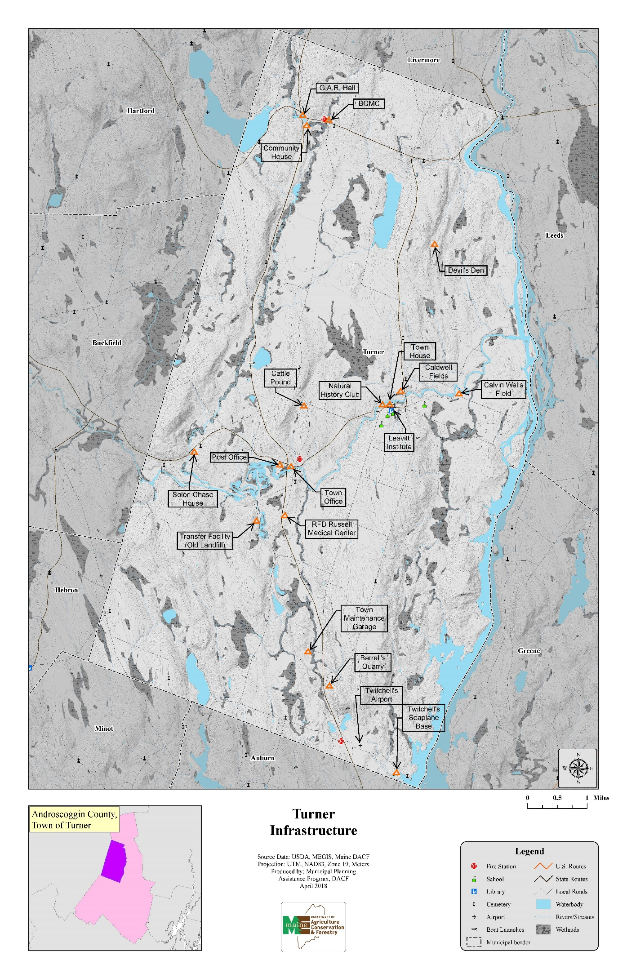
FISCAL CAPACITY

Findings and Trends 2002-2018

❖ Between 2000 and 2017 total town expenditures increased by 52% or $3,633,000.

❖ Education costs accounted for 73% of the town total expenditures in 2017.

❖ The town has a strong fiscal capacity and no debt.

Introduction

A community’s fiscal capacity refers to its ability to meet current and future needs through public expenditures. Turner’s population is currently stable, but any growth or significant increase in development could place demands upon its fiscal capacity to reasonably meet local education, municipal services and its county obligations. These may include new and improved roads, new or additions to town buildings, education facilities, public water and sewer, new or improved waste facilities, parks and recreational facilities, law enforcement, library improvements and public improvements to support economic development - just to name a few. The comprehensive plan will make various recommendations requiring public investment. These recommendations must be considered hand in hand with Turner’s capacity to pay for or finance them.

Revenues

Revenues considered in this fiscal analysis include those that are recurring such as property tax and various user fees. Turner’s largest source of revenues is from the property tax. The following table indicates the value of the municipal tax base, tax commitment and mil rate for the past nine years and also for 2000 and 2005. There was a significant increase in net valuation between 2000 and 2005 ($104,000,000) due to new construction. That momentum slowed several years later, consistent with the economic downturn that began in 2008, and valuation growth since then has been significantly more modest, yet reasonably steady. The net valuation also reflects various adjustments made by the State of Maine in the Homestead Exemption program.

Valuation Tax Commitment and Mil Rate
2000-2018

Year | Net Valuation | Tax Commitment | Mil Rate
2000 | $216,476,589 | $3,039,331 | 14.04
2005 | $320,592,540 | $4,536,384 | 14.15
2010 | $364,481,751 | $4,884,055 | 13.40
2011 | $369,485,820 | $5,047,176 | 13.66
2012 | $371,965,372 | $5,352,582 | 14.39
2013 | $361,885,950 | $5,421,052 | 14.98
2014 | $375,839,443 | $5,915,713 | 15.74
2015 | $390,450,163 | $6,047,906 | 15.70
2016 | $393,550,135 | $6,231,007 | 15.90
2017 | $395,298,173 | $6,502,256 | 16.86
2018 | $395,769,659 | $6,747,873 | 17.05
Source: Town of Turner Annual Reports

Mil Rate & Valuation

The mil rate is produced by dividing the Tax Commitment (the amount of money the town has to raise by property taxes to cover approved expenses) divided by the Net Valuation. Valuations are established by an equitable assessment of all taxable real estate and personal property, and are intended to reflect an actual market value. The last town-wide valuation in Turner was conducted in 1997. In 2004, those values were increased by an across-the-board rate of 15 percent to more closely reflect the market at that time. Those assessed values are still in use and are generally found to be about 82 percent of market value based on an annual study conducted by Maine Revenue Services which compares sale prices and assessed values for recent transactions.

The M.R.S. study is conducted mainly to determine the town's State Valuation. State Valuations become a tool used when state funds for municipalities are portioned out on an equitable basis, such as for education. Along with the State Valuation, however, M.R.S. study also produces a "Full Value Tax Rate", which is the rate that would be in effect if the town's assessments were at full market value and not discounted, like Turner's. Comparatively, Turner has the lowest Full Value Tax Rate in Androscoggin County, and is consistently under state average rates.

Comparatively, the Full Value Tax Rates for towns in Androscoggin County are as follows:

Full Value Tax Rates – Androscoggin County

Town | 2016 | 2015 | 2014 | 2013 | 2012
Auburn | 22.41 | 21.23 | 20.95 | 20.55 | 20.01
Durham | 16.49 | 16.08 | 15.65 | 14.23 | 12.82
Greene | 14.69 | 14.65 | 14.01 | 13.92 | 14.11
Leeds | 15.86 | 15.45 | 15.29 | 15.10 | 15.58
Lewiston | 23.66 | 23.42 | 23.06 | 22.98 | 22.21
Lisbon | 21.20 | 20.35 | 21.26 | 19.63 | 19.22
Livermore | 16.06 | 16.09 | 14.54 | 14.46 | 13.74
Livermore Falls | 20.75 | 20.98 | 21.06 | 21.02 | 21.25
Mechanic Falls | 20.07 | 20.65 | 20.65 | 20.46 | 19.06
Minot | 14.54 | 14.75 | 14.42 | 14.60 | 14.81
Poland | 14.44 | 14.35 | 14.44 | 14.02 | 14.00
Sabattus | 19.87 | 19.06 | 18.92 | 17.40 | 15.51
Turner | 13.69 | 13.14 | 13.11 | 13.21 | 12.18
Wales | 16.90 | 17.49 | 17.79 | 17.20 | 16.25
County Average | 20.12 | 19.65 | 19.47 | 19.07 | 18.45
State Average | 15.06 | 15.03 | 14.72 | 14.49 | 13.99

Other significant revenue sources have been excise taxes, state revenue sharing and state road assistance funding.

The Committee is recommending that the town complete a full profession revaluation no later than 2024.
Significant Sources of Revenue
2000-2017

Year | Excise Taxes | State Revenue Sharing | State Road Aid
2000 | $723,786 | $270,481 | $90,015
2005 | $949,480 | $400,000 | $91,328
2010 | $936,313 | $362,285 | $87,072
2011 | $940,719 | $264,024 | $87,072
2012 | $935,181 | $238,425 | $87,072
2013 | $996,841 | $236,903 | $88,732
2014 | $1,085,351 | $185,139 | $88,780
2015 | $1,085,580 | $186,958 | $81,116
2016 | $1,187,482 | $186,958 | $81,948
2017 | $1,244,237 | $202,766 | $81,820
Source: Town of Turner Annual Reports

Expenditures

The largest annual expenditure is for education through Turner’s share of MSAD #52's budget. The school assessment ($5,606,866) accounted for 64 percent of the town’s total expenditures ($8,814,401) in 2017. This compares to 57 percent in 1990, 63 percent in 2000, and 61 percent in 2010. The school assessment increased by 50 percent ($1,348,000) in the 10-years between 2000 and 2010 ($2,685,000 to $4,020,000). In the seven years since 2010, the increase was 39 percent.

Comparatively, town expenses grew by 51 percent between 2000 and 2010 (from $1,389,102 to $2,092,215), and by 28 percent since 2010. During this same 10-year period the total annual town expenditures have increased 73% ($1,800,000).
 | 2000 | 2005 | 2010 | 2013 | 2015 | 2016 | 2017
Education | 2,685 | 4,020 | 4,033 | 4,834 | 5,174 | 5,313 | 5,606
County Tax | 237 | 349 | 450 | 492 | 496 | 496 | 517
Administration | 247 | 349 | 336 | 300 | 329 | 340 | 338
Paving, constr, summer/winter roads | 725 | 732 | 608 | 947 | 903 | 1,008 | 1,042
Solid Waste, Landfill, Transfer Facility | 172 | 251 | 205 | 184 | 192 | 197 | 96
Totals | 4,066 | 5,701 | 5,632 | 6,757 | 7,094 | 7,354 | 7,699

Androscoggin County taxes grew by 90 percent from 2000 to 2010, and by 14.8 percent in the seven years since.
Significant Items of Expenditure
Turner, Maine
$000's

Source: Town of Turner Annual Report

Major Capital Expenditures

Major capital expenditures over the past four years have been for rescue barn renovations, ambulance upgrades, and plow trucks/equipment. The Committee would like to see the town allocate money to the reserve accounts every year so that major purchases could be covered in future years.
Major Capital Expenditures
2015-2018

 | 2015 | 2016 | 2017 | 2018
Fire truck | $80,000 | $7,500 | ---- | ----
Highway Trucks | $191,418 | ---- | $94,505 | $90,644
Rescue Equipment | ---- | $24,985 | $12,500 | $6,500
Rescue Barn Improv. | $75,369 | ---- | $8,100 | $5,003
Rescue - Ambulance | ---- | ---- | $60,000 | $37,431
Transfer Station | $23,654 | $44,779 | ----
Highway equipment | $7,193 | $150,980 | $35,038 | $7,135
BQMC | ---- | $9,200 | $5,854
GAR Hall |  | $8,313 |  | $3,500
Totals | $377,634 | $245,757 | $215,997 | $150,213
Source: Town of Turner

Balance Sheet

At fiscal year ending June 30, 2017 the Town of Turner had no long-term debt obligations and showed a strong undesignated fund balance of $2,013,103 or 30.09% of total assets of $6,689,684. The only indebtedness is the town’s share of the MSAD #52 indebtedness. On June 30, 2017, MSAD #52 had total debt of $3,895,400 and Turner’s share of that was 49.11% or $1,913,031. As of June 30, 2017, Androscoggin County had no debt attributable to Turner.

Fiscal Capacity

The Town’s total outstanding debt is limited by state law to 7.5% of the Town’s last full state valuation. This limit may be higher if the debt is for schools, sewer and airport, water and special district purposes. With Turner’s valuation of $505,700,000 on June 30, 2017, the Town’s total debt limit, established by State law, would be $37,927,500.

TRANSPORTATION

Findings and Trends 2002-2018

❖ Approximately one half of the town road mileage is considered in excellent or good condition.

❖ Five to seven miles of town roads have been repaved in each of the last five years.

❖ Route 4 in Turner has been classified as a retrograde arterial by the Maine Department of Transportation.

Introduction

Turner’s transportation system is primarily limited to its roadway system. There is a privately owned airport and float plane base located in South Turner. The Committee recommends that the Town should look into the possibility of keeping the airport functional as either a municipal or private facility.

A community’s roadway system is extremely important to future development. Traditionally, the roadway system has been second only to education in the amount of tax dollars expended annually. Turner has approximately 67 miles of totally town-maintained roads. In addition, there are some 19 miles of road for which the State Department of Transportation has summer maintenance responsibility, and which Turner plows and sands in the winter. The 12.7 miles of Route 4 which bisects the Town are totally maintained by the State. Since 1991, the town has accepted approximately two miles of new public roads. These roads serve residential subdivisions.

In addition to public roads there are of privately owned roads serving residential subdivisions and homes adjacent to ponds.

Roadway Conditions

Physical conditions of all Town maintained roads were rated by the Board of Selectmen as their role of Road Commissioner. The rating system was based upon the surface conditions and drainage. This analysis found that 14.9 miles of Town roads were in excellent condition, 22.4 miles in good condition, 16.07 miles in fair condition and 4.64 miles in poor condition.

Road Conditions, 2018

ROADS IN GOOD CONDITION
Road/Street | Miles
Abenaki Way | .25
Allen Road | .24
Back Cove Road | .81
Belisle Road | .19
Berry Road | .56
Bluff Drive | .16
Bradford Road | .79
Canterbury Lane | .18
Clover Lane | .45
Cobb Road | 1.78
Colony Drive | .28
Dump Road | .29
East Hebron Road | 2.97
Forest Trail | .38
Harlow Hill Road | 2.35
Heiken Drive | .25
Hillside Drive | .23
Holbrook Road | .85
Little Wilson Pond Road | 1.56
Long Meadow Estates | .24
Macavity Drive | .15
Magnum Drive | .48
Moody Way | .11
Nezinscot Drive | .38
Outlook Drive | .22
Pit Road | .27
Poland Road | .12
Richmond Road | .31
Round Pond Road | .17
Shire Lane | .11
Skillings Wood Road | .32
Snell Hill Road | 1.44
South Livermore Road | 1.24
Staples Road | .34
Stone Road | .32
Teague Avenue | .18
Turkey Lane | .65
Wood Street | .87
Total | 22.44

ROADS IN GOOD TO FAIR CONDITION
Road/Street | Miles
General Turner Hill Road | 3.1
Total | 3.1

ROADS IN FAIR CONDITION
Road/Street | Miles
Aspen Way | .1
Blake Road | .43
Brookfield Estates | .15
Buck Lane | .3
Hammond Road | .17
Knight’s Farm Road | .17
Lard Pond Road | .19
Lone Pine Road | .37
Lower Street | 3.9
Mancine Road | .69
Mason Road | .57
Merrill’s Mill Road | .92
Mill Hill Road | .4
Mooselook Drive | .15
North River Road | .36
Pearl Road | .74
Poplar Hill Road | .73
Ricker Hill Road | 1.48
School House Hill Road | 1.32
Spikehorn Way | .23
Tidswell Road | 1.0
Torrey Hill Road | .7
White Birch Drive | .8
Willard Drive | .2
Total | 16.07

ROADS IN FAIR/POOR CONDITION
Road/Street | Miles
Fish Street | 2.3
Pleasant Pond Road | 2.51
Total | 4.81

ROADS IN EXCELLENT CONDITION
Road/Street | Miles
Beach Street | .2
Brody Way | .09
Bryant Road | .74
Cobblestone Way | .13
County Road | 3.24
Fern Street | 1.95
Field Lane | .12
Main Street | .25
Mountainside Drive | .57
Orchard Drive | .3
Plains Road | 2.93
Potato Road | .66
Scenic View Drive | .41
Skillings Corner Road | .29
Stonecrest Drive | .08
Wilderness Way | .34
Wilson Hill Road | 2.6
Total | 14.9

ROADS IN POOR CONDITION
Road/Street | Miles
Kennebec Trail | .86
Bean Street | 1.65
Bennett Road | .2
Church Street | .24
Cross Street | .1
Dow Farm Road | .34
Jennifer Drive | .2
Johnson Hill Road | .29
Townsend Brook Road | .06
Trask Road | .29
Young Road | .24
Pheasant Run | .17
Total | 4.64

It is recommended that the town think about widening Cobb Road at the Primary School and at the Cobb Road ball field to allow for parking on the side of the road and still allow traffic along the road safely.

Roadway Capacities

Turner’s residential development and projections of continued residential growth will place additional burdens upon the local roadway system. Because of this and the substantial annual investment, to maintain roads and the even greater investment to upgrade them, a highway maintenance and capacity analysis was conducted as an element of the 2019 comprehensive plan. The results of this analysis has been an aid in roadway improvement programming and the determination of future development impacts upon local roadways.

The following methodology was employed to collect the base line information to determine roadway capacity:

a. Each road was driven and various road segments were located on the Town of Turner’s Street Base Map.

b. Each segment was numbered for each road name from one end consecutively to the other end. Segments were determined by intersections or other relevant features of the road.

c. Road type was designated as one of the following:
State route
Urban/village
Local collector
General rural
Limited use

d. Paving was indicated by the type of surface, bituminous or gravel.

e. Drainage was determined by the suitability of ditches and culverts and a historic perspective on flooding and washouts. It was rated as good, fair or poor.

f. Base was a general description of the adequacy of base--rated as good, fair or poor.

g. Alignment was used to indicate the adequacy of alignment to provide for safe travel. Again a good, fair, poor rating was used.

h. The actual width of pavement was recorded.

i. Shoulders were recorded as the average width of shoulder over the length of the segment.

This information was recorded on field sheets that corresponded to the road segments located on the street base map.

The assessment factors were separated into two distinct parts--factors related to adequacy of service and the factors related to maintenance costs. All can be combined into an overall adequacy of the road to provide a sufficient level of service at a reasonable maintenance cost.

Capacity rating of a road, or particular segments of a road, are important to planning for Turner’s future. Capacity of roads should be a consideration in the future development patterns of the community. Based upon the roadway capacity analysis, the following major transportation routes have the following capacity ratings:

High Capacity
Upper Street
Lower Street
North Parish Road
Route 117
Route 219

Medium Capacity
Wilson Hill Road
Main Street
School House Hill Road
Low Capacity

North Auburn Road
East Hebron Road
General Turner Hill Road
Gauthier Hill Road

Traffic Volumes

Route 4 is one of the major arterials in Maine. It carries industrial traffic to the paper mills in Livermore Falls, Jay and Rumford and to the urban center of Lewiston and Auburn. As residential development expanded in Turner and other rural communities, commuter traffic has increased. It also carries recreational traffic to the Western Mountains of Maine. Annual average daily traffic volume on Route 4 at Tuner Village increased by 34% or 3,400 vehicles between 1998 and 2000. Between 2000 and 2017, traffic volumes at this intersection have been stable with only a minor increase of about 60 vehicles reported at this intersection. Other major roads are Route 117 which provides east/west travel through Norway and Paris and Route 219 that connects with Route 26 in West Paris. Other roads that receive a high level of traffic although not as great as the State routes include the Center Bridge Road, Lower Street, Upper Street and Western Road.

The Maine Department of Transportation maintains traffic volume data for several locations throughout Turner. The following table presents annual average daily traffic data at several locations. Over this 17 year count cycle, traffic volumes have increased only slightly at the first three locations noted. Volumes at Route 219/Howe’s Corner and Lower Street/Greene Road have decreased by 1.4% and 38% respectively. Volumes in Turner Center have increased by 28%.

Annual Average Daily Traffic
Number of Vehicles

Location | Year
 | 2000 | 2017
Route 4/Turner Village | 13,360 | 13,420
Route 4/Lower Street | 13,550 | 14,270
Route 4/North Turner | 9,650 | 10,450
Route 219/Howe’s Corner | 2,140 | 2,110
Lower Street/Rt. 117 | 3,010 | 1,864
Turner Center | 2,770 | 3,550

High Crash Locations

The Maine Department of Transportation maintains reports of all reportable crashes ($1000 damage or personal injury). A report entitled “Maine Accident Record Summary” provides summarized data relating to the location and nature of crashes. One element of the summary report is the identification of a “Critical Rate Factor” (a statistical comparison to similar locations in the State). Locations with a critical rate factor of greater than 1.00, with a total of 8 or more crashes, should be of concern because it is considered a high accident location. Based upon the information provided by the MDOT, there are a number of locations with a critical rate factor greater than 1.00 in Turner.

High Crash Locations
2013-2017
Turner, Maine

Location Description | # of Accidents* | Critical Rate Factor**
Route 4/Route 117 | 20 | 2.78
Route 4/Route 219 | 18 | 2.68
Route 4/Weston Road | 14 | 1.82
Center Bridge Road/Upper Street | 10 | 3.62
Source: Maine Department of Transportation
*Maine Public Crash Query Tool, Maine Department of Transportation
**Maine Chapter, Institute of Transportation Engineers

At this time, MDOT is proposing safety improvement projects at the intersections of Route 4/Route 117 and Route 4/219. Those improvements are expected to address accidents at these intersections with projects expected to be constructed within the next two to five years. No improvements are planned for the remaining intersections at this time.

Retrograde Arterial

Route 4 in Turner has been classified as a retrograde arterial by the Maine Department of Transportation. A retrograde arterial is a mobility arterial where the access related crash-per-mile rate exceeded the 1999 statewide average for arterials of the same posted speed limit. Access to retrograde arterials will be regulated by the Maine Department of Transportation through driveway and entrance permits.

Sidewalks

The only sidewalks found in Turner are located on Lower Street from the Leavitt Area High School parking lot entrance to Route 117(Turner Center Road) on the bridge that crosses the Nezinscot River in Turner Village and the remnants of a side walk on the easterly side of a portion of Main Street in Turner Village. The total length of sidewalks in Turner is approximately 1,600 feet, this includes the new sidewalk from Cobb Rd intersection to Caldwell Field.

In Turner Center, there is a need for additional sidewalks to serve school pedestrian traffic. The area along Turner Center Road and Cobb Road to the Turner Primary School are priority locations.

State Highway Improvement Plan
2018 - 2020

Bridge Replacement & Rehabilitation
North Parish Bridge / replacement
Martin Stream Bridge / substructure rehabilitation
Russell Bridge / East Hebron Rd / repairing drains & joint
Turner Center Bridge / Rt. 117 / bridge repainting

Road Reconstruction
Rt. 4 / From Upper Street northerly 11.18 miles

Safety Improvements
Rt. 4 / .12 miles north of Mason Rd. extending northerly .06 miles

OUTDOOR RECREATION RESOURCES

Findings and Trends 2002 - 2018

❖ The Turner Athletic Association has added new recreation fields.

❖ Traditional outdoor recreation opportunities may decrease as the result of land posting.

❖ Additional outdoor recreation facilities will be needed over the next ten years.

Introduction

Most public recreation facilities in Turner are associated with the school system. Recreation oriented facilities owned directly by the Town have expanded over the past ten years and include the town beach at Bear Pond, boat launching area at Pleasant Pond, the Boofy Quimby Memorial Center in North Turner and baseball fields on the Cobb Road. Recently, the Turner Athletic Association (TAA) has purchased property from the Caldwell Family in Turner Center. TAA has developed practice fields at this location and is actively raising funds for a multi-million dollar, indoor/outdoor sports complex at this location.

Recreation in Turner, as in many rural communities, has been non-facility oriented. Traditional access to water bodies and woodlands has provided for many recreational opportunities with limited demands for facility-oriented recreation.

Public/Semi-Public Recreational Facilities/Areas

In 2009 Androscoggin Land Trust constructed a half-mile loop at the Jones-Bonney Turner Village Park on the land adjacent to Hannaford Supermarket that provides walking access to the Nezinscot River. School Administrative District #52 owns and maintains the majority of the public recreational facilities in Turner. Although these facilities are primarily utilized for school activities, the Turner Athletic Association enjoys a level of cooperation with the District and in the utilization of their various facilities.

SAD #52 Recreation Facilities
Turner Center

Type | Number
Baseball fields | 2
Softball fields | 4
Football fields | 2
Soccer field | 1
Field hockey field | 1
Track | 1
Tennis courts | 3
Basketball court (outdoor) | 3
Basketball courts (indoor) | 5
Playground areas | 2
Cross-country trails | Yes

Boofy Quimby Memorial Center
Recreation Facilities
North Turner

The Boofy Quimby Memorial Center located on Route 219 in North Turner is located on the site of the old North Turner School. The center was made possible through a gift in memory of a young North Turner boy

Baseball/softball fields 2
Indoor basketball 1
Outdoor Basketball 1

The Comprehensive Plan Committee believes that the indoor facilities at this location should be improved to create a community center. This would require the relocation of the fire station and improvements to the existing building to better serve existing children programs and provide community meeting spaces.

In 2001, two new little league baseball fields were constructed off the Cobb Road. This was made possible through donations and volunteer labor. In 2014, TAA purchased 57 acres from the Caldwell Family in Turner Center. With support from local business and the community, TAA has already constructed 2 new athletic fields on this property. These fields increased the number of playable surface and provided needed space for TAA’s youth athletic programs. This property is also large enough for TAA to expand its operations. Using a capital fundraising campaign, TAA plans to construct multiple athletic fields, courts and indoor facilities to support their youth athletic programs at this location. At this time, TAA is filling the needs for youth sports. In the future, the Town should look to apply for grants or funding and continue to support youth athletics.”

Recreation Programs

The Turner Athletic Association sponsors recreation programs for elementary school age children. The program is run by volunteers with a portion of costs appropriated by the Town. However, to date, the majority of money has been raised through fund-raising. The Association conducts year-round sports programs. In the spring and summer, baseball, softball and T-ball are provided, involving approximately 1000 children. Flag Football, soccer and Peewee football is conducted in the fall. In the winter, basketball is played by children in grades three through six. Other sports include cheering and field hockey. In order to keep in line with the sports offered at the high school level both skiing, wrestling and golf have been considered as additional offerings.

Formal Public Access to Surface Waters

In 1997, the Town purchased property on Bear Pond for a Town Beach. A total of 3.7 acres was purchased with 1.1 acres of beach area. The beach is overseen by a volunteer Beach Committee. That continues to be a destination for Town residents.

The Town has 12 Great Ponds, (lakes and ponds with a surface area of 10 acres or more) including Gulf Island Pond on the Androscoggin River. The Town also has recreational opportunities along Martin Stream and the Nezinscot River. With all of these water bodies available, the Town has provided public boat access to only one Great Pond. The Town-owned land, approximately 1/4 acre, at the southern end of Pleasant Pond, has been improved for boat access to Pleasant Pond.

In the Fall of 1988, a hard surface launching area and parking facility were completed at the Turner-Greene Bridge on Gulf Island Pond of the Androscoggin River. This facility was constructed by Central Maine Power Company and is now owned by Florida Power and Light. It was constructed to provide recreation access to the largely undeveloped Gulf Island Pond Area as a condition of the Federal Energy Regulatory Commission’s relicensing of Gulf Island Pond Dam. The facility receives a high amount of use. The Town has committed to improving this area for recreational use and has been working on creating even more accessibility by creating a handicapped accessible fishing area at this location.

When Route 4 was realigned in the area of Crystal Pond (aka Beal’s Pond), the state retained a portion of the former roadway for use as a carry-in boat launch. The area is maintained by the Maine Department of Inland Fisheries and Wildlife.

There are several informal access sites to the Town’s surface waters where the public has enjoyed access across private lands. These include: the area immediately above the Main Street Bridge on the Nezinscot River, where an unpaved boat launch exists; the parking lot behind the former Hearth & Cricket Building (the mill building) below the Main Street Bridge on the Nezinscot, and at the Route 117 Bridges across the Nezinscot in Turner Center. There are numerous other informal access sites to the rivers, streams and ponds.

Access to these natural resources for paddle sports or other enjoyment in outdoor recreational activities will bring more visitors to our community to support our current businesses and provide new outdoor resource-based business opportunities in town.

Action Plan for public access to Surface Waters

We had a good dose of public input at the Outdoor Recreation hearing and from our questionnaire that the people of Turner continue to value our waterways and want more access, as is consistent with earlier versions of the Comprehensive plan. The following is a large undertaking of many small sections that will develop not only more outdoor recreation in Turner, but very likely help our business economy as well. The Town sees the importance of maintaining safe, functional, and accessible access points to all of our surface waters. We hope to continue to do so by partnering with state agencies, applying for grants when they become available and harboring strong relationships with private landowners. The Town will develop a written plan to determine who is responsible for upkeep and maintenance of these access points, including appropriating funds for those that the Town owns currently to ensure that they are well kept and suitable for use.

Open Space Areas

Turner is endowed with a large amount of privately owned open space that has traditionally been open to the public for snowmobiling, hiking, cross-country skiing and hunting. The largest area, often referred to as the Diamond Match Land, is located along Gulf Island Pond. The parcel contains some 1,800 acres and 9.4 miles of undeveloped shoreland along the Androscoggin River. The public has enjoyed access to these lands and because of development potential, the Land for Maine’s Future Board purchased the tract in fall of 1990. It is now known as the Androscoggin Riverlands Park. It is managed by the Bureau of Parks and Lands and has had walking and ATV trails developed.

These open space areas have made a large snowmobile trail system possible throughout the town, connecting to the trail systems in other communities and the statewide snowmobile trail system.

The 4-wheeler or ATV is becoming a popular outdoor recreation activity. The Maine Department of Parks and Lands has designated the Androscoggin Riverlands as an ATV riding area. There is interest of ATV owners in Turner and surrounding communities to establish a system of trails outside the State owned Androscoggin Riverlands through Turner to communities north of the park. In recent years, the Riverlands has been host to numerous events; including but not limited to a 24 hour ultra-running race that has received national attention.

Other private recreation in the town includes Turner Highlands Golf Course, Steven’s Mountain View Disc Golf Course and Cranberry Valley Disc Golf Course. Some national events have been held at both of these disc golf courses.

The Maine Outdoor Wellness Center seeks to preserve the memory of Roy Varney by providing opportunities to access the outdoors for all Turner and surrounding residents of central Maine and New England. The Center plans to provide an extensive cross country trail system on its 300+ acre farm that can be utilized year-round for hiking, skiing, biking, and running. Additional space for events and additional activities will be added as development progresses.

These Open space areas need to be protected for use by future generations. Turner should learn more about the national events in running and disc golf and help promote those events and other similar recreational activities. The Town should support the creation of a Town wide ATV trails with the Turner Timberlands ATV Club or multi-use trail system with the ATV club and the Turner Ridge Riders Snowmobile Club. Outdoor recreational activities can and should become a significant economic opportunity for Turner.

Action plan for ATV trail development and access improvements.

Action plan to create a designated lane/trail for bicycles, walkers, joggers, stroller pushers, road skiers, and those who roller blade:

The outdoor recreation offered by ATV’s has been limited in Turner by the lack of trails available from private land owners. This is in large part due to the environmental risk that can incur with trail use on dirt in the summer compared to snowmobiling on frozen snow covered trails in the winter. The ATV club in Turner is organized and willing to help coordinate communication with the ATV community and training for proper responsible use of their vehicles. They would like a trail to get ATV’s from the BQMC to Cobb road which they currently have permission to use to continue on to the Riverlands State Park. There are some big gaps in ATV access approximately paralleling the Plains Road and from BQMC north to Livermore. The committee would encourage as much off-road trail use as the private land owners may offer. The possibility exists of building a multi-use paved activity lane 8’ wide along the side of parts of the plains road, with two lanes of 4 feet delineated for recreation traffic. A small parking area would be helpful. This could provide trail connection for the ATV’s (at slow speeds only) and a great place for all the other activities that our residents like to do, without the danger of being right next to speeding vehicles. This is only workable if the club can secure trail permission from land owners that can connect from Plains road across to the new bridge in Turner Center and onto Cobb road.

Important Hunting and Fishing Areas

Turner has traditionally been a favorite hunting area for both town residents and nonresidents. The Town’s farming activities and woodlands provide excellent wildlife habitats. Significant hunting areas include the lands along the Androscoggin River and land along Upper Street. More and more land is being posted to no hunting in Turner. The Nezinscot and Androscoggin Rivers traditionally have been favorite water fowl hunting areas.

The rivers, streams and brooks in Turner provide for numerous fishing opportunities. In recent years, the Nezinscot River has become an important fishery for brown trout. The Androscoggin River has gained national attention for its World Class Smallmouth Bass fishing. The Androscoggin River is fished year round and there are several fishing tournaments held annually.

Various brooks and streams provide for a brook trout fishery as do the ponds. In addition, the Androscoggin River has become a regionally important bass fishing water.

Facility Need Analysis

Turner’s existing outdoor and indoor recreation facilities were assessed using the Guidelines for Recreation and Park Services prepared by the Community Parks and Recreation Program. The analysis compared the facilities identified in the above sited report with current day facilities in Turner. The first column in the following chart identifies the type of facility. The second column lists recommended capacities for each type of facility. Based upon a planning population of 5,000, the second column identifies capacity and facilities needed, in parentheses. The last column represents current day facilities in Turner.

The analysis indicates that Turner meets or exceeds most of the recreation facilities needs considered, however, several deficiencies exist. Based upon the analysis, Turner has deficiencies in neighborhood parks, ice skating and picnic tables.

Outdoor Recreation Facility Analysis

Type of Facility | Recommended Facilities | Existing Facilities
Neighborhood Playgrounds  Community Recreation Area  Community Park  Baseball Diamond  (90 foot base paths)  Softball/Little League Diamond  Basketball Court  Tennis Courts  Multi-purpose Field/Football, Soccer, Field Hockey  Swimming Area  Ice Skating  Playgrounds  Picnic Area  Outdoor Education Area | 10 acres; located within ½ mile of each housing concentration of 50 or more homes - playground basketball court, play field, etc.  12-25 acres developed with ballfields, tennis courts, swimming facilities, ice skating, etc.  100+ acres; largely undeveloped for walking, cross-country skiing, nature study, etc.  0.16 per 1,000 population ( 1 diamond)  0.75 per 1,000 population (4 diamonds)  0.50 per 1,000 population (2 courts)  0.67 per 1,000 population (3 courts)  0.50 per 1,000 population (3 fields)  Area to serve; 5% of population 15 sq.ft./user  5,000 sq.ft. per 1,000 of population (24,000 sq.ft.)  .50 per 1,000 population (3)  2 tables per 1,000 population (10 tables)  1 per town | 1 located at Turner Elementary School  1 Boofy Quimby (no swimming)  1 Androscoggin Riverlands  2 diamonds  8 diamonds  3 courts  3 courts  4 fields  1 swimming area  0  3  0  Androscoggin Riverlands Lands

SCENIC RESOURCES

Findings and Trends 2002 - 2018

❖ Scenic views help define Turner’s character.

❖ Agriculture plays an important role in maintaining the scenic views in Turner.

❖ Scenic view locations are in demand for residential development.

Introduction

Turner is endowed with a number of scenic areas and views. These scenic views is second only to farmland of the characteristics that residents most often use to describe Turner’s character. The Town’s topography and several north-south roads which traverse these ridges provide striking scenic views, some reaching Mt. Washington.

Scenic Resources

During the inventory element of the 1991 Comprehensive Planning Program, 18 scenic vistas were located and ranked and these vistas were verified in 2018. A system to rank each site was developed with the highest possible score being 12. Although there are other scenic areas throughout the Town, the following is representative of the most significant.

Current development regulations in Turner require an assessment of the impacts upon scenic locations when a subdivision or commercial type development is proposed. However, they fall short in providing an adequate level of protection when single lots are developed for residential use.

Many of the scenic locations will be attractive for development if agriculture declines in the future. Since 1990 several scenic view locations and view sheds have been developed for residential use. Scenic view locations which have seen residential development include the views westerly from General Turner Hill, Lower Street and Upper Street.

Visual Quality Assessment
1990

Location | Distance | Duration | Uniqueness | Accessibility | Total Score
Upper St. Westerly | 3 | 3 | 3 | 2 | 11
Gen. Turner Hill Westerly | 3 | 3 | 3 | 2 | 11
Lower St. Westerly | 3 | 3 | 3 | 2 | 11
N. Parish Rd. Westerly (Merrill Hill) | 3 | 2 | 3 | 2 | 10
Rte. 4 South | 3 | 2 | 3 | 2 | 10
Upper St. Easterly | 3 | 2 | 2.5 | 2 | 9.5
Pearl Road/West & North Schoolhouse Hill | 3 | 2 | 2.5 | 2 | 9.5
Poplar Hill Rd. Westerly | 3 | 2 | 2 | 2 | 9
Top of Ricker Hill Westerly | 3 | 1 | 3 | 2 | 9
Harlow Hill Rd. Westerly | 3 | 2 | 2 | 2 | 9
Rt. 117 (Turner Ctr.) East | 1 | 3 | 3 | 2 | 8
N. Parish Rd. Westerly  (Caldwell's) | 3 | 1 | 2.5 | 2 | 7.5
Upper St. N.W. (Schoolhouse Hill) | 3 | 1 | 2 | 2 | 8
N. Parish Rd. (E/SE) | 1 | 2 | 3 | 2 | 8
Gen. Turner Hill Rd. S.E. | 3 | 1 | 1.5 | 2 | 7.5
Andros. River, Greene Bridge | 1 | 1 | 2 | 3 | 7
Bear Pond Rd. West | 1 | 1 | 2.5 | 2 | 6.5
Rt. 117 (Chases Mills) W/SW | 1 | 1 | 2 | 2 | 6

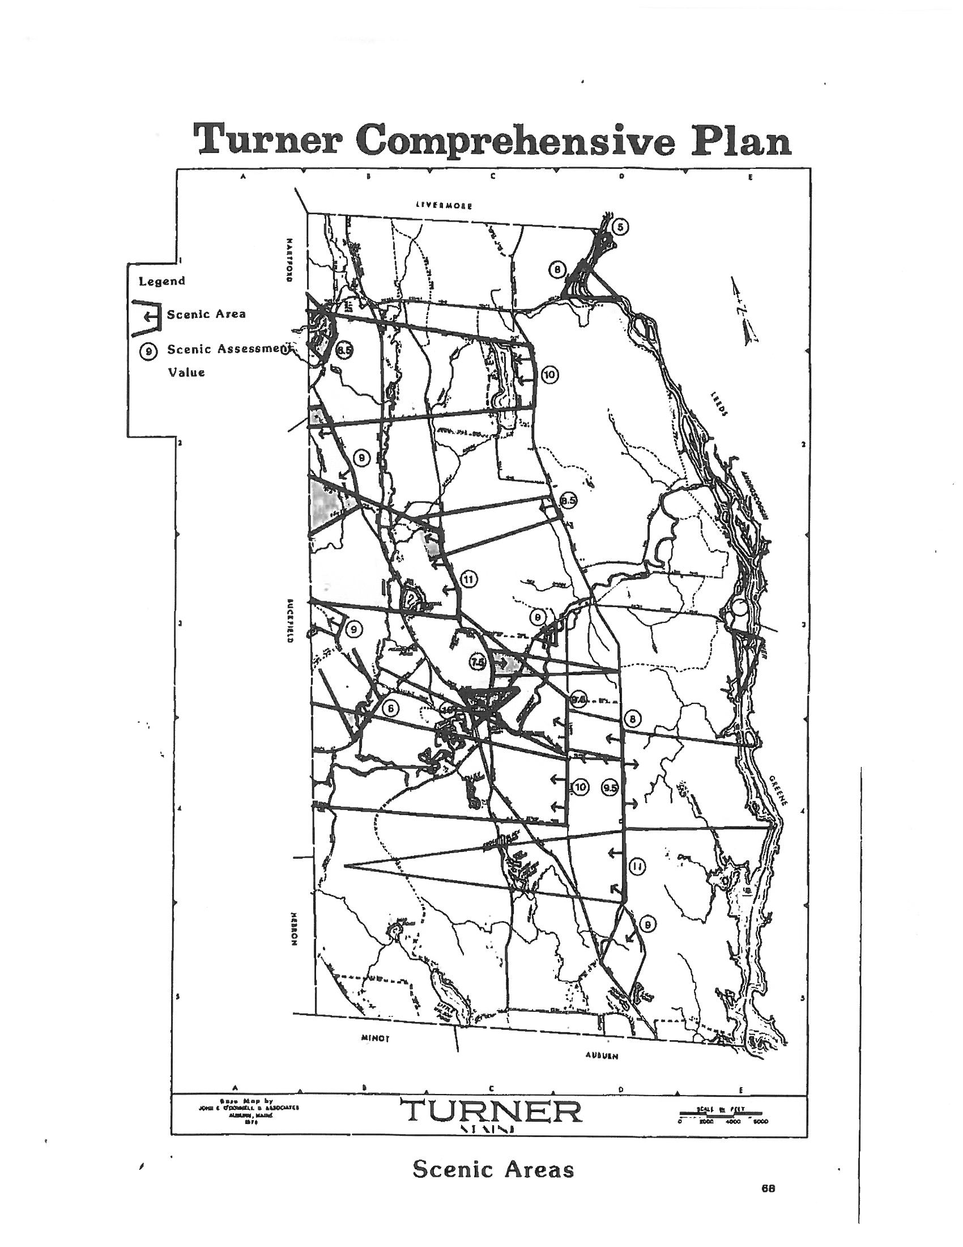

HISTORIC AND ARCHAEOLOGICAL RESOURCES

Findings and Trends 2002 - 2018

❖ Two sites, the Turner Town House and the Cattle Pound, are listed on the National Register of Historic Places.

❖ The historic Turner Creamery was lost to fire in 1995.

❖ The Maine DOT has designated part of Rt. 117 as a historical district (From Meredith Biggs house to the home presently owned by Lindy and Bruce Gallup)

❖ Seventeen prehistoric sites have been identified along the banks of the Androscoggin River.

Introduction

The Town’s formal history began in 1765 when the General Court of Massachusetts chartered a town known as Sylvester-Canada. In July 1786 Sylvester-Canada became Turner. The three remaining villages, Turner Village, Turner Center and North Turner, were important community centers. Today, these three village areas provide some evidence of Turner’s past.

In addition to the villages, the Turner Town House is listed on the Natural Register of Historic Places. A number of locally significant historic buildings and sites are also scattered throughout the Town.

Historic Resources

The Town House situated between the Universalist Church and the Natural History Club building in Turner Center is quite a distance from the site that was originally intended for its construction. Around 1831, the town chose a central spot to build the town house. The spot was chosen near a farm now owned by Gregg Varney on Route 117 between Turner Village and Turner Center. The lumber was acquired and stacked for the new building to begin. It seems that some people were not in favor of the location, and one night a group of 40 men moved the lumber to the east side of the river, and before dawn the town house was well advanced on its present site. To prevent its being moved, the men used notched wooden spikes in its framing. Records show that they won the battle but lost the war, because at the next meeting, all officers were replaced in elections. The building is now in the custody of the Natural History Club. Story taken from Trails Magazine, Class of 1976 by Wendy Libby.

Locally Significant Historic Buildings and Sites

Site | Location | Owner | Surroundings
Cattle Pound | General Turner Hill | Town | Private residents
Devil’s Den | Merrill’s Hill | E. Russell | Woodlands
Bible Corner | Ricker Hill | Rickers | Fields & woods
Town House | Turner Center | Town | Village, church
G.A.R. Hall | North Turner | Randolph/ Thomas | Private homes
Barrell’s Quarry | Poplar Hill, | Barrells | Private woods
Solon Chase House | Rt. 117, Chases Mills | Timothy & Beth Kelly | Private homes
Leavitt Institute | Turner Center | Town of Turner | Schools, village

Archaeological Resources

Archaeological resources are physical remains of the past, most commonly buried in the ground or very difficult to see on the surface. Archaeological sites are defined as prehistoric or historic. Prehistoric sites are those areas where remains are found that were deposited thousands of years before written records began in the United States. These sites are the only source of information about prehistory. More recent archaeological sites are those sites which occurred after written records began.

In Maine, archeological sites are most commonly found within 25 yards of an existing or former canoe-navigable waters including lakes, rivers, streams and swamps. These areas provided good locations for boat access and camp locations. Although some 4,500 archeological sites have been identified in Maine, there may be an additional 12,000 sites to be discovered.

The Maine Historic Preservation Commission (MHPC) database has listed 8 historic archaeological sites and 23 prehistoric archaeological sites in Turner. Specific locations of these sites are not shown in this document to protect those sites from vandalism. Areas Sensitive for Prehistoric Archaeological Sites in Turner are shown on the graphic map provided by MHPC below. This map should be used by the Town in review of future development. These were found as part of relicensing studies for the FPL Gulf Island Dam. Three of these sites are listed on the Register of Historic Places and four others may be eligible for listing. It is expected that additional prehistoric sites could exist along the banks of the Nezinscot River and other streams, brooks and ponds in Turner.

A single historic archeological site, the Keene’s Mills Archeological District, has been identified in Turner. It is believed that other historic archeological sites exist which represent early mill and farmstead sites representing the first wave of Euro-American settlement of Turner.

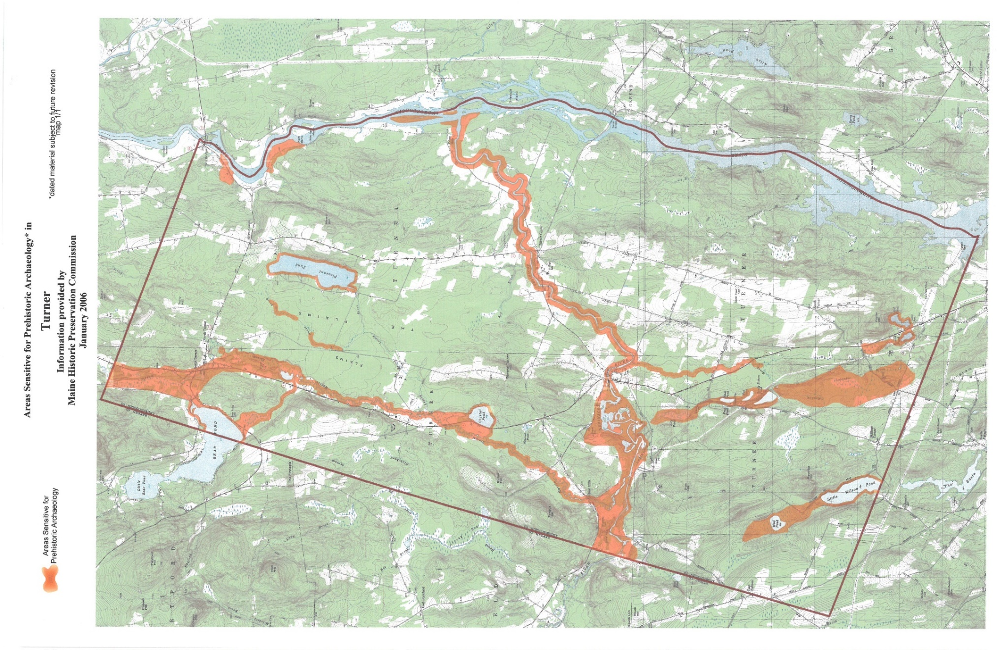

LAND USE/UTILIZATION

Findings and Trends 2002 - 2018

❖ From the beginning of 2000 to the present we saw a net loss in agricultural land in Turner.

❖ From 2003 to 2017, 21 residential subdivisions were approved or pending approval with a total of 250 lots.

❖ Since 2002 there have been 17 new structures constructed for businesses along Route 4.

Introduction
A major element of the Comprehensive Plan is the analysis of the use of land and existing development patterns. Through such an analysis, insights into community functions, spatial relationships, past and current priorities and future directions are possible. Current land use patterns and expected future development trends are cornerstones in the development of policies and strategies which will shape Turner’s future land utilization characteristics.

Turner has a total land area of approximately 62 square miles and is the largest geographic community in Androscoggin County. The Town partially developed as a manufacturing community based upon its natural resources and agricultural products. Water from the Androscoggin and Nezinscot Rivers powered the mills that transformed raw materials into various products. By the early 1900's, the manufacturing economy had declined. However, the importance of agriculture continued. While, today’s land use patterns are still reflective of the importance of agriculture low density residential development has become much more prominent.

Agricultural Land Use
Agricultural land use has been historically the most prevalent use of land other than woodlands in Turner. Agricultural land use includes those lands currently utilized to produce agricultural commodities such as croplands, pasture lands, orchards, farmsteads, and at one time, one of the largest egg farms in the nation. Forest lands or woodlands closely associated with agriculture are considered as an individual land use category for the purposes of the Plan. It is difficult to specifically identify the total land area utilized for agriculture in Turner.

Several past studies and discussions with agricultural landowners, provide insight into the significance of Turner’s agricultural land utilization. In a study published in March 1981 based upon 1977 aerial photography, 5,087 acres of agricultural land use was identified in Turner.

The 1982 Study of Farmland Conversion in Nineteen Maine Communities published by the Maine State Planning Office reported that Turner had 8,698 acres of open land in 1981. That same report found that Turner had a net gain of 515 acres of agricultural land between 1964 and 1981. This gain was calculated based upon 827 acres of new land cleared with 650 acres attributed to DeCoster Egg Farm operations. Over the period, 312 acres of available agricultural land were reported lost, thus a total gain of 515 acres was realized.

Between 1980 and 1990, additional lands were cleared for agriculture, although the exact amount is not known. During that period, land once used for agricultural purposes was converted to other uses, including residential and woodlands. However, in that 10 year period, it is estimated that there had not been a net loss in agricultural land.

The decade of the 90's saw a net loss in agricultural land in Turner. That loss is contributed to residential development through the subdivision of land and individual lot development on land formally used for agricultural purposes. Thirteen subdivisions with a total of 110 individual lots were approved in the 90’s in areas formerly used for farmland. The land area subdivided and removed from agriculture exceeded 400 acres. In addition to subdivided land, there have been more than 30 new individual residential lots created on land formally used for agriculture. In total it is estimated that more than 500 acres of land was converted from agriculture to residential uses between 1990 and 2002. The greatest loss of agricultural land was in orchard land and the more marginal crop and hay lands.

The majority of land utilized for agriculture is situated in the eastern half of Turner. Upper and Lower Streets, which follow a long ridge, are major centers of agricultural land use. In addition lands along the banks of the Androscoggin and Nezinscot Rivers are major agricultural areas. The Turner Plains area contains the site of the 1,200 acre DeCoster Egg Farm. A small portion of the site is used for the production of eggs, their processing and shipping. The remaining land area was used for crop production or remains forested.

As of 2017, many changes to agricultural have occurred. There are fewer active farms. With the loss of prime agricultural field to development, these remaining farms are relying on less land or reclaiming old overgrown, less productive fields. Some are creating new fields or orchards from forested areas. Instead of each farmer investing in tractors and equipment to manage these fields, there has been a move to a central farming operator. The Hood Family has invested in larger farm equipment which can harvest more acres faster. Hood Farm LLC can now manage fields and crops for many of the existing farm operations.

The impact on the entire agricultural community of the current and future operations at DeCoster Egg Farm cannot be underestimated. Since the last Comprehensive Plan update in 2006, the farm has been leased by different operators. Under these tenants, egg production at the farm has been significantly reduced. Many barns are now empty and may never be able to be used again to house chickens. Less chickens, means less manure for area farms. Given the loss of prime agricultural fields, farmers need to maximize crop production on the remaining fields they have. Without the chicken manure, they will need to rely upon expensive commercial fertilizers to grow the crops they need. Turner is also beginning to see a growth in organic farming practices. These new farming practices will be significantly impacted if egg production at DeCoster is further reduced in the future.
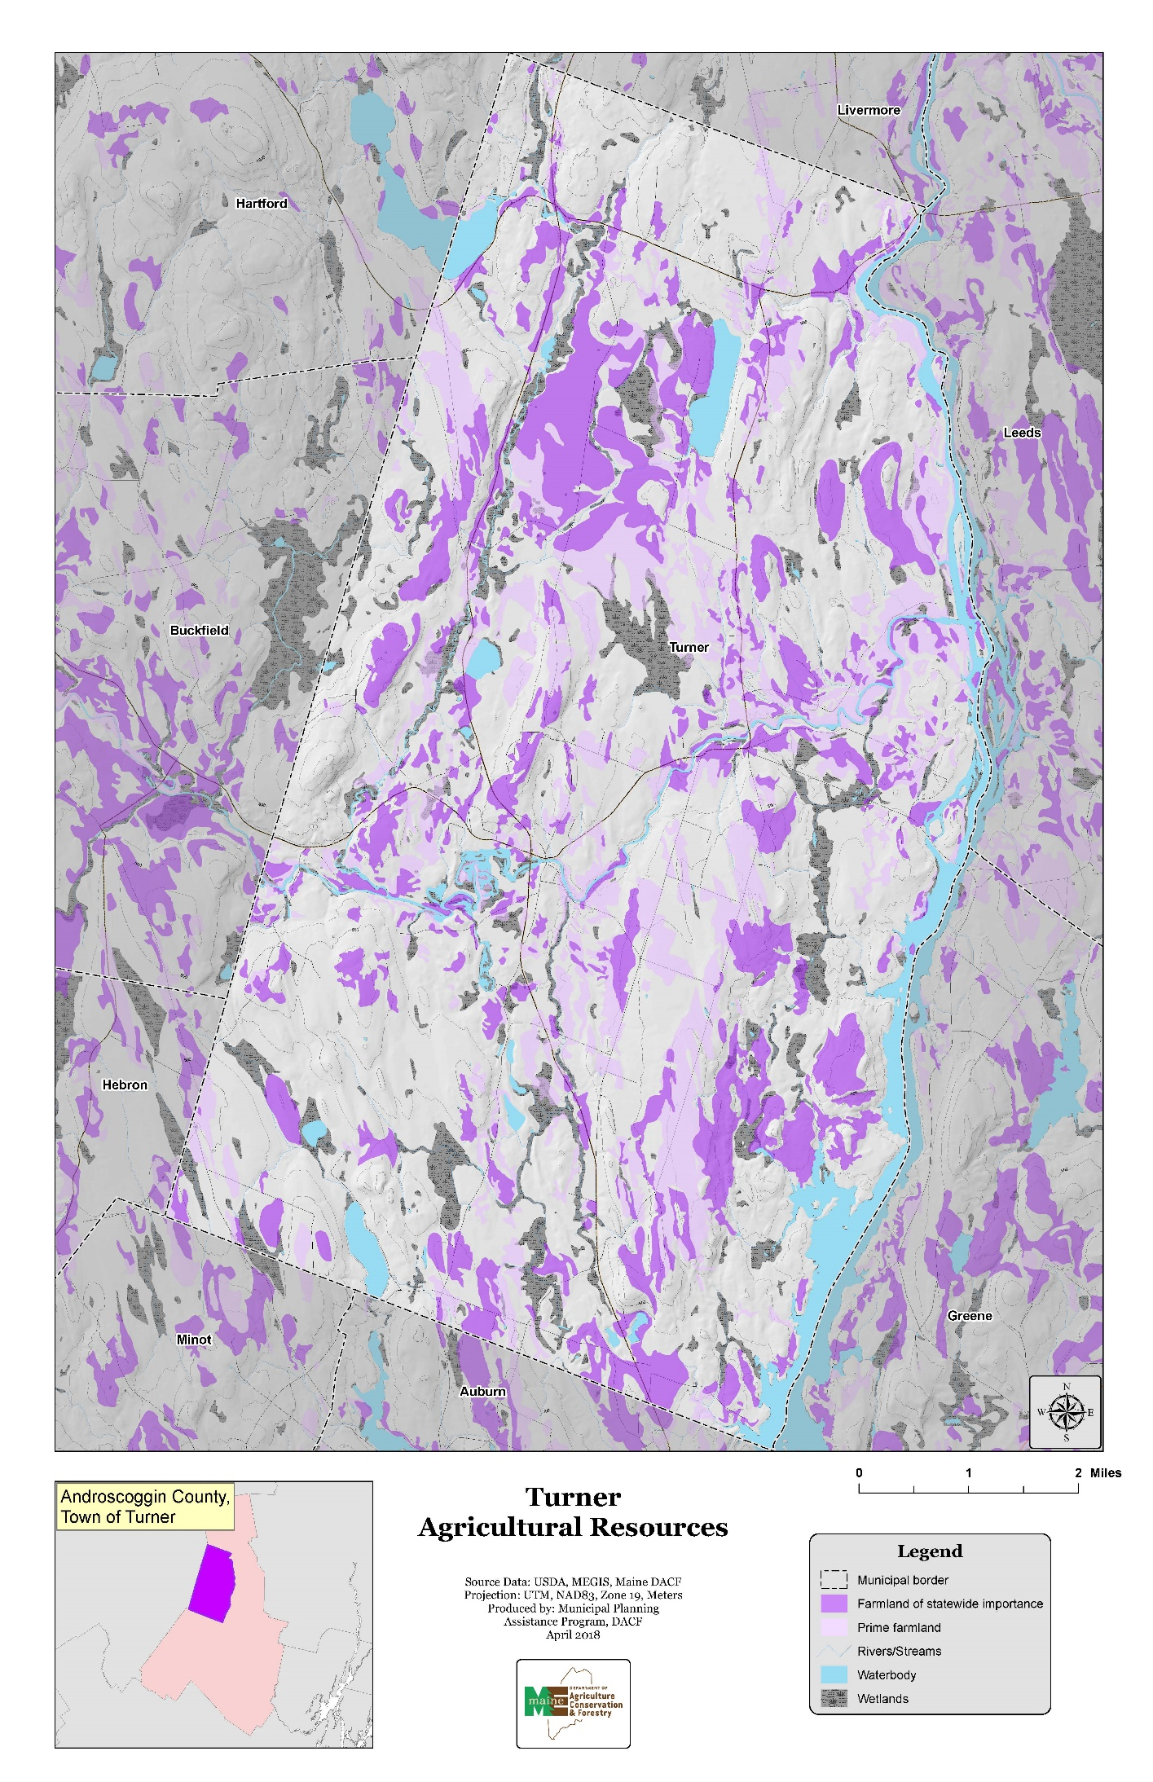
Forested Land

Forest or woodlands cover the majority of land in Turner. It is estimated that some 30,000 acres are covered by trees at various stages of maturity. These woodlands provide raw material for the pulp and paper industry, and the lumber industry. They are also important recreation resources and wildlife habitats and protect the quality of water in our ponds and streams. It is estimated that there are some 5,000 acres of forest land under active management in Turner. Much of the remaining forest land has been or will be harvested sometime in the future.

Information provided by the Maine Forest Service indicates that from 1991 to 1999 timber was harvested from 6,313 acres in Turner. There were 4,858 acres of selection harvest, 377 acres of shelter wood harvest and 76 acres clear-cut. In addition, there were timber stand improvement on 318 acres and 237 acres of woodland changed to a use other than forestry. Between 2000 and 2018, there was a total of 9,427 acres harvested in Turner. There were 8,926 acres of selection harvest, 1,466 acres of shelter wood harvest and 39 acres of clear cut. A total of 249 acres of woodland was changed to a different land use.

Residential development has resulted in the loss of commercial woodland. Between 1990 and 2002 fifteen subdivisions were approved with a total of 105 lots in forested locations. In addition, it is estimated that 60 homes were constructed in forested locations. Between 2003 and 2017, only 22 subdivisions were approved with a total of 250 lots or condominium dwelling units. Thirteen of the approved subdivisions will result in the loss of forested areas, the others occurred within prime agricultural fields or created new lots within existing developed areas. Commercial woodland areas will continue to be lost in Turner where requirements place more controls to preserve the agricultural land and encourage development of homes in the wooded areas.

The 2006 plan reported that most of Turner’s woodland owners had not placed their land under the Tree Growth Tax Program which is intended to lower the amount of property tax paid if certain conditions are met. Some 2,100 acres had been registered under the program or approximately 10 percent of the total woodland.

According to data included in the 2018 Municipal Valuation Return, there are 34 parcels with a total of 2,248 acres now registered under the Tree Growth Tax Law in Turner. This report also notes that there are 16 parcels with 615 acres classified as Farm Land and 2 parcels with 224 acres classified as Open Space under the Farm and Open Space Tax Law.

Residential Land Use
The 2000 Census reported 1,977 housing units in Turner. This was an increase of 265 units or a growth rate of 15.5 percent over the 10 year period which started in 1990. Based on building permit records it is believed that an undercount of some 100 new housing units occurred in the 2000 reported count. This rate of growth represents a significant residential growth rate when compared to surrounding communities. In 2010, the Census reported 2,314 housing units for an increase of 337units which represents a 17 percent increase since 2000.

In 1993 the Town’s first zoning ordinance was adopted. That ordinance established several districts. An analysis of building permit information for the years 1995 -2001 found that the 70% of the new residential dwellings were constructed in the rural zoning districts. Review of building permits between 2007 and 2017 found that only 46% of new residential dwellings were constructed in the rural districts.
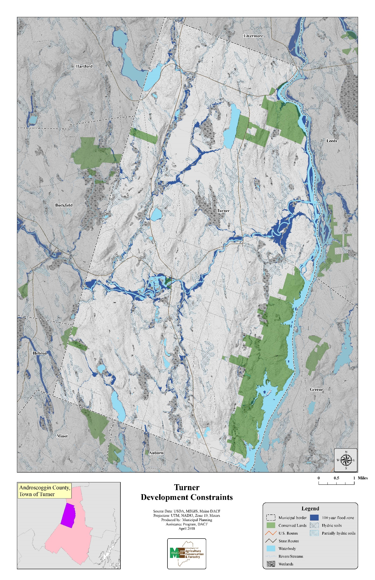
Residential Building Permits Issued By Zoning District
1995-2001

Zoning District
Year | Village | G- Res | Rural-I | Rural-II | M-Use | Shoreland | Total
1995 | 2 | 5 | 8 | 3 | 0 | 1 | 19
1996 | 4 | 11 | 19 | 2 | 0 | 0 | 36
1997 | 5 | 15 | 27 | 12 | 1 | 0 | 60
1998 | 1 | 11 | 13 | 6 | 0 | 0 | 31
1999 | 0 | 7 | 35 | 7 | 1 | 1 | 51
2000 | 3 | 4 | 26 | 7 | 0 | 0 | 40
2001 | 2 | 13 | 21 | 8 | 0 | 0 | 44
Total | 17 | 66 | 149 | 45 | 2 | 2 | 282

Residential Building Permits Issued By Zoning District
2007-2017

 | Zoning District
Year | Village | G. Res-I | G. Res-II | Rural-I | Rural-II | M-Use | Shoreland | Total
2007 | 4 | 2 | 13 | 6 | 0 | 3 | 1 | 29
2008 | 6 | 3 | 5 | 11 | 1 | 3 | 1 | 30
2009 | 3 | 3 | 7 | 4 | 1 | 1 | 1 | 20
2010 | 3 | 1 | 4 | 8 | 0 | 2 | 1 | 19
2011 | 2 | 6 | 4 | 12 | 0 | 1 | 4 | 29
2012 | 0 | 7 | 5 | 16 | 0 | 0 | 3 | 31
2013 | 0 | 6 | 7 | 5 | 0 | 0 | 2 | 20
2014 | 2 | 2 | 2 | 10 | 0 | 0 | 0 | 16
2015 | 3 | 3 | 1 | 9 | 0 | 0 | 1 | 17
2016 | 1 | 5 | 6 | 7 | 0 | 0 | 3 | 22
2017 | 0 | 4 | 7 | 10 | 0 | 2 | 0 | 23
Total | 24 | 42 | 61 | 98 | 2 | 12 | 17 | 256

Turner’s residential land use and development can be separated into several types. These include traditional compact village areas, recent low density subdivision and scattered residential development.

Traditional Compact Village Areas

Turner contains three traditional compact village residential areas. They are Turner Village, Turner Center and North Turner. These areas are comprised of older residential structures on lots ranging from 15,000 to 30,000 sq. ft. Frontages are generally in the 100' range. As many as 200 residential structures are contained in the three villages.

The 1993 zoning ordinance created a village district allowing residential lots of 20,000 square feet with a minimum frontage of 100 feet. New residential development has been minimal with 15 dwelling units reported between 1995 and 2001or 6% of the new residences constructed in this zoning district. Building permit data between 2007 and 2017 found 24 new residential units in this district or 9% of the building permits issued in this same period.

Low Density Subdivision

Since the 1990, Turner has experienced significant level of residential development in low density subdivisions. Low density subdivisions contain lots generally ranging in size from two to five acres with frontages in excess of 200 feet. While in the 1980's most low density subdivision development occurred off existing roads in wooded areas, the trend in the 1990's has been toward open fields that offer views.

From 1990 to 2002, 39 residential subdivisions were approved or pending approval with a total of 256 lots. This level of subdivision development was greater than in surrounding communities. Subdivision development has been primarily in rural areas of the town. An analysis of the subdivision development by zoning district shows that 30 of the 39 subdivision were located in the two rural zoning districts. Eighty percent or 211 new lots were created in the rural I and rural II zoning districts.

Residential Subdivision by Zoning District-1990-2002
Zoning District | # of Subdivisions | # of Lots
Village | 1 | 8
General Residential | 7 | 33
Rural I | 23 | 138
Rural II | 7 | 73
Mixed Use | 1 | 4
Totals | 39 | 256
Source: Town of Turner

Although low density subdivision development has occurred in a number of areas, several concentrations exist. These include south east Turner, General Turner Hill, adjacent to the Center Bridge Road and the Howe’s Corner area.

Residential Subdivisions by Zoning District – 2003 to 2017
Zoning District | # of Subdivisions | # of Lots
Village | 1 | 11
General Residential | 10 | 90
Rural I | 10 | 148
Rural II | 0 | 0
Shoreland | 1 | 1
Totals | 22 | 250

Between 2003 and 2017, only 22 subdivisions were approved with a total of 250 lots or condominium dwelling units. Records show that 148 or 59 percent of the lots are located in the Rural I district and there were no lots created in the Rural II district. During the same period, 90 lots or 36 percent of the total were created in the General Residential District and 11 lots or 4 percent were created in the Village District. When these subdivisions are plotted on a town wide map, they appear scattered throughout the Town. There are no obvious development concentrations. Six of the approved subdivisions will result in the loss of prime agricultural fields; the others occurred within forested areas or created new lots within existing developed areas.

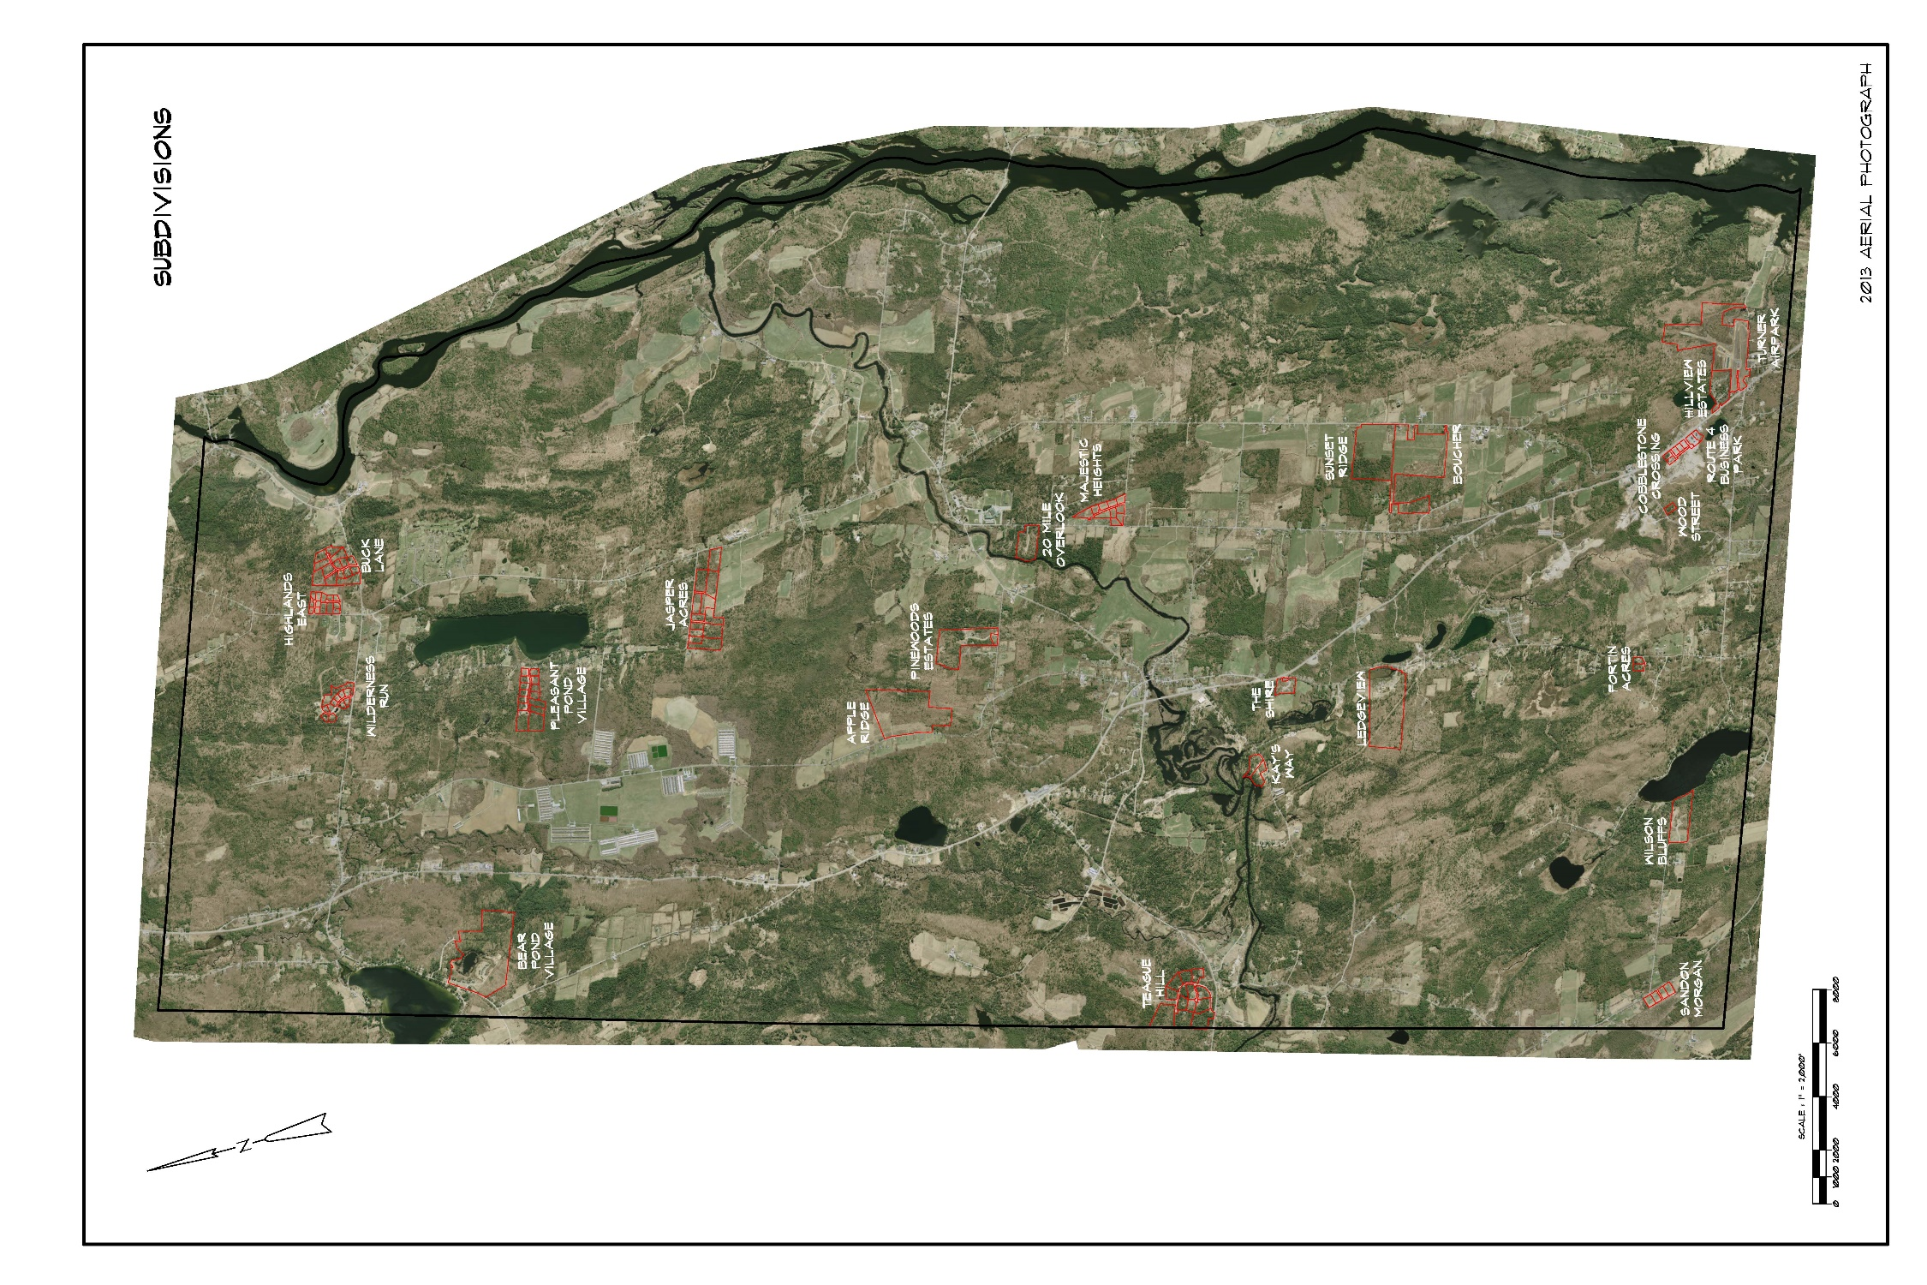
Scattered Residential

Scattered residential development is residential that takes place on individual lots or lots not in a subdivision. Individual lot sizes range from less than an acre to more than five acres. Since 1990, this type of residential develop has occurred adjacent to most public roads and has accounted for the majority of new development.

A review of the 2007 to 2017 building permits issued for new home construction indicates that 59% of new home construction occurred on individual lots scattered around the Town. Only 41% of the new home construction occurred on approved subdivision lots. While all scattered lot development is occurring along existing public roads, there appears to be an increase of backlot development with small private access roads or driveways.

Commercial Land Use

The importance of Turner’s village areas for commercial use has diminished since the time when 19 separate retail or service businesses were located in Turner Village along with an electric car service. Although limited commercial land use exists today in each of the three traditional villages, Route 4 with its high traffic volumes has attracted many of Turner’s new commercial establishments.

South Turner, adjacent to the City of Auburn’s town line, is a center of commercial activity. Located here are the Turner Business Park with six businesses and 10 service related businesses.

Route 4, which has an annual average daily traffic volume of more than 10,000 vehicles has become the place of choice for commercial development. Commercial businesses are scattered along the entire length of Route 4. Since 1990, there have been 15 new structures constructed for businesses along Route 4. In addition, a number of other existing structures have been converted to commercial uses.

Since the 2006 Comprehensive Plan inventory, three commercial subdivisions have been approved. These subdivisions include Route 4 Business Park with 3 lots, Turner Airpark with 3 lots and Cobblestone Crossing with 3 lots. All of these developments are located in South Turner on Route 4. The Turner Airpark was revised to allow reconstruction of a small gas station into a larger convenience center with gas and diesel pumps, convenience store and food services.

Route 4 Business Park includes another full service convenience center, construction company and auto sales business. Cobblestone Crossing was approved in 2017 and has already been developed with a Dunkin Donuts, multi-tenant office building, tractor sales business and daycare building. Recent approvals and construction of a motorcycle training facility has completed development on all six lots of the Turner Business Park that was originally approved in 1987.

New commercial structures along Route 4, between South Turner and the Turner Village, include a multi-tenant office building near the Upper Street intersection and an auto sales lot near Meadow Brook. Turner Village has seen development of a large Hannaford Store, a Dollar General and a credit union. Just north of Turner Village, you will find a snowmobile parts supply shop, a marijuana grow facility and a multi-tenant commercial building at the intersection of Tidswell Road. There has been no new commercial business development north of Tidswell Road, but there is a major expansion underway at Scott’s Recreation facilities just south of North Turner Village. Only two or three other commercial related building permits were issued in other areas of the Town since 2003.

Industrial/Manufacturing Land Use

Today Turner does not contain major amounts of industrial/manufacturing land use. Several saw mills exist in the community and are located along Route 4 between Turner Village and the Turner/Livermore town line.

Although not traditionally considered as manufacturing, several of the agricultural processing facilities in Turner have been considered in a broad manufacturing/industrial classification. These include the area of the DeCoster Egg Farm which cleans, packs and ships eggs, and apple storage and packing facilities.

Marijuana stores, cultivation, manufacturing and testing facilities have seen a significant increase in the town. As a result of the influx of these establishments the Town passed an ordinance on May 22, 2021 to regulate and permit/license these businesses.

Institutional Land Use

The major area of institutional land use is the School Administrative District property located in Turner Center. The area includes some 75 acres of developed and undeveloped land. In total acreage, institutional land use comprises a small portion of Turner’s total land area. Other than the SAD property, small areas of land are devoted to the Town Office, fire stations, post offices, and other public buildings

Since the 2006 Comprehensive Plan update, there have been no additional school expansions in Turner Center. A new Town Office has been constructed at the former Town Office site in Turner Village and the fire house has been expanded to include the Town ambulance and EMT services.

Undeveloped Land

Undeveloped land is land that is not utilized for agriculture, residential, commercial, manufacturing/industrial or institutional land uses. This land may be in forest land or commercial woodlots.

Turner contains approximately 30,000 acres of undeveloped land. Significant portions of this 30,000 acres are located between Upper Street and the Androscoggin River, between the North Parish Road/Route 117 and the Androscoggin River, and from the County Road west to the Hebron town line.

Development/Land Use Trends

Over the past 20 years Turner has experienced considerable land use change. Residential development has accounted for the most significant shift in land use over the period. This shift had been primarily at the expense of woodland, but over the past 10 years development on traditional agricultural land has occurred.

It is expected that demand for residential development will remain steady over the next ten years, with about 250 new or replacement homes needed to meet that demand. The level of residential development is expected to be above that of adjacent communities over the next decade. The economy and market conditions may reduce the rate of growth that occurs. However, the rate of residential development will continue to exceed that of adjacent communities.

Commercial development and growth have increased about 35 sites over the past ten years and is expected to continue to grow at a similar rate over the next ten years. Turner’s population has attracted service related businesses to the community. Current and future population growth in Turner and the towns adjacent to Turner will create an additional demand for these services.

Route 4 has been a desired location for new and expanded businesses. Wooded areas and marginal agricultural land along this corridor have been converted to commercial use. Although commercial densities have not become significant, there is a definite trend towards a “commercial strip” along Route 4, particularly from the Auburn-Turner town line to Turner Village. Commercial land use will continue to expand adjacent to Route 4 over the next ten years. Existing zoning regulations with requirements for shared access points and State MDOT requirements for driveway separations and sight distances will protect Turner from the “commercial strip” type of development seen along Route 4 in Auburn. In addition, commercial ventures will seek locations adjacent or within Turner Village due to the existing and projected population concentration. The Plan recommends several new locations for commercial type development based on a desire to locate such development in centralized locations and near major transportation corridors. The plan has also proposed to place any shoreland areas adjacent to the existing commercial districts in the shoreland commercial districts allowed under the State of Maine minimum guidelines for shoreland areas. Zoning changes should allow commercial activities in these areas similar to the uses allowed in the existing adjacent zoning districts.

Industrial land use is presently minimal in Turner. The fabrication and manufacturing of goods is centered in Lewiston and Auburn where municipal services such as water and sewer are available. Turner’s industrial land use area is centered at the egg processing and packing facilities at DeCoster Egg Farms. Land devoted to industrial use will remain minimal over the next ten years.

Although small industrial type firms, with less than ten employees, may locate in Turner, they will not have a significant impact on land utilization. It is expected that these firms will locate adjacent to Route 4 or with easy access to it.

Agriculture is important in Turner and with that strength significant changes in agricultural land use patterns have not occurred. While it is believed that agriculture will remain strong in Turner, farmers are seeing more development on and adjacent to their agricultural land. It is expected that this trend will continue.

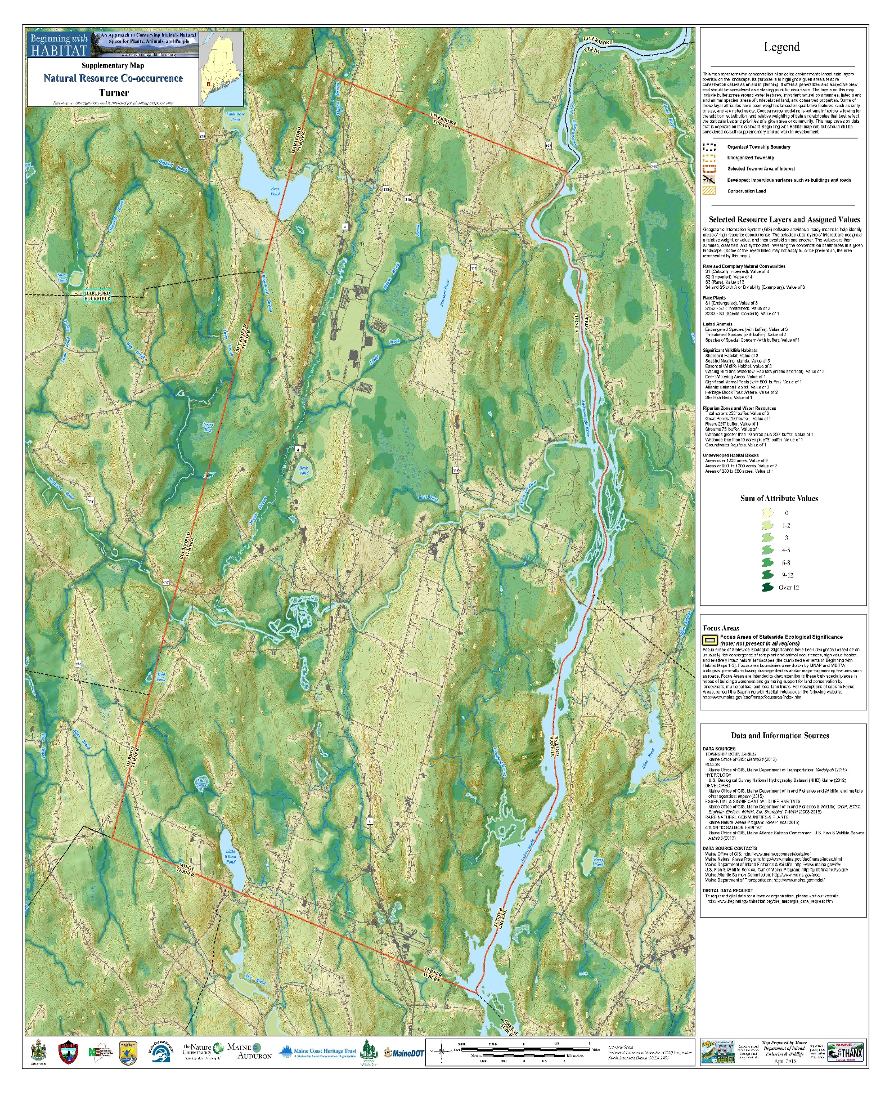

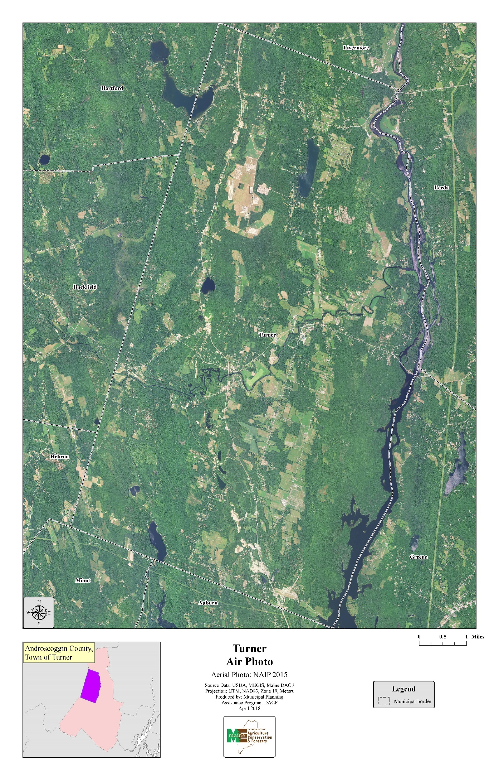
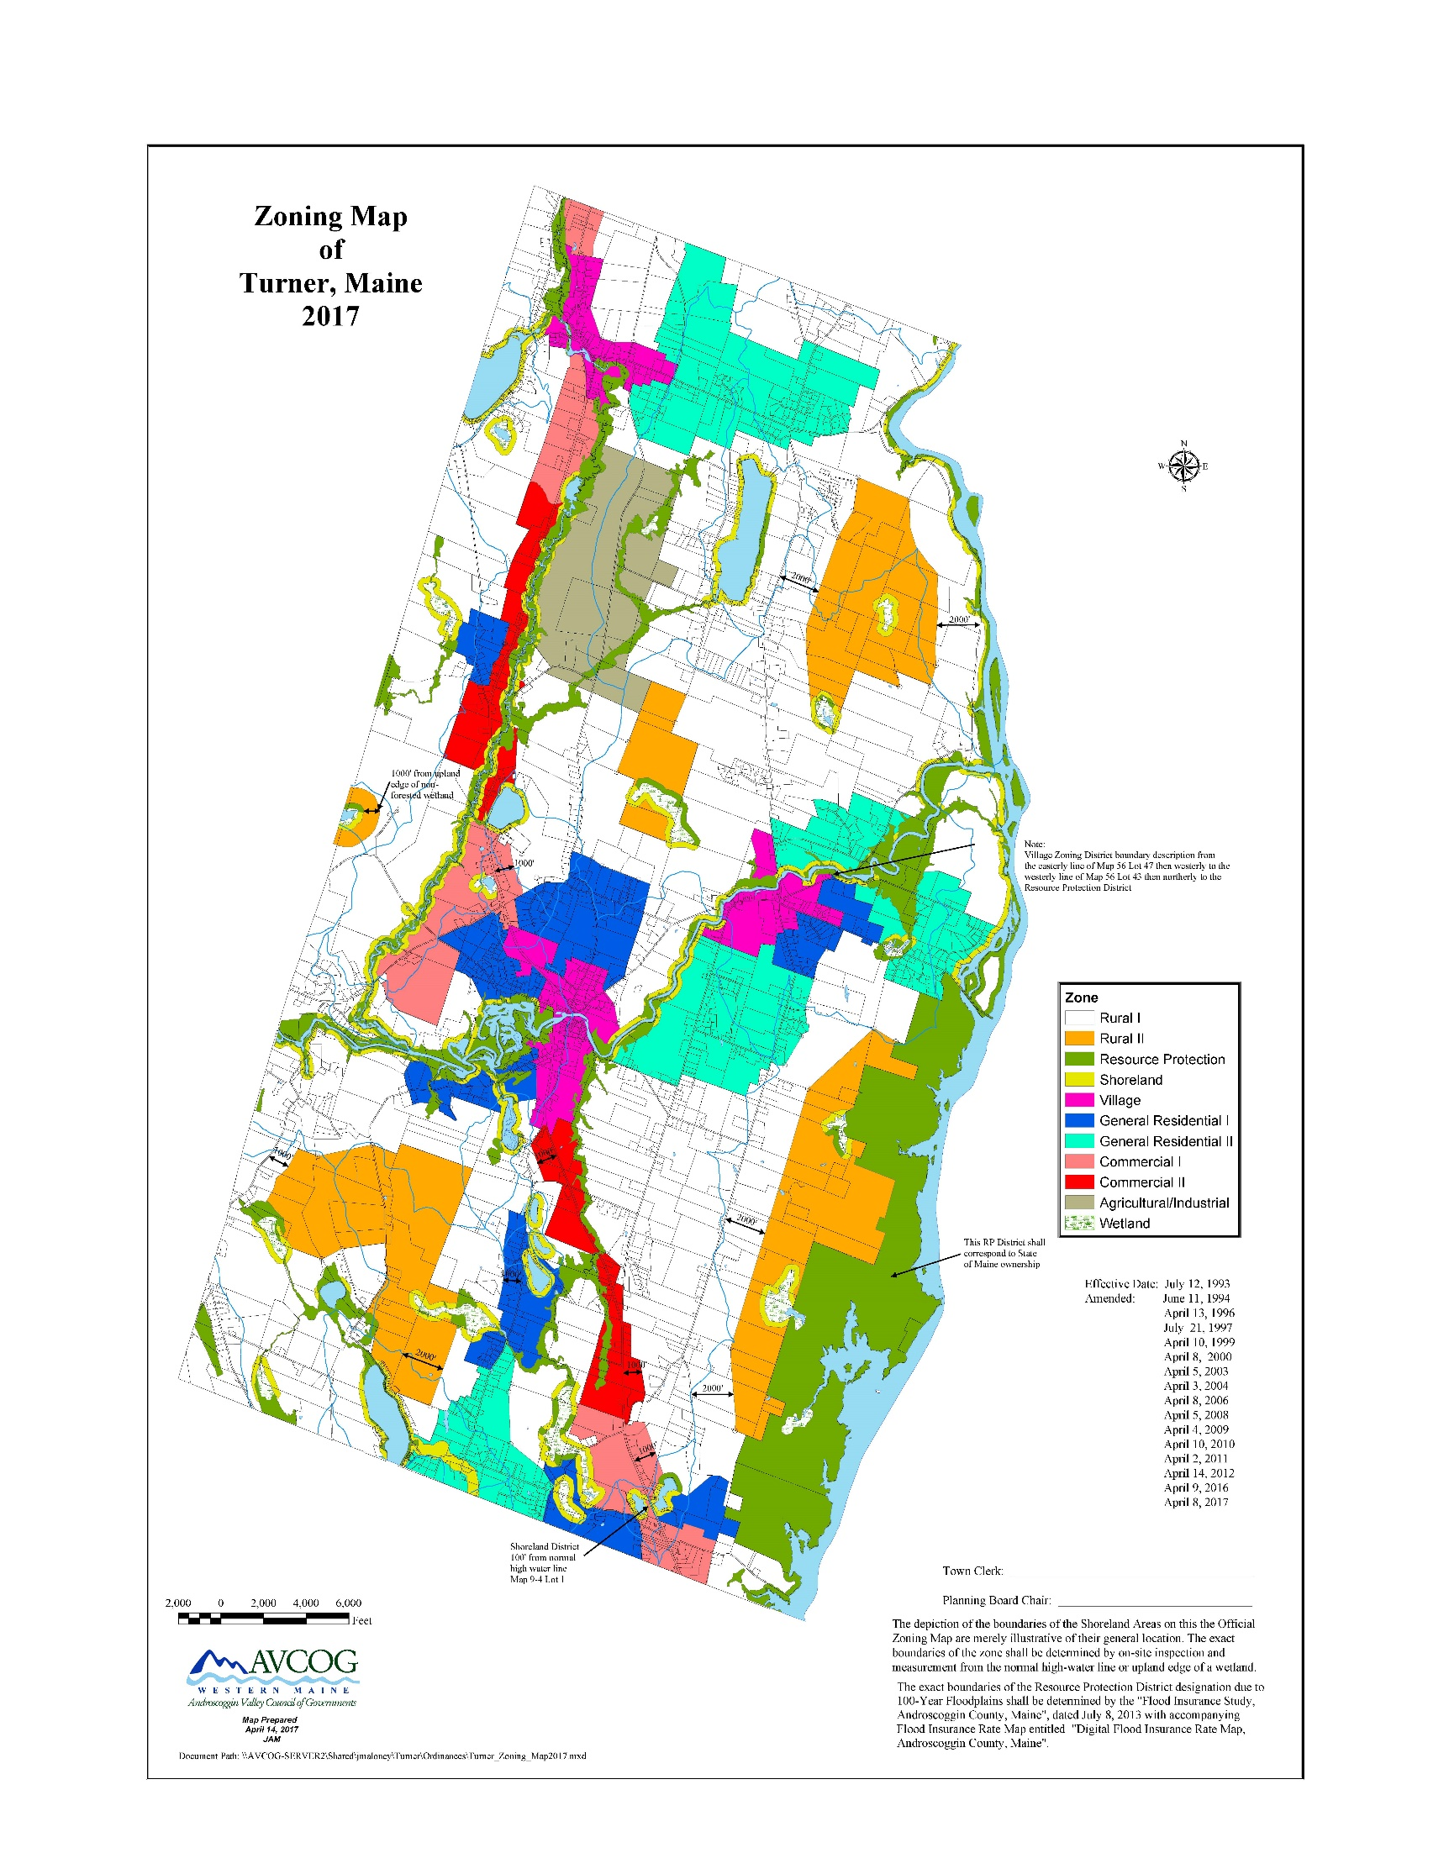
HOUSING

Findings and Trends 2002 - 2018

❖ The number of year-round homes increased by 26% (484) between 2000 and 2010.

❖ From 2007 to 2017, 256 building permits were issued for new residential homes.

❖ The average sale price of a home increased from was $110,900 in 2000 to $210,000 in 2017.

❖ Based on the prior ten years we expect there to be a growth of 250 new residential homes over the next 10 years.

Introduction

Housing characteristics within a community are an important consideration of the comprehensive plan. The documentation of housing development trends, availability of housing, its affordability and condition are important planning considerations. This information will allow decisions to be reached concerning the need for additional housing, provisions for affordable housing and the need for a mixture of housing types.

Housing Trends

In 2000, the Census reported 1,977 total housing units, 1,830 year round and 147 seasonal, in Turner. Since 1980, some 600 new year-round housing units have been added to the Town’s housing stock as reported by the 2000 Census. The 47% increase in year-round housing units between 1980 and 2000 was similar to surrounding comminutes that have experienced sprawl over the prior 20 year period.

Number of Year-Round Housing Units
1980-2010

 | 1980 | 1990 | 2000 | 2010 | Percent Change 1980-2010
Turner | 1,245 | 1,558 | 1,830 | 2,314 | 85.9%
Buckfield | 463 | 614 | 668 | 721 | 55.7%
Greene | 986 | 1,277 | 1,525 | 1,534 | 55.6%
Leeds | 460 | 599 | 776 | 804 | 74.8%
Livermore | 630 | 769 | 683 | 721 | 14.4%
Androscoggin Cty. | 37,208 | 42,615 | 44,532 | 47,651 | 28.1%
SOURCE: 1980, 1990, 2000, 2010 Census

Change in of Total Housing Units
1990-2010

 | 1990 | 2000 | 2010 | # Change | % Change
 |  |  |  | 1990-2010 | 1990-2010
Turner | 1,707 | 1,977 | 2,481 | 774 | 45.34%
Buckfield | 633 | 715 | 832 | 199 | 31.44%
Greene | 1,277 | 1,525 | 1,802 | 525 | 41.11%
Leeds | 670 | 856 | 1,018 | 348 | 51.94%
Livermore | 919 | 1,066 | 1,094 | 175 | 19.04%
Androscoggin | 43,815 | 45,960 | 49,090 | 5,275 | 12.04%
SOURCE: 1990, 2000 & 2010 Census

The report of the 2000 Census regarding the number of new housing units is somewhat suspect. An under count could have occurred considering that between 1995 and 2000 town records indicate that building permits were issued for 238 residential dwellings. This number is only 60 less than the Census reported total for the 1990 - 2000 period. Between 2007– 2017, the Town of Turner issued 256 building permits for new home construction.

Type of Housing Unit

Turner’s housing stock is comprised primarily of the traditional year-round, single-family home. In 2016, 70.7% of the total housing stock was single-family. The percentage of the tradition single family home decreased between 2011 and 2016 due to the rate of increase in mobile homes reported by the Census. The number of mobile homes increased by 65 or 13% between 2011-2016. Mobile homes comprised approximately 19% of the housing stock in 2016. Multi-family dwellings or apartments and seasonal dwellings comprised a small share of the total housing stock in 2016, 8.3% and 2.2%, respectively. When compared to Androscoggin County’s housing stock, Turner had a higher percentage of single-family dwellings and a much lower percentage of multi-family dwelling units. The urbanized center of Lewiston/Auburn greatly influenced the County’s 39% multi-family housing stock composition. More rural communities typically contain a small percentage of multi-family housing units due to a historical lack of demand and the constraints to developing such housing.

Between 2011-2016, the percentage of total housing units consisting of the traditional single-family home has decreased. This shift was caused by an increase in the number of mobile or manufactured homes. Multi-family dwellings increased by 31% between 2011 and 2016.

Distribution of Housing Units by Type
Turner, 1990 - 2016

 | #1990 | 2000 | 2011 | 2016 | % Change 1990-2016
Single-family | 1,135 | 1,439 | 1,993 | 1,863 | +64.14
Mobile home | 432 | 387 | 428 | 493 | +14.12
Multi-family | 140 | 144 | 151 | 219 | +56.43
Seasonal | 149 | 147 | 136 | 60 | -59.73
TOTAL | 1,707 | 2,117 | 2,572 | 2,635 | +54.36
SOURCE: 1990-2010 Census; American FactFinder

Owner/Renter Patterns

Traditionally rural communities typically have a much larger percentage of owner occupied dwelling units than renter occupied dwelling units. This is due to the large percentage of the overall housing stock consisting of the single-family home. In 2016, 85.9% of all housing units were owner occupied and 14.1% were renter occupied.

Distribution of Occupied Housing
Units by Tenure
2016

 | Owner |  | Renter
 | # | % | # | % | Total
Turner | 2,002 | 85.9 | 329 | 14.1 | 2,331
Buckfield | 562 | 84.0 | 106 | 16.0 | 668
Greene | 321,325 | 81.1 | 309 | 18.9 | 1,634
Leeds | 710 | 83.4 | 141 | 16.6 | 851
Livermore | 702 | 78.3 | 194 | 21.7 | 896
Androscoggin Cty. | 28,442 | 63.6 | 16,305 | 36.4 | 44,747
SOURCE: American Community Survey
NOTE: These numbers do not include vacant units.

Housing Conditions

The Comprehensive Planning Committee did not undertake a detailed housing conditions survey, because although scattered substandard housing exists in Turner, it was not deemed a significant planning issue. However, several indicators of housing conditions from the 2016 American Fact Finder information were examined.

One indicator of the overall physical condition of a community’s housing stock can be its age. However, caution must be exercised when age is considered as an indicator of physical condition. Many of Turner’s older homes are in excellent condition and are assets to the community. The older dwelling units may be in need of energy efficiency and/or electrical upgrading.

In 2016, 17.2% of the total occupied housing supply was constructed earlier than 1960 and 40.9% had been constructed between 1960 and 1990. Seventy Six percent of the town’s occupied housing units have been constructed since 1970.

Date of Construction of Housing Units
2016

Year | Number | Percent
2010 or later | 102 | 3.8
2000-2009 | 531 | 20.2
1990-1999 | 470 | 17.8
1980-1989 | 493 | 18.7
1970-1979 | 401 | 15.2
1960-1969 | 185 | 7.0
1940-1959 | 107 | 4.1
1939 or earlier | 346 | 13.1
SOURCE: 2016 American FactFinder

Overall, the indicators point toward the Town’s housing stock being in good condition. Although structurally substandard dwelling units are found in Turner, there is not a significant community problem with substandard housing.

Housing Costs

The cost of purchasing or renting a home has increased significantly in recent years throughout Maine. Increased housing costs are also evident in Turner. Numerous factors have led to these increased costs; including land costs, construction cost and market demand for housing in Turner. Turner’s attractiveness for residential development has been a factor in increased housing costs over the past 10 years.

The real estate transfer tax declaration forms provide sale prices of all homes sold. Turner’s average sale price of homes in 1989 was $95,400 and had risen to $110,900 by 2000. In 2017, the average home selling price has increased to $210,000.

Average Sale Prices of Homes
1989-2017
Turner, Maine

Year | # of Sales | Average Sale Price
1989 | 33 | $ 95,400
1999 | 37 | $94,600
2009 |  | $170,000
2010 |  | $169,900
2011 |  | $185,000
2012 | 50 | $155,500
2013 | 52 | $139,900
2014 | 46 | $155,350
2015 | 59 | $166,000
2016 | 83 | $180,000
2017 | 74 | $210,000
SOURCE: Maine State Housing Authority

Rental Rates

A detailed rental rate survey was not conducted as an element of the prior comprehensive plan. Due to the rural nature of Turner our available rentals are not a typical apartment and range from mobile homes to larger homes with the current rates ranging from $800 - $1,500 per month.

Vacancy Rates

Turner’s vacancy rate for year-round dwelling units has been estimated to be approximately one percent of the total year-round housing stock. Rental units in Turner are limited and current vacancy rate of less than one percent have also been estimated. A vacancy rate of 5% is generally seen as necessary to provide housing opportunities within a community. The high rate of home ownership and lack of vacant housing make it difficult for new families and/or workers to reside in Turner.

Affordable Housing

Increases in land costs, construction costs and financing costs, coupled with market conditions have created a significant affordable housing problem in the southern portion of Maine. The general “rule of thumb” states that housing should be able to be rented or purchased for a reasonable percentage of a household’s income. These generally accepted percentages are 28% of gross monthly income for mortgage payments and 30% of gross income for rental payments (including utilities). Affordability is typically expressed as a percentage of income, thus what is affordable to a household earning $50,000 a year will not be affordable to a household earning $30,000 or less.

Affordable housing under the Comprehensive Planning and Land Use Regulation Act has been defined as decent, safe and sanitary dwellings, apartments or other living accommodations for low and moderate income households.

The common definition defines “very low income households” as those households with an income no greater than 50% of the median income for a four-person household, “low income households” as those households with an income no greater than 80% of the median income for a four-person household and “moderate income households” as those households with an income no greater than 120% of the median income for a four-person household.

The affordable housing needs in Turner can be qualified but to quantify the specific number of needed affordable units for the current and future years is extremely difficult. A major factor in determining affordable housing need is the income of current or perspective households residing or wishing to reside in Turner. To determine affordable housing needs, the estimated median family income of $62,450 for 2017 was utilized. Based upon that data, the following table has been developed to represent affordable housing costs for very low, low and moderate income families.

Affordable Sales Price of Homes and Rental Units
For Very Low, Low and Moderate Income Families
2017

 | Family Income | Affordable Gross  Rent (mo.) | Affordable Sales Price
Very Low | up to $31,225 | $781 | $64,796
Low | $31,225 to $49,960 | $781 to $1,249 | $148,271
Moderate | $49,960 to $74,940 | $1,249 to $1,874 | Up to $254,377
SOURCE: Maine State Housing Authority

Based upon information derived from the real estate sales data, which indicated the average sale price of homes in Turner as $210,000 in 2017, housing costs are above the affordability range of many current and prospective residents that are in the very low and low income ranges. Although current rental rates are generally in the $800 - $1,500 per month range in Turner, their non-availability makes it difficult for those wishing to rent in Turner.

Turner’s regulations encourage affordable housing opportunities in Town. Mobile home parks are allowed where municipal services can support that type of development. Accessory apartments are allowed where sewage disposals can be met. Density bonuses of 10% are provided when lots or structures are affordable and can remain affordable. Mobile homes are allowed on individual lots in Town. Multi-family housing developments at greater densities are allowed in areas with suitable infrastructure. Even with these regulations, Turner has only one senior living project and there are no assisted living options available in Town.

Our review has found that most housing unit costs in Turner are above the affordability range for many current and prospective residents. This carries through for typical rental units. Area farms typically provide housing for their workers. Four mobile home parks in town provide more affordable housing options as do individual mobile homes located on standard size lots. While Turner supports workforce and affordable housing options, under current conditions, it is more likely that low and moderate income housing needs will only be met regionally.

Future Housing Demand

Turner’s population has been projected to increase to approximately 5,912 people by the year 2029. Based upon an estimated household size of 2.44 persons, some 250 new or replacement housing units will be needed over the 10-year period.

Future Housing Mix

Not only is an estimation of total new housing necessary in the comprehensive plan but also the type of housing, owner and rental. Over the next 10 years, an increased demand for rental property will develop in Turner.

NATURAL RESOURCES

Findings and Trends 2002 - 2018

❖ Although most prime farmland soils is used for production agriculture, over the past ten years there has been conversion of agricultural use to residential use.

❖ The Bear Pond and Pleasant Pond watersheds have seen the greatest amount of subdivision development of any lake watershed in Turner.

❖ Invasive aquatic plants continue to be a threat to the quality and economic value of the town’s ponds.

Introduction

The natural resources base of a community plays an important role in overall community development. Natural resources can enhance or limit the growth potential of a community. They are significant factors in the planning for a community’s future. Various natural resources can also enhance the quality of life within community.

All of the natural resources listed below have been protected since the writing of the Town’s first ordinances back in 1971. The first Comprehensive Plan in 1991 and the updated Plan in 2006 supported these protections. Our Critical Natural Resources were identified in these first two plans as Special Protection areas under their Future Land Use Plans. This plan has adopted the Critical Natural Resource term to comply with changes in the Comprehensive Plan Rules. We found no evidence that any of our critical natural resources are threatened by overuse. Turner’s current shoreland standards exceed State Minimum Guidelines for shoreland areas. Based upon public comments, this Committee has recommended that the Town Ordinances should be changed to be consistent with the uses allowed and the specific district names found in the State Minimum Guidelines for Shoreland Areas.

Topography

Topography relates to the general land form of an area. Often a locale may be referred to as mountainous, hilly or flat. Knowledge of the topographic characteristics of a community is important because of its influence on development, views and aesthetics.

There are two factors that are important when topography is considered: relief and slope. Relief reflects the height of land above sea level and surrounding areas. It identifies significant or dominant physical features that form natural barriers that hinder development or valley corridors that permit easy access. Slope, on the other hand, measures the amount of rise or fall in feet for a given horizontal distance. It is a significant aspect of land form which presents various limitations to development and other land use activities. As slopes become steeper, construction is more expensive, roads and services are more difficult and expensive to construct and maintain, and the potential for environmental degradation increases.

Turner’s general topography is a series of ridges running in a north-south direction with a broad flat plain in the north-central portion of the community known as “The Plains.”

The highest point in Turner is Teague Hill on the western border of the Town with an elevation of 827 feet above sea level. The lowest points are found along the Androscoggin River at approximately 260 feet above sea level. Local relief or the difference in elevation between the lowest and highest points is approximately 525 feet.

Slopes of greater than 15% do not cover a significant portion of Turner. They generally run in narrow north-south bands.

Soils

Soils are extremely important to community development. They are the underlying material upon which roads, buildings, sewage and waste disposal occur. Development upon or in soils that are unsuitable for proposed uses will likely increase development and construction costs, annual maintenance costs and cause environmental degradation.

Current soil mapping conducted by the United States Department of Agriculture, Soil Conservation Service indicates two main soil associations. They are the Adams-Hinckley-Ninigret Association and the Charlton-Sutton-Paxton Association. The Adams-Hinckley-Ninigret association are deep, excessively drained to moderately well drained, nearly level to moderate steep, coarse and moderately coarse textured soils. Charlton-Sutton-Paxton association are deep, medium-textured and moderately coarse textured, well drained and moderately well drained, nearly level to moderately steep soils, on hills and ridges.

Because Turner relies upon subsurface disposal systems for all sewage disposal soils are important to current and future environmentally safe development.

Soils potentials for low density development have been developed by the Soil Conservation Service and mapped as an element of the comprehensive plan. Soils potentials for low density development is a rating system to rate soils as to their potential for low density development. Basically, a local committee of knowledgeable contractors considers the type of corrective measures needed to overcome soil limitations for single-family homes with subsurface waste disposal and paved roads in a typical subdivision development. The committee addresses local costs associated with these corrective measures (such as fill, site preparation, blasting, etc.). The best soil, the one that has the least limitations for low density development is assigned a value of 100. All other soils have index points subtracted from the 100 depending on the degree of site modification needed to make the soil satisfactory for subsurface waste disposal, house building and roads. The result is a listing of the soils in the county arranged according to their potential for low density development. This approach to soil interpretation allows local people to determine costs and corrective measures needed to overcome such limitations.

It emphasizes local criteria to meet local needs. Soil potentials allow the relative quality of a soil of a particular use to be compared to other soils in the area.

Based upon the soils potential rating system and identifying soils within a three category classification system, very high to high potential, medium potential, and low to very low potential the general suitability of soils for development have been determined.

Approximately 40% of land area in Turner has a soils potential rating of low to very low for low density residential development. These areas include areas of soils with high water tables and excessive slopes. Twenty percent (20%) of the land area has soils rated as high to very high for low density residential development. Concentrations of these soils are generally located from the intersection of Upper Street and Poplar Hill Road along Upper Street to Pearl Road; north of Turner Village along the General Turner Hill Road, North of Route 219 to the Livermore town line and in the vicinity of Little Wilson Pond.

The remainder of the Town’s land area, approximately 40%, has a potential rating of medium.

Although this soils potential rating should not be used for specific development planning, it provides insight into areas which are more suitable than others for low density residential development.

Prime Farmland Soils

Prime farmland soils, as defined by the United States Department of Agriculture, Soil Conservation Service, are the best “farmlands” nationwide. Criteria for designation as “Prime Farmland” are tied directly to soil properties and not land use, except for urban land. If the land is urban or built-up, it cannot be prime farmland. Prime farmland, however, can be land in cultivation, forest, pasture or idle, and it can be remote or inaccessible. The exact number of acres of prime farmland soils has not been determined, however, a conservative estimate is that 20% of the land area of Turner is covered by Prime Farmland Soils. As would be expected, a large percentage of these soils are utilized by Turner’s farmers for crop production. The remainder of prime farmland soils are wooded or have been developed for residential uses.

Significant areas of prime farmland soils are located along Upper and Lower Streets, along the shores of the Nezinscot River from Turner Center to the Androscoggin River, the Plains and along the North Parish Road.

In Turner, conversion of prime farmland from agricultural uses to residential and commercial uses continues. While there are still large areas of prime farmland used for production agriculture, conversions has occurred along General Turner Hill Road, East Hebron Road, Blake Road, Howe’s Corner area, Route 4 and Turkey Lane.

Forest Resources

Forests provide many resource values including wood, wildlife habitat, water quality protection, fish habitat, clean air, ecological values, recreation, existence values and avian species habitat. The existence of these values happens to coincide with maintaining the rural character of the town. In fact, it is often the mosaic of fields, farms and forests young and old that creates the naturally diverse landscape. Most of the land in Turner, some 30,000 acres are forested at this time.

Soils in Turner are mostly well suited for timber production as they are for agriculture. Soils range from well drained through moderately well drained to poorly drained. Glacial outwash exists in the low land flats. Soil texture varies on topography and geographic location but most soils are sandy loams or loamy sand.

The forest types are mostly pine, oak/northern hardwood consistent with the temperate transitional type. Harvesting and/or silviculture activities totaled more than 6,300 aces from 1991 through 1999. Most cutting was selection harvest with only 1% of the harvest clear cuts. Forest in Turner were impacted by the ice storm of 1998. In fact, in some areas of town there was a severe impact. Nearly 35% of the total acres harvested between 1991 and 1999 was after the ice storm.

In 2018, there were 35 parcels for a total of 2,248 acres of forest land enrolled in the Tree Growth Program in Turner. This represents only approximately 7% of the forest land. Management incentive programs as well as increased interest in land trusts will continue.

Parcel size often is the limiting factor for woodlot management. In Turner, there are several larger tracts of intact forest that are suitable for management. Current uses include wildlife, water, recreation and wood. Forest management also includes management of several other values both socially and economically. Often it is the integration of these values that is challenging. In addition, most forested areas are regulated by individual landowner values and harvesting practices. Anywhere from ten acres up can be managed under current tree growth tax law. Smaller acreage certainly can produce many forest values as well, but management for timber production and other forest resource values for acreage less than 10 is less common. However, groups of landowners could come together and form management agreements across ownership boundaries. These larger managed areas can support numerous values including economic, cultural, wildlife, recreation, avian and ecological goals in the landscape. Forestry is a key component to create a mosaic of various successional or serial stages.

Small parcels can be managed as well for individual landowner values. Several wildlife and avian species can be promoted on these smaller lots as well as promoting individual tree species over others. The backyard maple producer makes plenty of maple syrup for family and friends.

Development can impact forest in many ways. In particular, as lot sizes get smaller and smaller over time, less management will occur. Forests will mature and be naturally pruned. This increases downed debris and disease. Wildlife species that depend on a mosaic of patches at various stages will shift to preferred habitats during certain time of the year.

Wood land is an important economic asset to Turner. It is not limited by any means. Over time, the challenge will be keeping the land working in order to maintain forest values.

Wetlands
Wetlands are important natural resources because they store large amounts of water helping to reduce flooding. In addition, wetlands provide habitat for many species of game and non-game wildlife. Filling of wetlands can significantly increase flood levels and add to the loss of wildlife habitat.

National Wetland Inventory mapping by the U.S. Fish and Wildlife Service and the Maine State Planning Office has identified 336 forested and non-forested wetlands in Turner. Of this number, 56 are 10 acres and greater. Using a geographic information system the State Planning Office characterized each wetland for its ability to provide a chosen function and value at a significant level. The functions and values assessed included hydrological function (flood flow alteration), a biogeochemical function (sediment retention), a biological function (plant and animal habitat and fin fish habitat) and cultural value (education and research). Based on the characterization the following table present the number of wetlands in each function category.

Wetland Functions
Function | Number of Wetlands Scoring ‘Yes’
Cultural | 6
Freshwater Fish Habitat | 111
Flood flow Control | 3
Wildlife Habitat | 231
Sediment Retention | 35
A second element of the State Planning Office evaluation of wetlands was the tallying of the number of each wetland functions. Based on the valuation, the greatest score possible was five. The following table presents the result of the total scores.

Wetland Function Scores
Total Score | Number of Wetlands
0 | 64
1 | 190
2 | 51
3 | 30
4 | 1
5 | 0

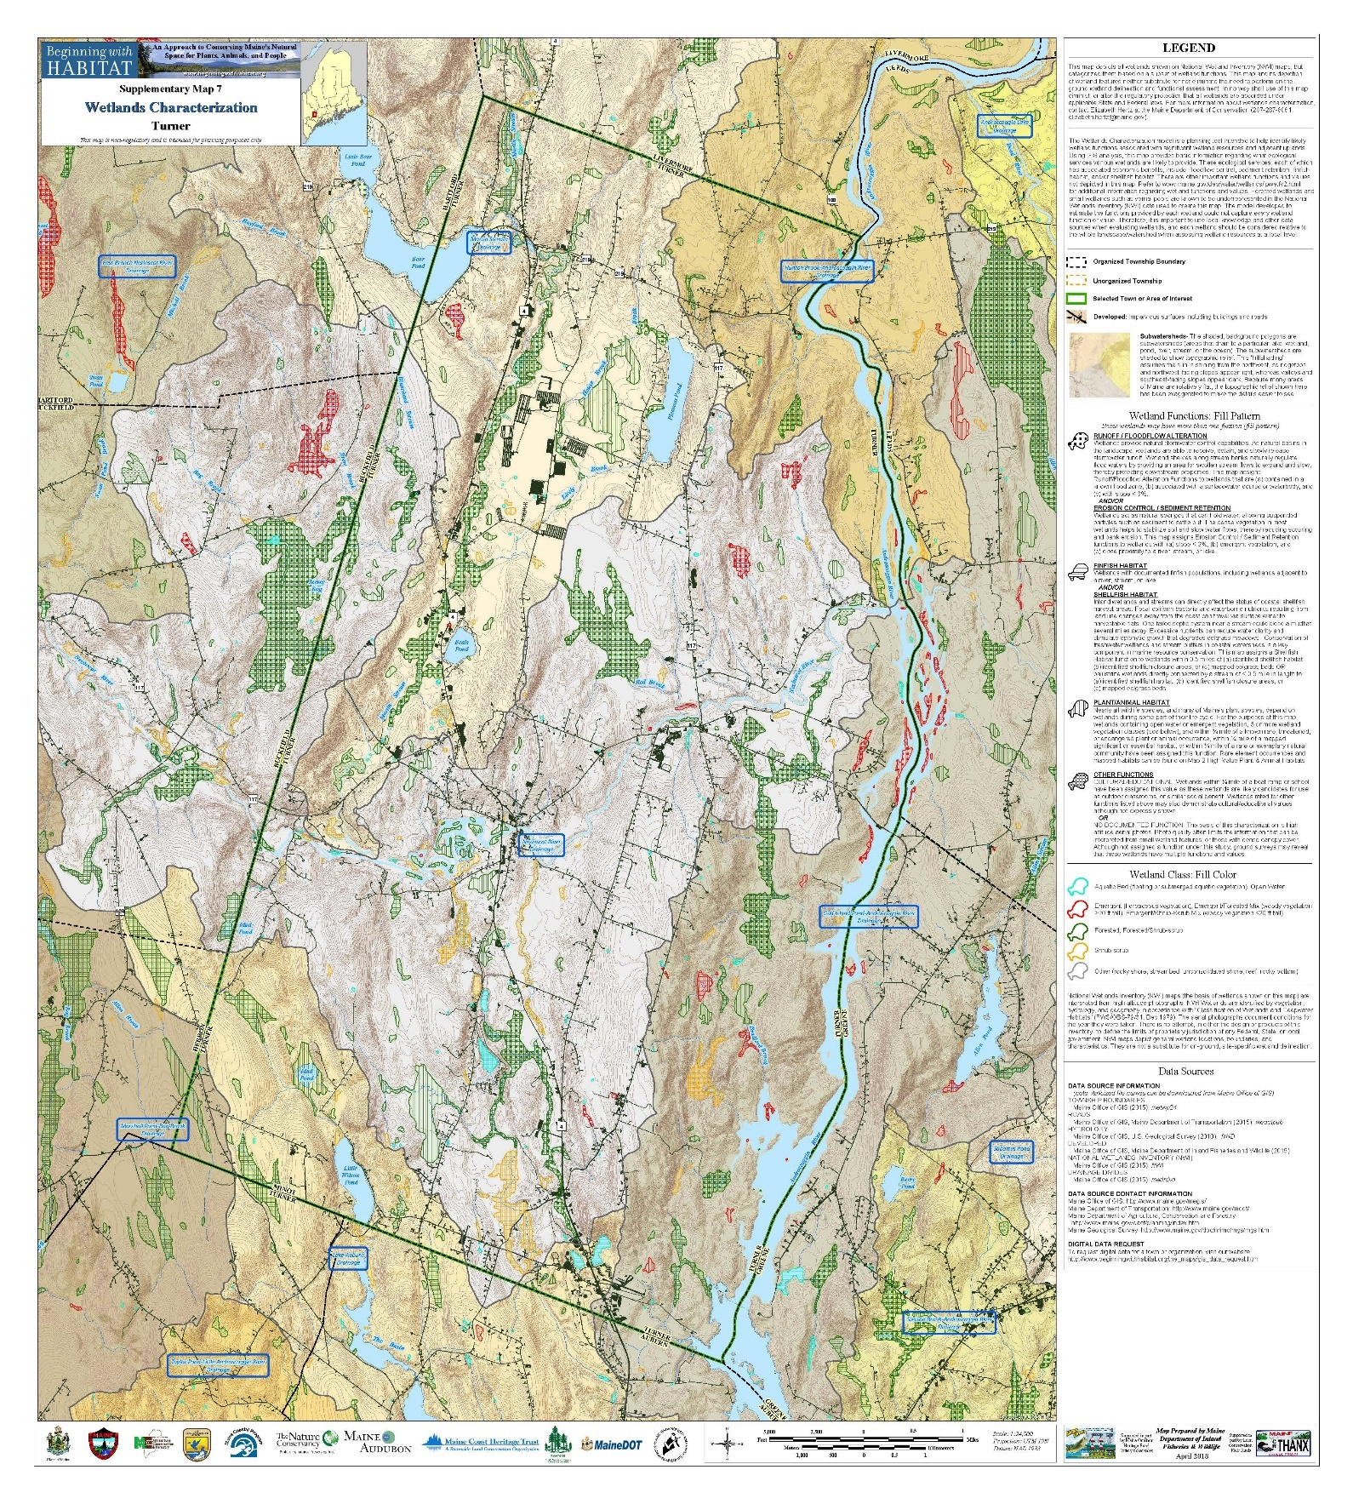
Surface Waters

Turner’s surface waters include the Androscoggin and Nezinscot Rivers, 14 ponds and lakes totally or partly located in the community and a number of streams and brooks. In earlier times, these surface waters were important to Turner’s manufacturing economy. However, today they are not major factors in the local manufacturing economy. They are, however, significant local natural resources utilized recreationally and are important factors in Turner’s overall character. While some of these water resources must continue to be monitored against specific threats to water quality discussed below, no non-point sources of pollution have been identified in Turner. Turner requires use of Best Management Practices when any construction work is done to protect these water resources. Training certifications for Public Works crews are on file at the Town Office. Contractors working in shoreland areas are also required to provide copies of their certifications prior to beginning any work adjacent to these water resources.

Androscoggin River

The Androscoggin River forms the eastern border of Turner. The Gulf Island Dam in Auburn, constructed in 1925-27, creates the largest impoundment, the Gulf Island Pond, along the river. Approximately, one half of Turner’s eastern border is along Gulf Island Pond.

The Androscoggin River has a highly regulated flow management system. A number of headwater lakes are manipulated to store water during periods of high runoff and to release water to the river stream during periods of low runoff. This flow management system was established to enhance the river’s suitability for power production and manufacturing processes. Through flow regulation, spring flows are reduced and summer flows are increased significantly above what would naturally occur.

Prior to the damming and industrialization of the Androscoggin, it was a rough and rugged river system. With an average drop of eight feet per mile, it was a raging torrent during periods of high runoff. At times of minimal runoff, the river resembled a brook at various points along its path to the sea. Prior to the changes in the river system created by man, it was naturally pure; however, even then, the river experienced siltation and contamination from organic debris.

The pulp and paper industry anchored along the Androscoggin River during the mid-1890's. The continued expansion of this industry had long-term impacts upon the economy of the river basin and the quality of its waters. Mills were constructed at Berlin, New Hampshire, Livermore Falls and Rumford; they discharged raw liquors from the sulfite pulping process to the river. As the pulp and paper industry and the economy grew, increased demands were placed upon the river to assimilate industrial and domestic wastes.

In the early 1940's, the public would not tolerate the condition of the river which gave off hydrogen sulfide gases and discolored exposed metal and paint. In a report presented to the Maine Sanitary Water Board in February, 1942, it was stated that “the pollution responsible for the objectionable conditions of the river is derived from industrial wastes and municipal sewage discharges without treatment”. It was further noted that “few streams in the United States of comparable size showed evidence of such extreme pollution”. It was estimated that the industrial discharge to the river was equivalent to that from a population of 2,411,500 people.

Since the 1940's, both industries and municipalities have constructed treatment plants which treat waste before they are discharged to the river. The river is classified as “C” as it flows past Turner, but is impaired due to dioxin, algae blooms, low dissolved oxygen, phosphorus, total suspended solids, and biochemical oxygen demand.

The Androscoggin River is one of Maine’s major industrial rivers. However, the river, in Turner, has been found to have a significant recreational potential and, as water quality improves, an even greater potential.

The Lower Androscoggin River Recreation Study and Management Plan found that the ten-mile section of the overall study corridor which begins at Gulf Island Dam and proceeds upstream to approximately two miles above the Greene-Turner Bridge, exhibits the greatest overall recreational potential within the study corridor. The large impoundment of water, some 2,000 surface acres, created by Gulf Island Dam, has a positive impact upon several recreational activities evaluated. Shoreline characteristics within this ten-mile segment are conducive as well to the majority of recreational activities evaluated.

Physical characteristics which create a high potential for the majority of the activities evaluated within the ten-mile section are many. The large impoundment of water is conducive to canoeing, power boating and boat fishing. The large islands enhance the potential for canoe camping and provide for wildlife habitat. Numerous large coves or bays are also positive influences upon canoeing, fishing, hunting and nature study due to their biological factors, which attract fish and wildlife. Shorelines within this section are primarily undeveloped which is also a positive factor to the potential of many activities evaluated. The Committee believes the community needs to promote these opportunities and better use of this river.

While promoting these activities is important, to sustain these activities, the Town also needs to monitor the significant changes in water levels of Gulf Island Pond. Landowners have noted significant erosion issues caused by these water level changes which can lead to water quality issues or growth of evasive plants along the shoreline. The Town should pursue public or private partnerships to protect the shoreline from erosion and play an active role in any applications to relicense the Gulf Island Dam where these changes in water levels are regulated.

Nezinscot River

The Nezinscot River flows in an easterly direction bisecting Turner approximately in half and joins the Androscoggin at Keene’s Mills. The Nezinscot has a total drainage area of 180 square miles. Its sources are located in Hartford and Sumner.

The Nezinscot River is currently a Class B river under the State classification of fresh surface waters system. Class B waters shall be such quality that they are suitable for the designated uses of drinking water supply after treatment; fishing; recreation in and on the water; industrial process and cooling water supply; hydroelectric power generation, except as prohibited under Title 12, section 403; and navigation; and as habitat for fish and other aquatic life.

The Nezinscot River was a major factor in the development of Turner due to its value as a power source. Although no power is generated along the Nezinscot River, a dam at Turner Village still exists.

In 1998, the selectmen appointed the Nezinscot River Dam Committee to consider options for the dam including its removal. After study and community input, it was decided to retain the dam and to plan for minor structural improvements.

Today, the river is used primarily as a recreational resource. The river below the Turner Village dam has become a popular Brown Trout fishery as well as a white water boating area. Canoeing above the dam is popular as well. Floodplains along the river’s banks are used agriculturally. The Committee believes the community needs to promote the use of this river and provide better access to support that use.

Streams and Brooks

There are a number of streams and brooks that drain portions of Turner. They include the following:

Bradford Brook
House Brook
Lively Brook
Martin Stream
Meadow Brook
Pickerel Pond Outlet
Red Brook
Skillings Corner Brook

All of these brooks and streams currently meet Class B standards under the State Fresh Surface Waters classification system. Attainment data does vary and MDEP continues to monitor Martin Stream and House/Lively Brook.

Lakes and Ponds

Turner has all or a portion of 13 ponds within its boundaries. Several of these ponds are of medium size and both seasonal and year-round residential development is located along their shorelines. These include Bear Pond, Crystal (Beal’s) Pond, Little Wilson Pond and Pleasant Pond. A portion of Turner is also within the Lake Auburn watershed; Lake Auburn is an important cold water fishery and is the water supply for the Cities of Lewiston and Auburn. In addition, Gulf Island Pond on the Androscoggin River is a major water body which was formed in 1925 when Gulf Island Dam was constructed.

Surface Waters Characteristics
Name | Surface Area (acres) | Maximum Depth (feet)
Bear Pond | 328 | 28
Black (Snake) Pond | 7 | 36
Crystal (Beal’s) Pond | 48 | 39
Frog Pond | 2
Lard Pond | 15 | 14
Lily Pond | 19
Little Wilson | 112 | 56
Lincoln Pond (Jersey Bog) | 8
Mud Pond | 7 | 21
Mud Pond (Lake Auburn Watershed) | 23
Pickerel Pond | 5
Pleasant Pond | 191 | 68
Round Pond | 8 | 39
Sandy Bottom | 20 | 14

Various amounts of information are available on the quality of waters in Turner’s ponds. The Maine Department of Environmental Protection now collects baseline water quality data on select lakes every 5 years. The former Volunteer Lake Water Quality Monitoring Program is now a separate non-profit organization known as Lake Stewards of Maine. Volunteers with Lake Stewards of Maine also collect water quality data. Their results can be found on their website at www.lakesofmaine.org.

Based upon monitoring, Crystal Pond, Little Wilson Pond, Pleasant Pond, Sandy Bottom Pond and Mud Pond (1) are considered to be ponds most at risk by MDEP. Little Wilson Pond and Pleasant Pond are also on the MDEP NPS threatened lakes priority list.

Lakes in Maine are classified by statute (Title 38, §465-A). All great ponds and natural ponds and lakes less than 10 acres in size have a GPA classification. This classification requires values to be of such quality that they are suitable for drinking after disinfection and recreation in and on the water. In addition, there will be no direct discharges to GPA waters.

The land area that contributes water to a particular lake or pond is known as its watershed. Watershed boundaries can be identified by connecting points of highest elevation around a lake or pond and its tributaries. Rain and snow falling within this area eventually flow by gravity in surface runoff, streams and ground water to the lake or pond which is the lowest point in the watershed.

Studies over the past decade indicate phosphorus, which acts as a fertilizer to algae and other plant life in the lake, is a major threat to lake water quality. While Shoreland Zoning has provided some protection, the studies indicate phosphorus can be contributed in significant quantities from the entire watershed.

The quality of water in a lake depends on the condition of the land in its watershed. Phosphorus is abundant in nature, but in an undisturbed environment it is tightly bound by soil and organic matter for eventual use by plants. Natural systems conserve and recycle nutrients and water. Runoff from the forest is relatively low in quantity and high in quality. Water is stored in depressions and evaporates or seeps into the ground to become ground water, thereby preventing it from running over the land surface and exporting nutrients (i.e. phosphorus) from the system. Land development changes the natural landscape in ways that alter the normal cycling of phosphorus. The removal of vegetation, smoothing of the land surface, compaction of soils and creation of impervious surfaces combine to reduce the amount of precipitation stored and retained, dramatically increasing the amount of water running off the land as surface runoff. The increased stormwater runoff from disturbed land generally carries higher concentrations of phosphorus and may also exacerbate erosion and sedimentation problems.

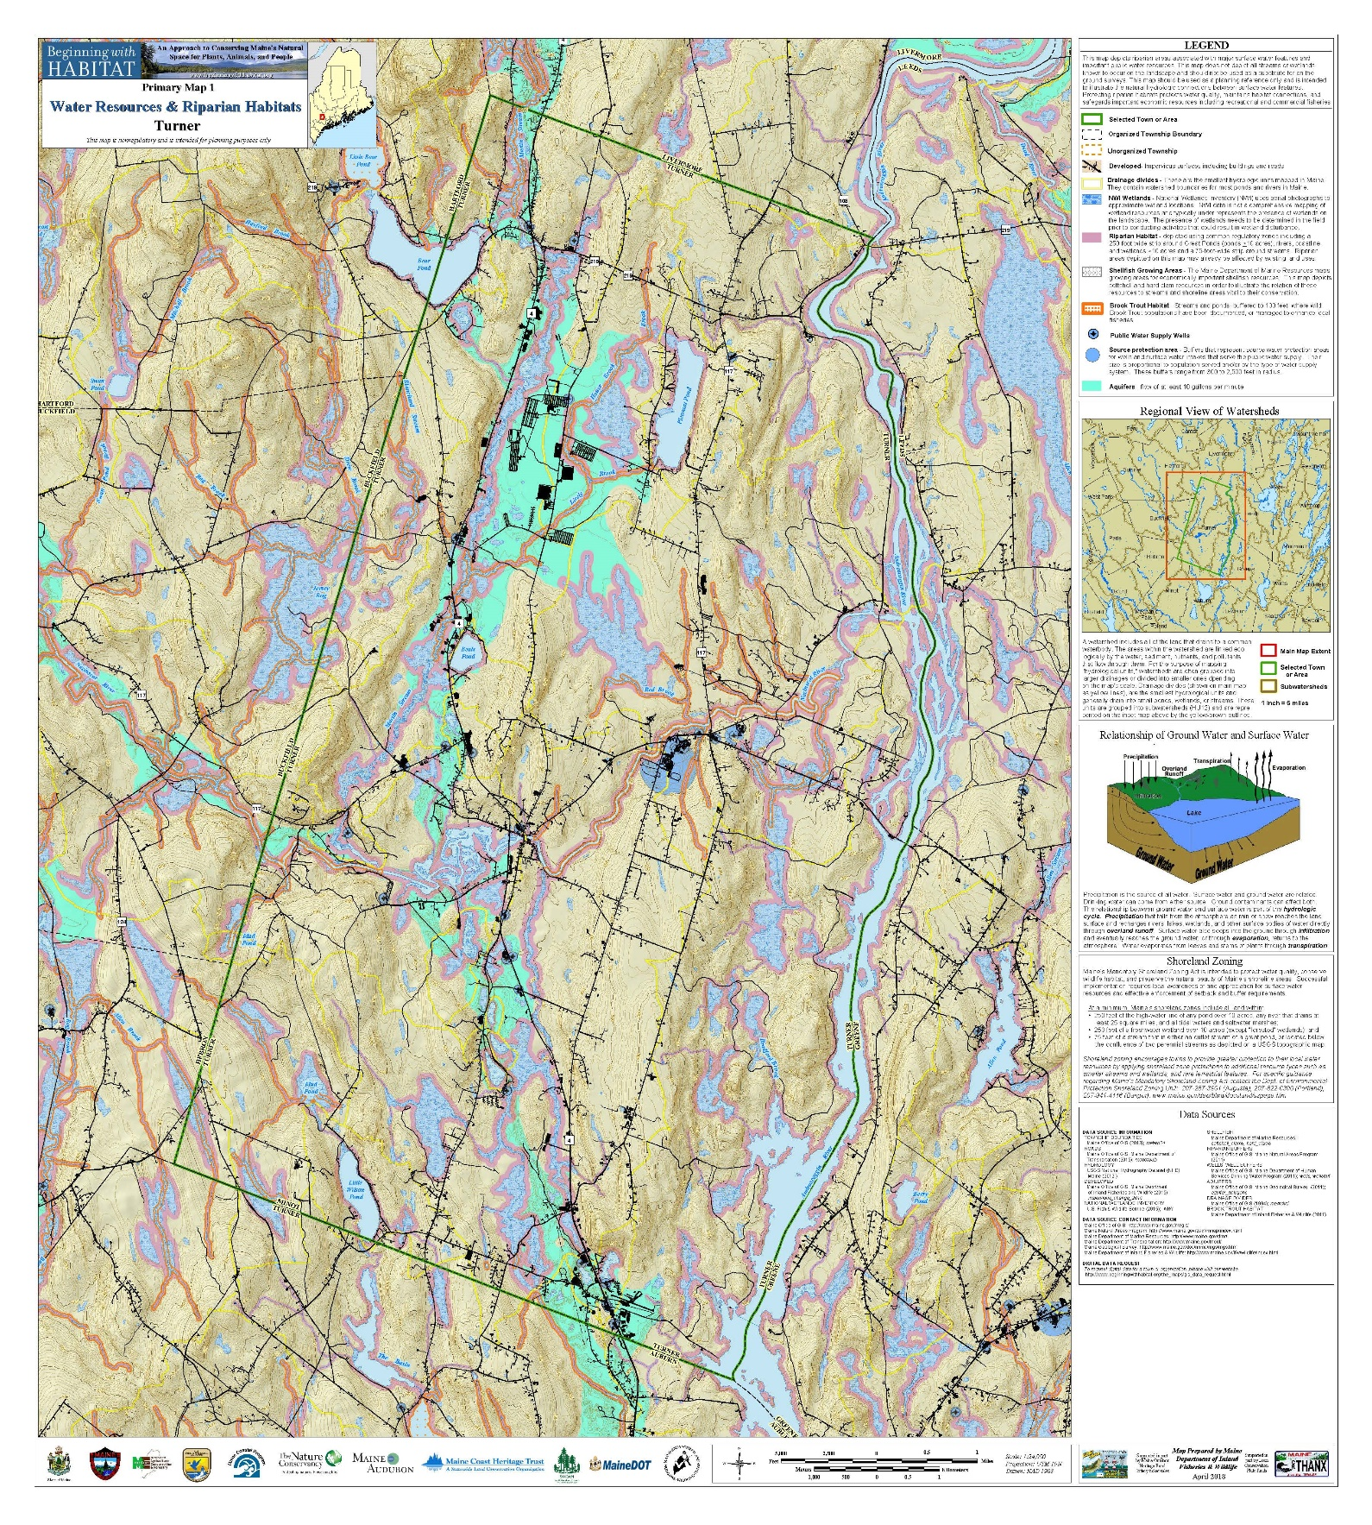
A phosphorus analysis was conducted for Turner’s ponds on which adequate data was available, and also on Lake Auburn. This information is important to make development proposals in the Town meet current MDEP stormwater rules to control stormwater runoff from all proposed projects. The following table is a listing of the lakes from the Department of Environmental Protection. It lists the name, the direct drainage area in Turner and percentage of the total watershed in Turner. It also lists the phosphorus load from land within Turner which would produce an increase in phosphorous concentration of 1.0 part per billion.

2017 Vulnerability Listing
 | Drainage Area In Turner (Acres) | % of Total in Turner | Watershed Phosphorus Load (#/ppb)
Bear Pond | 222 | 21.9 | 2.31
Blacksnake Pond | 12 | 100 | 0.13
Crystal Pond | 284 | 100 | 3.04
Frog Pond | 88 | 100 | 0.55
*Lake Auburn | 160 | 3.3 | 3.74
Lard Pond | 106 | 100 | 0.85
Lily Pond | 252 | 100 | 2.16
Little Wilson Pond | 827 | 86.8 | 7.27
Mud Pond (1) | 1519 | 63 | 8.11
*Mud Pond (2) | 44 | 52.4 | 0.39
Mud Pond (3) | 29 | 100 | 0.39
Pleasant Pond | 570 | 100 | 8.48
Round Pond | 24 | 100 | 0.35
Sandy Bottom Pond | 59 | 100 | 0.74
*The Basin | 34 | 2.3 | 0.13
* Not located in Turner
Source: Maine Department of Environmental Protection-2017
(M) MDEP Protection Level Medium
(1) North of Little Wilson Pond
(2) Mud Pond in Buckfield
(3) North of Sandy Bottom Pond

The first step in the methodology is to determine the degree of risk of a change in water quality which the Town is willing to accept for each lake. The next table is used to do this. It presents phosphorus coefficients for each Quality Category and or High, Medium, and Low levels of protection, or degree of risk.

Phosphorus Coefficient Selection
Water Quality Category | Lake Protection Level
 | High | Medium | Low
Good | 1.0 | 1.5 | 2.0
Moderate/Stable | 1.0 | 1.25 | 1.5
Moderate/Sensitive | 0.75 | 1.0 | 1.25

The Comprehensive Plan recommended that all lakes and ponds be assigned a high lake protection level. The next table establishes the protection levels and per acre phosphorus loads as recommended and prepared by the Maine Department of Environmental Protection and the Town of Turner phosphorus coefficient that must be used for all phosphorus studies required for developments in the Town of Turner.

2017 Per Acre Phosphorus Loads
 | Lake Protection Level | Phosphorus Coefficient  (Turner) | Phosphorus Loads | Per Acre Phosphorus Load (pounds)
Bear Pond | High (M) | 1.0 | 2.31 | 0.047
Blacksnake Pond | High (M) | 1.0 | 0.13 | 0.036
Crystal Pond | High | 1.0 | 3.04 | 0.035
Frog Pond | High (M) | 1.0 | 0.55 | 0.038
*Lake Auburn | High | 1.0 | 3.74 | 0.082
Lard Pond | High (M) | 1.0 | 0.85 | 0.044
Lily Pond | High (M) | 1.0 | 2.16 | 0.051
Little Wilson Pond | High | 1.0 | 7.27 | 0.031
Mud Pond (1) | High (M) | 1.0 | 8.11 | 0.033
*Mud Pond (2) | High (M) | 1.0 | 0.39 | 0.048
Mud Pond (3) | High | 1.0 | 0.39 | 0.043
Pleasant Pond | High | 1.0 | 8.48 | 0.045
Round Pond | High (M) | 1.0 | 0.35 | 0.053
Sandy Bottom Pond | High (M) | 1.0 | 0.74 | 0.048
*The Basin | High (M) | 1.0 | 0.13 | 0.027
* Not located in Turner
Source: Maine Department of Environmental Protection-2017
(M) MDEP Protection Level Medium
(1) North of Little Wilson Pond
(2) Mud Pond in Buckfield
(3) North of Sandy Bottom Pond

An examination of subdivision approvals since 1988 indicated that Crystal Pond watershed had the greatest number of lots created of any lake watershed in Turner. Three subdivisions were approved with all or portions of their lots within the watershed. In each of the subdivision approvals, buffers were required to limit phosphorus export. Other subdivisions have been approved in the Little Wilson, Mud Pond and Pleasant Pond Watersheds.

Individual lot development has been greater than subdivision lot development in most of the watersheds over the past ten years. This type of development is now required to consider phosphorus export under current land use ordinances.
Invasive aquatic plants are a continued threat to the quality and recreation value to Maine’s lakes and ponds. While some milfoils are native to Maine such as Slender Watermilfoil and Myriophyllum tenellunm Bigelow. These are non-invasive and contribute to a healthy lake environment. Invasive aquatic plants such as Eurasian Milfoil and Variable Watermilfoil are non-native to Maine lakes and ponds and they take possession of a lake or pond, injure native plant communities, interfere with recreation and can depress property values. The spread of these invasive aquatic plants is most commonly by boats and gear.

Ground Water

Ground water is water that is derived from precipitation that infiltrates the soil, percolates downward and fills the tiny, numerous spaces in the soil and rock below the water table. In Maine, from an average of 42 inches of precipitation each year, only 10 to 20% stays in the ground as ground water; the remainder runs off into streams or is returned to the atmosphere. Wells draw water from permeable layers or zones in the saturated soil and rock that are called aquifers. Two major types of aquifers occur in Maine: sand and gravel aquifers and bedrock aquifers. Wells in sand and gravel aquifers can yield up to 2,000 gallons per minute (gpm) while wells in fractured bedrock generally yield less.

A sand and gravel aquifer is a water bearing geologic formation consisting of ice contact, outwash and alluvial sediments left by the melting glaciers and subsequent melt water rivers and streams that were once part of this area of Maine. The sand and gravel deposits range from ten to better than one hundred feet thick.

Sand and gravel aquifers are generally large continuous sand and gravel deposits that extend along the river valley. The aquifer deposits fill the valley between the hills on either side of the river. In most cases, the flow path of the ground water through the aquifer is from the valley walls towards the river, which acts as a drain to the ground water system. Water moves between the sand grains at a rate that is determined by the sizes of the pores (called the porosity) and the steepness of the flow path (called the hydraulic gradient). The flow rates of ground water through the sands and gravels found in the area average from 10 to 500 feet per day, depending on the coarseness of the material the water is traveling through.

Sand and gravel aquifers can be contaminated from any substances that seep into the ground directly or are carried into the ground after dissolving in water. As water infiltrates from the ground surface and goes down through the unsaturated zone above the water table, the soil, sands and gravel act as a filter and remove some of the contaminants. The degree of filtration depends on the thickness of the unsaturated zone above the water table.

Once contaminants enter the water table, they may travel thousands of feet over time. In many Maine aquifers, the water table is generally close to the surface (within 20 feet) so that natural removal of contaminants by the soil is not nearly complete before the leachate containing the pollution reaches the ground water.

The slow rate of ground water movement causes this resource to be particularly sensitive to contamination. Once contaminants enter the ground water, they do not flush out of the system readily and residual contaminants are often left on the particles of sand or gravel to leach slowly into the surrounding ground water. Often hundreds of years are necessary for an aquifer to clean itself through natural means.

The Maine Geological Survey has mapped the location of significant sand and gravel aquifers in Turner. An extensive sand and gravel aquifer runs the entire length of Turner in a north/south direction. It generally follows Route 4 ranging from several hundred feet wide to over a mile wide at the “Plains”. Within this major aquifer are several high yield sand and gravel deposits that have the ability to produce 50 or more gallons of water per minute from properly constructed wells. These areas of high yield are generally located in South Turner from Round and Lard Ponds north to Black and Mud Ponds. The area north of the Snell Hill Road to the Nezinscot River; adjacent to Crystal Pond and from North Turner to the Livermore town line along Martin Stream.

Information obtained from various sources including well drilling logs indicates various thickness of the sand and gravel aquifer as well as well yields. In some areas of the aquifer, the sand and gravel deposits are up to 70 feet in depth and the water table is a little as five feet from the surface. Several shallow gravel packed wells are reported to produce up to 60 gallons per minute.

The Town’s former landfill was thought to be located on a portion of the mapped sand and gravel aquifer. Test wells exist and no reports of contamination has been reported. In addition, much of the current commercial development is located atop the aquifer, particularly in South and North Turner.

Bedrock Aquifers

Most of the private individual wells in Maine are drilled into bedrock. The wells penetrate through water bearing cracks or fractures in the bedrock. These water bearing fractures are bedrock aquifers. Most domestic wells penetrate relatively small fractures and, therefore, only produce small amounts of water. However, there are areas where the volumes are adequate to provide municipal water supplies.

Over the past several years, it has been found that bedrock aquifers are highly susceptible to contamination. The fracture system in the rock is generally extensive and interconnected over large distances. Since the water is confined to the narrow fractures, it may move very quickly over the large distances especially when supply is being pumped out.

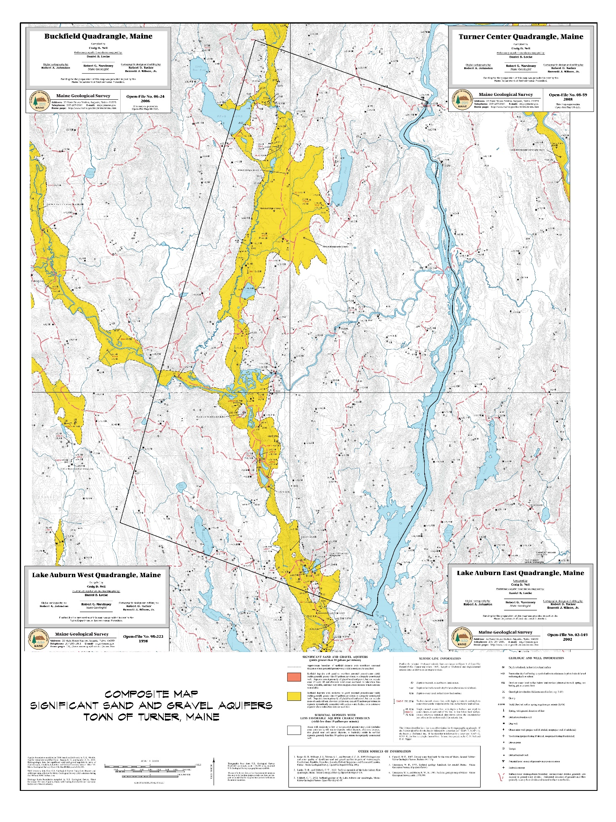
The type and depth of soil above the bedrock as well as the extent of recharge area to the bedrock determine the degree (less cover) of contamination. Underground petroleum and other chemical products storage have the most significant potential to contaminate bedrock aquifers. Underground tanks are that much closer to the water table and, in some cases, may have been placed in the water table.

Unlike sand and gravel aquifers bedrock aquifers have not been mapped. Data collected from local well drillers provide information including depth of wells, length of well casing and volume of water. Analysis of this information points towards areas of town where low yield bedrock wells are common. Also, there are general locations that point towards wells producing more than 30 gallons per minute. However, the amount of data does not allow for the designation of high yield bedrock aquifer areas.

Wildlife Habitat

Wildlife should be considered a natural resource similar to surface waters or forest land. Our wildlife species are a product of the land and, thus, are directly dependent on the land base for habitat. Therefore, if a habitat does not exist or an existing habitat is lost, various types of species will not be present. Although there are many types of habitat important to our numerous species, there are four which are considered critical. They include wetlands and surface water, riparian areas (shorelands of lands, ponds, rivers and streams), and deer wintering areas, large habitat blocks as well as other unique and/or critical habitats.

Every wetland has wildlife value. Small wetlands can be as important as larger ones. They provide habitat for most species of waterfowl, aquatic fur bearers and deer. The Maine Department of Inland Fisheries and Wildlife have identified 20 significant areas of waterfowl and wading bird habitat in Turner. These habitats are characterized as both seasonal and behaviorally as: breeding habitat, migration and staging habitat and wintering habitat.

The areas along watercourses, or riparian habitat, support high levels of wildlife and plant species. These areas provide travel lanes for wildlife and are a transition zone between various habitat types. While much of this area is offered some protection under shoreland zoning there are many miles of streams and wetlands that do not fall under the shoreland zoning regulations.

Deer wintering areas may represent only 10% of the total deer range, but, without such areas, deer will not survive in any but the smallest numbers. These wintering areas ideally consist of forested stands with a dense softwood canopy interspersed with mixed standards of hardwoods and softwoods. The dense softwood core areas provide shelter for deer by reducing snow accumulation and wind within the stand. The mixed hardwood and softwood cover provide food close to the core area. Oak, birch and red, sugar, mountain and striped maple are preferred foods and should be retained and cultivated whenever possible. Hemlock, cedar and balsam fir provide both cover and food. Although many types of human activity are not compatible with deer yards, good timber management can be beneficial.
The Maine Department of Inland Fisheries and Wildlife has mapped 21 Deer Wintering Areas in Turner. Several of these cover a significant amount of area including west and north of Pleasant Pond, between North Parish and General Turner Hill Roads and between Upper Street and the Androscoggin River.

Large habitat blocks provide habitat for plants and animals not included in riparian or high value habitats. Large blocks are relatively unbroken areas of habitat that include forest, grassland/agricultural land and wetlands. Unbroken means that the habitat is crossed by few roads and has relatively little development and human habitation. Animals that have large home ranges such as bear, bobcat, fisher and moose among other need large undeveloped habitat blocks. Blocks of 1 to 19 acres are home to species typical of urban and suburban species like raccoons, skunks and squirrels. Moose, bear, goshawks and bald eagles need blocks of 500 to 2,500 acres.

Turner’s landscape and land ownership patterns have worked to maintain several large blocks of undeveloped land. These include the area between Upper Street and the Androscoggin River, between County Road and the Turner/Hebron line, between North Parish Road and Plains Road, North Parish Road and the Androscoggin River, and Route 4 and Buckfield.

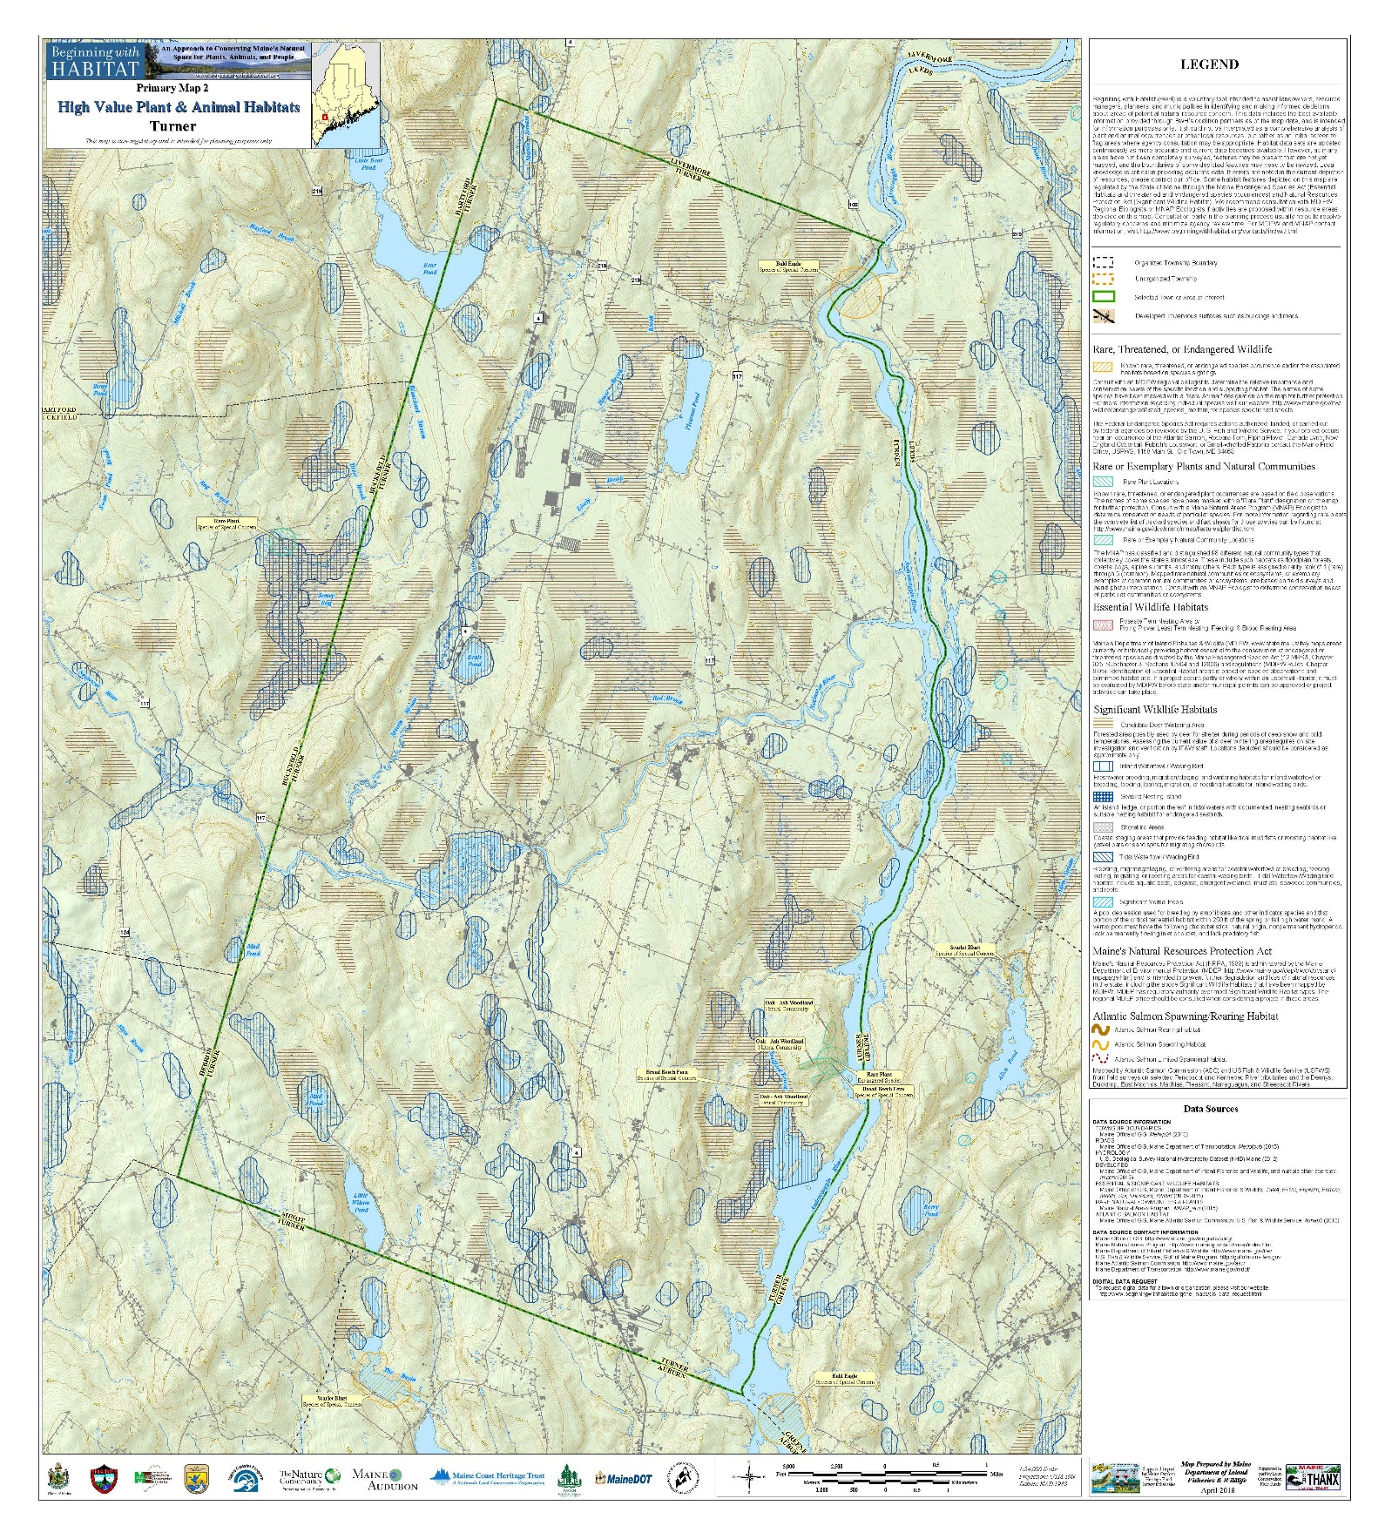
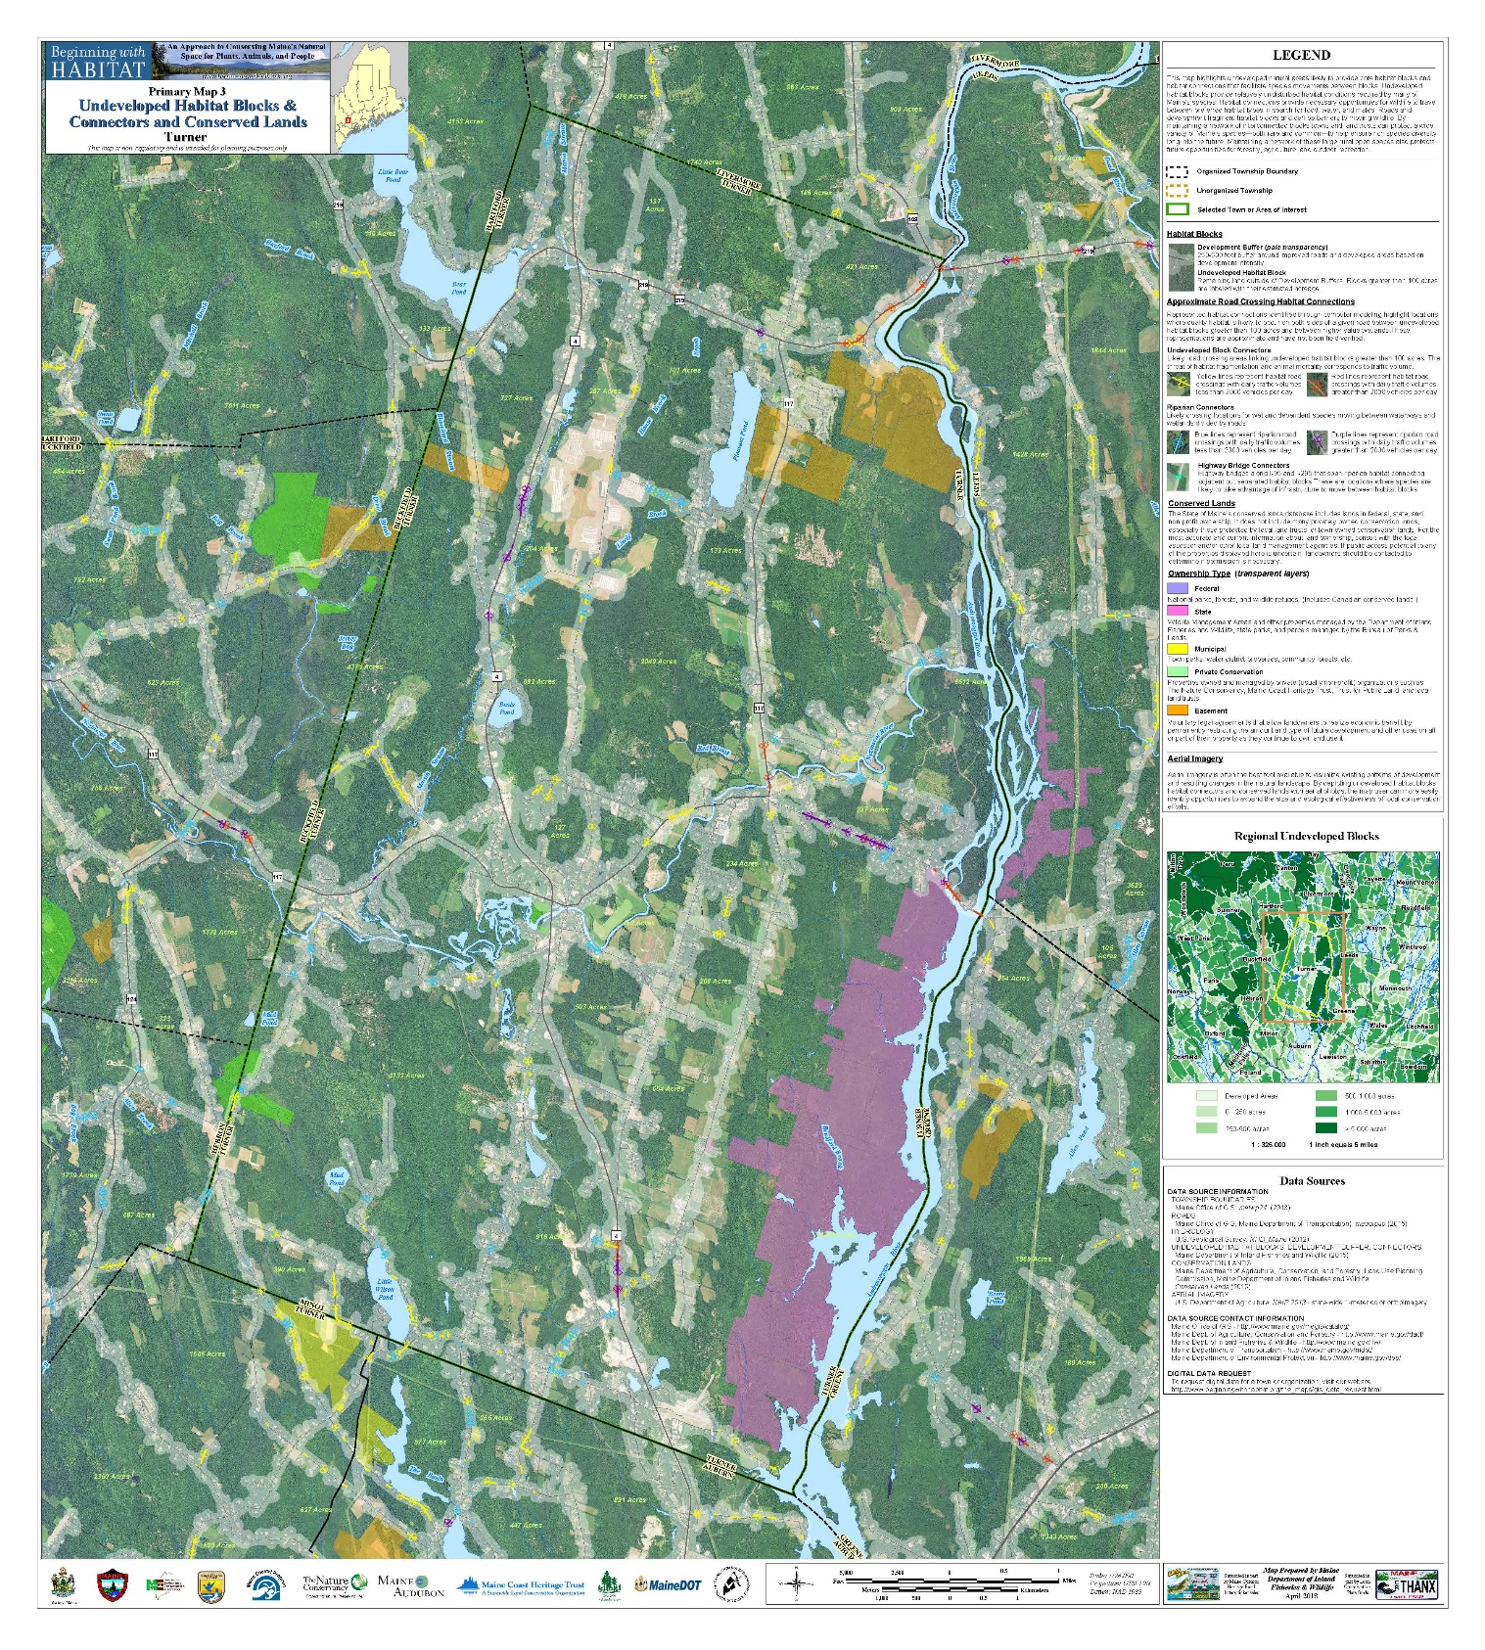

Floodplains

A floodplain is the flat expanse of land along a river or shoreline that is covered by water during a flood. Under the Federal Insurance Program, the 100-year floodplain is called the flood hazard area. During a flood, water depths in the floodplain may range from less than a foot in some areas to over 10 feet in others. However, regardless of the depth of flooding, all areas of the floodplain are subject to the requirements of the Flood Insurance Program. Floodplains along rivers and streams usually consist of floodway, where the water flows, and a flood fringe, where stationary water backs up. The floodway will usually include the channel of a river or stream as well as some of the land area adjacent to its banks.

The areas of flooding include areas along the Androscoggin and Nezinscot Rivers, Martin Stream and the smaller Brooks. During major flood events portions of Turner Villager are flooded. Undeveloped floodplains have been placed in a resource protection district which limits most structural development.

Turner participates in the National Flood Insurance Program which allows property owners that are located in the 100-year floodplain to purchase flood insurance. In 2018, there were 21 flood insurance policies issued in Turner with a total coverage of $3,815,900.

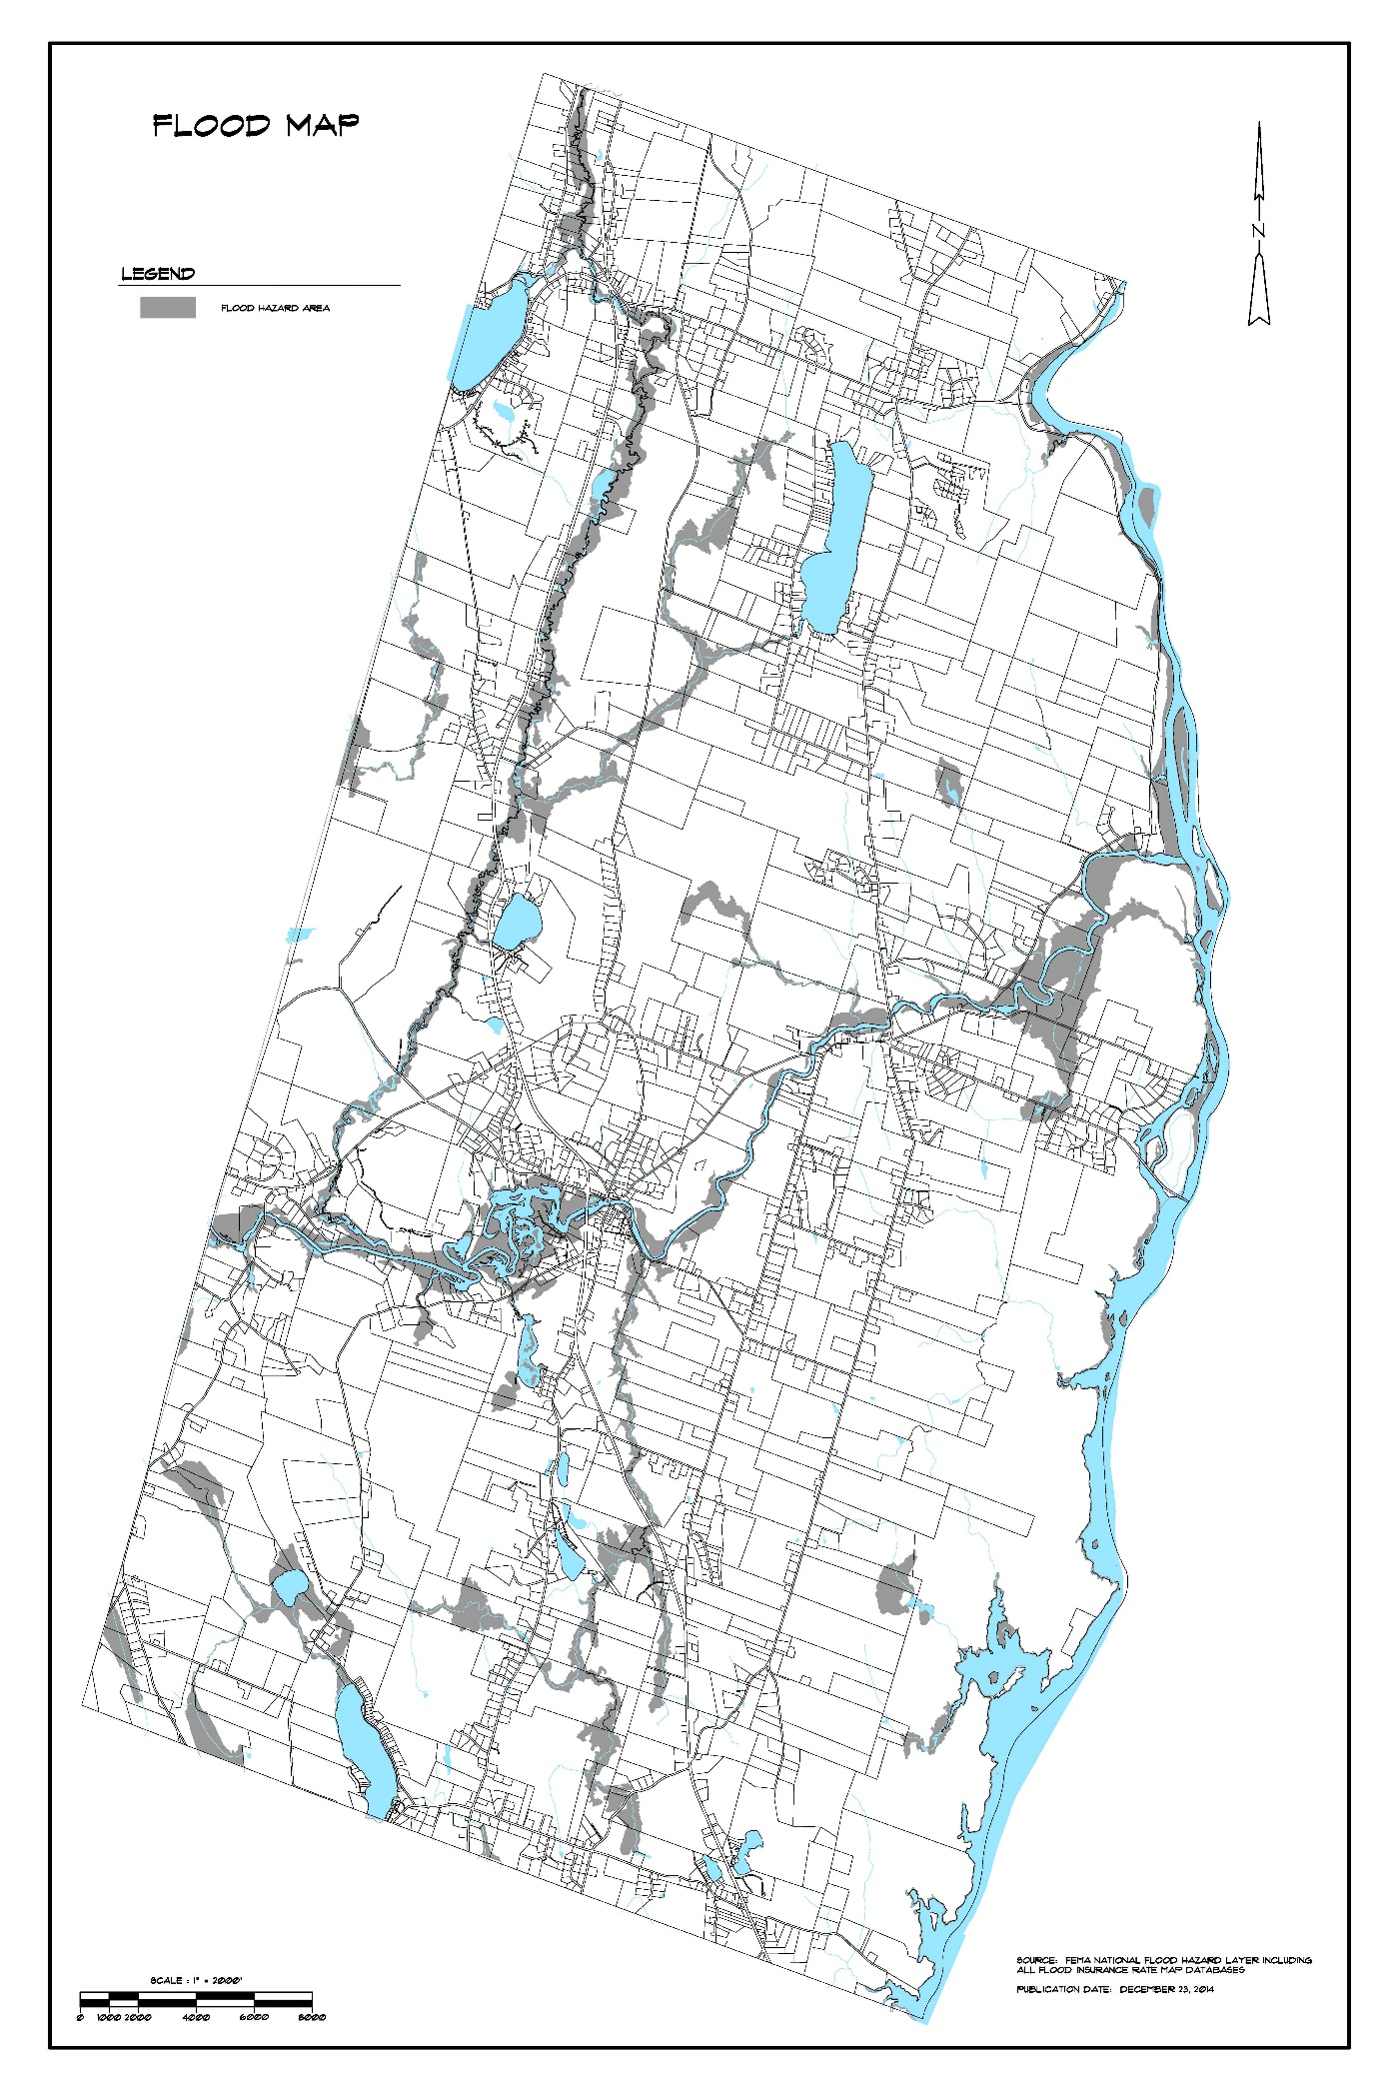
RARE, ENDANGERED AND SIGNIFICANT NATURAL FEATURES

Findings and Trends 2002 - 2018

❖ The purchase of the Androscoggin River Lands by the State has conserved significant natural areas adjacent to the Androscoggin River.

❖ There are several large tracts of undeveloped lands with high recreation value in Turner.

❖ Several rare and/or endangered botanical features have been identified on the Androscoggin River Lands.

Introduction

The Maine Natural Areas Program has compiled data on Maine’s rare, endangered or otherwise significant plant and animal species, plant communities, and geological features. While this information is available for preparation and review of environmental assessments, it is not a substitute for on-site surveys. The quantity and quality of data collected by the Natural Areas Program are dependent on the research and observations of many individuals and organizations.

Rare or Exemplary Botanical Features

Rare or exemplary botanical features reported by the Natural Areas Program in Turner include the following:

Scientific Name | Common Name | Last Seen | Maine Status
Clematis occidentalis | Purple Clematis | 1907 | Special Concern
Cynoglossum virginianum | Northern Wild Comfrey | 1915 | Endangered
Isotria verticillata | Large Whorled Pogonia | 1938 | Possibly Extirpated
Phegopteris hexagonoptera | Broad Beach Fern | 1997 | Special Concern
Subularia aquatica | Water Awlwort | 1989 | Special Concern
Utricularia resupinata | Small Purple Bladderwort | 1989 | Endangered

Androscoggin River Corridor

The Androscoggin River forms the eastern border of Turner. The Gulf Island Dam in Auburn, constructed in 1925-27, creates the largest improvement, the Gulf Island Pond, along the river.

The Androscoggin River is one of Maine’s major industrial rivers. However, the river corridor, in Turner, has been found to have a significant recreational potential and, as water quality improves, an even greater potential.

The Lower Androscoggin River Recreation Study and Management Plan found that the ten-mile section of the overall study corridor which begins at Gulf Island Dam and proceeds upstream to approximately two miles above the Greene-Turner Bridge, exhibits the greatest overall recreational potential within the study corridor. The large impoundment of water, some 2,000 surface acres, created by Gulf Island Dam, has a positive impact upon several recreational activities evaluated. Shoreline characteristics within this ten-mile segment are conducive as well to the majority of recreational activities evaluated.

Physical characteristics which create a high potential for the majority of the activities evaluated are many. The large impoundment of water is conducive to canoeing, power boating and boat fishing. The large islands enhance the potential for canoe camping and provide for wildlife habitat. Numerous large coves or bays are also positive influences upon canoeing, fishing, hunting and nature study due to their biological factors, which attract fish and wildlife. Shorelines within this section are primarily undeveloped which is also a positive factor to the potential of many activities evaluated.

In the late 1980's more than 2,000 acres of land was purchased by the Land for Maine’s Future Fund along the Androscoggin in Turner. The Committee believes the community needs to promote these opportunities and better use of this river and the Riverlands Park.

NATURAL HAZARDS/TECHNOLOGICAL HAZARDS/CHEMICAL SPILLS

Findings and Conclusions

- Turner is susceptible to natural and technical hazards. These include flooding, summer and winter storms, forest fires and chemical/oil spills.

- Since April 1987 the Town of Turner has received approximately $247,000 from the Federal government for Natural Disaster Relief.

Introduction

Turner is vulnerable to both natural and technological hazards. Natural hazards most likely to occur include flooding, severe winter and summer storms, forest fires, drought, dam failure and earthquakes. Technological hazards would relate to chemical/oil spills on highways and other major accidents. These hazards put lives and property at risk. As the cost of disasters continue to rise, the need to act before a disaster occurs to reduce the potential losses becomes more and more evident.

In 2015 the Town of Turner received $22,000 for a blizzard.

Hazard mitigation can be defined as sustained actions taken to reduce or eliminate long-term risk to people and property from hazards and their effects. Between 2009 and 2014, the Town of Turner received $93,348 from FEMA as a grant for hazard mitigation along the Nezinscot River.

Flooding

Flooding, or a temporary overflow of water onto lands not commonly covered by water, is the most frequent natural hazard in Turner. The two primary areas with flood potential are the Androscoggin and Nezinscot Rivers. Structure damage from flooding is most likely to occur along the Nezinscot River in Turner Village. The floodplain along the Androscoggin River for the most part is non- developed.

In 2018, there were 21 flood insurance policies issued in Turner with a total coverage of $3,815,900.

Consequential effects of flooding in Turner could include the following:

* Damage or destruction of structures and property within floodplains.
* Damage to public infrastructure, including streets and bridges.
* Forced shutdowns of affected businesses and industries.
* Possible loss of life.

Severe Winter Storms

The climate of Turner is classified as Humid Continental with cool summers. Minimum winter temperatures may drop to -20 or -30º F. However, daytime temperatures generally range from 0º to 30º F. Summers are pleasant but cool with daytime temperatures in the low 70s.

Average annual precipitation, including the water equivalent of snow, is approximately 45 inches. Annual snow fall averages some 80 inches, with the greatest amounts falling in January and February.

Blizzards, sleet, and ice storms can threaten Turner at any time from December through April. The most recent catastrophic winter storm to hit the area was the Ice Storm of January 1998. More than 1½ inches of ice collected on utility lines, causing them to break from the weight of the ice or to be broken by ice-laden trees falling across them. Blizzards carry with them their own problems. Lasting from 12 to 24 hours, with some dropping snow for up to 72 hours, blizzards often interrupt electrical and telephone service and cause roads to become impassible as the result of snow accumulation and drifting. Business closings can occur due to road conditions and loss of power. Structural failures are possible as the result of snow loads on roofs.

Consequential effects of a severe winter storm could include the following.

* Disruption of transportation.
* Disruption and delays in public safety emergency response services.
* Disruption or cancellation of essential community services.
* Loss of electrical power, telephone service and the essential living conveniences they provide.
* Disruption or forced shutdown of business and industry.
* Increased health risks associated with the combined effects of cold, overexertion and the increased chance of injury through falls and accidents.
* Damage to public and private infrastructure.
* Structural failure.
* Critical demand for public works activities.

Severe Summer Storms

Severe summer storms can be violent weather phenomenon’s producing high winds, heavy rains, lighting and hail that cause injuries and damage to property. While the entire state is vulnerable to one or more severe summer storms each year, the effects are usually felt the strongest in the western mountains and foothills of Maine. Storms tend to follow the course of the Androscoggin River valley passing through Turner.

Consequential effects of a severe winter storm could include the following.

* Power and communication outages
* Fires caused by lighting
* Flash flooding
* Road closings
* Structural damage
* Crop Damage

Forest Fires
Turner has more than 30,000 acres of forest land, and therefore, forest fires are a major concern. During dry periods the danger of forest fires increases. The last large forest fire in Turner was likely in 1931on the “Plains.” The last major forest fires in Maine were in 1947 destroying more than 200,000 acres and hundreds of homes. Much of the forest land in Turner is difficult to access by road making access to fires difficult. In addition, with the number of homes now located in forested locations the losses associated with a major forest fire would be great.

Causes of forest fires include debris burning, arson, lighting, machine use and campfires.

Consequential effects of a severe winter storm could include the following.

* Loss of property and life
* Loss of the value of trees as a resource to area industry
* Loss of wildlife habitats
* Increased erosion and sedimentation

Drought
Maine has recently been in drought conditions. The year 2001 was the driest year in Maine in 107 years of record keeping. Even normal precipitation for several months would not relieve the drought conditions. A drought is defined as a twelve-month period during which precipitation is less than 85% of normal as defined by the National Weather Service (44 inches is the average precipitation level per year). The Palmer Drought Index is used for the purpose of activating the Drought Emergency Plan. That index is comprised of evapotranspiration, recharge, runoff, loss and precipitation.
Consequential effects of a drought could include the following.

* Dry or low domestic wells/loss of drinking water
* Economic loss to businesses
* Increased danger of forest fires
* Crop damage or loss

Dam Failure

Dam failure is the spontaneous release of water from the loss of structural integrity of a barrier constructed to hold back the flow of water causing rapid flooding, loss of life, damage or destruction of property and forcing the evacuation of people and essential resources. There has not been a catastrophic dam failure or breach in Turner. However, in 1806, the Keene’s Mills dam was destroyed and in the early 1990s the Pleasant Pond dam was damaged. While dam failure could occur at any time the probability is greater during flood events.

Turner Village Dam was constructed in its current configuration sometime around 1886 to provide power for mills in Turner Village and is the largest dam in Turner. The town acquired the dam in 1955. The town in recent years has studied the needed repairs. Much of the inundation area is cropland.

Consequential effects of a dam breaching in Turner include the following.

* Severe damage to structures and property within the inundation area.
* Damage and loss of utilities.

Earthquake

Earthquakes are caused by modern stress released occasionally along zones of weakness in the earth’s crust. The resulting movement causes a shaking and/or shifting of the earth’s crust. This movement and shifting may cause objects to fall, glass to break, and structural failure. Earthquakes occur without warning.

Earthquakes occur most commonly west of the Rocky Mountains. However, all states are vulnerable to earthquakes. The largest modern time earthquake in the United States, measuring 9.2 on the Richter Scale, occurred in 1964 in Alaska. On average, one earthquake with a magnitude of 8.0 and higher occurs somewhere in the world each year.

Between 1747 and 2019, the largest earthquake recorded in Maine was near Eastport in 1904. That earthquake has been estimated to have had a Modified Mercalli intensity of VII. An earthquake of that intensity can damage weak masonry and cause chimneys to fall. The largest accurate measurement of an earthquake locally was in June of 1973 from an earthquake on the Quebec border near northern Oxford County. That earthquake was measured at magnitude 4.8 on the Richter Scale. Most earthquakes in Maine are of small magnitude and too small to feel. No significant damage has been caused by an earthquake in Maine, although the largest reported earthquakes in Maine caused damage to chimneys and broken glass near the epicenter. During the last 100 years, Oxford County has experienced the effects of a number of earthquakes in the 2.0 to 3.4 magnitudes.

The greatest danger to life from a significant earthquake is from falling objects, broken glass and structural failure. Dam failures may also occur as a result of a significant earthquake. Should a severe earthquake of magnitude of 6.0 and greater strike, there would be a great need for search and rescue of persons trapped in damaged or collapsed structures and fire fighting.

Consequential effects of an earthquake in Turner include the following.

* Danger to life from falling objects, broken glass and structural failure.
* Loss of power and telephone service.
* Damage to structures and property.

Technological Hazards/Chemical Spills

Between 2009 and 2018 there have been 81 spills reported in Turner totaling 1,273 gallons. The largest spill in that time frame was in 2018 and involved 100 gallons of diesel fuel.

The potential for an oil or hazardous material spill in Turner is high. This is due to the number of trucks traveling Route 4 carrying such materials.

Consequential effects of a technological hazard/chemical spill in Turner include the following.

* Disruption of traffic movement
* Threats to health
* Damage to property
* Environmental degradation

